Standard Operating Procedure
Business Energy and Water – Annual Report Lifetime Savings Calculations
Purpose

This Standard Operating Procedure (SOP) sets out procedures for the Business Energy and Water Assessor for the Actsmart Business Energy and Water (BEW) Program to follow when calculating the lifetime energy savings for the Directorate’s annual report.
Scope

This procedure applies to all technical staff involved in the Actsmart Business Energy and Water (BEW) Program. This includes, but is not limited to, the lead assessor for the program, the Actsmart senior energy and water assessor and the manager of the Actsmart Business Energy and Water program.

The employees undertaking the lifetime energy savings are responsible for being familiar with this SOP and applying it in practice.

Procedure

The purpose of the Actsmart Business Energy and Water Program is to provide a financial incentive to assist small businesses in upgrading inefficient technologies with the aim of reducing their electricity bills and reducing their CO₂ emissions.

The directorate’s annual report includes a statement on the estimated lifetime energy savings from the upgrades installed since the program commenced.

The program database records information on individual businesses’ upgrades, including annual energy, dollar and greenhouse gas emission savings. This data is exported to Excel and analysed to calculate lifetime energy savings using the following methodology:

lifetime energy savings (MWh) = [Annual energy savings (kWh) x deemed lifetime (years)]/1000

Source of data:
- Annual energy savings (kWh): exported from the BEW database
- Deemed lifetime (years): Table A3 from Overview of the ESS (2014)

Previous years’ annual report lifetime energy savings calculations are saved in Objective in the following location:
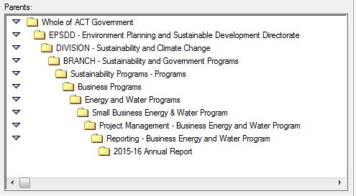

Disclaimer: This document has been developed by Environment, Planning and Sustainable Development Directorate specifically for its own use. Use of this document and any reliance on the information contained therein by any third party is at his or her own risk and Environment, Planning and Sustainable Development Directorate assumes no responsibility whatsoever.

