Standard Operating Procedure
Business Energy and Water – Managing the Business Energy Mailbox
Purpose

This Standard Operating Procedure (SOP) sets out procedures for the Business Energy and Water Assessor for the Actsmart Small Business Energy and Water Program (BE&W Program) to follow when managing the business energy mailbox utilising the businessenergy@act.gov.au email address.
Scope

This procedure applies to all staff involved in the Actsmart Small Business Energy and Water Program. This includes, but is not limited to, the lead Assessor for the program, the Actsmart Senior Energy and Water Assessor, the Manager of the Actsmart Business Energy and Water team, and any staff that take part of the administration of the program assessment such as new employees undergoing training or other staff (technical and non-technical) for the purposes of cross-team training.

The Employees undertaking management of the businessenergy@act.gov.au mailbox are responsible for being familiar with this SOP and applying it in practice.

Procedure

The purpose of the Actsmart Business Energy and Water dedicated email address (businessenergy@act.gov.au) is to provide a centralised email and single point of communications for all client and tradesperson correspondence for the Business Energy and Water program. This serves several purposes:

- Should the main Energy Assessor and administrator of the mailbox be away (leave) then alternative staff can access emails to ensure the correspondence is actioned
- As staff move between roles, the email address remains consistent so that no matter who is administering the program, the clients and tradespersons can be sure the contact details are the same.

Procedure

Inbox Management
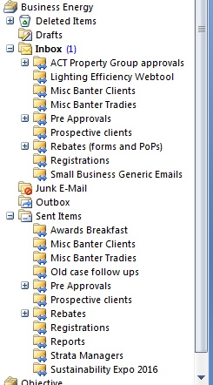
All emails that are sent to the small business program arrive
in the Inbox. New emails are bolded indicating they have
arrived and have not been looked at, and the Inbox shows the
number of these unread emails – in the picture to the right one
unread email is currently in the Inbox, although there may
be other (read but not necessarily actioned) emails in there.

It can be seen below that there are four emails in the
Inbox in total, of which one is unread

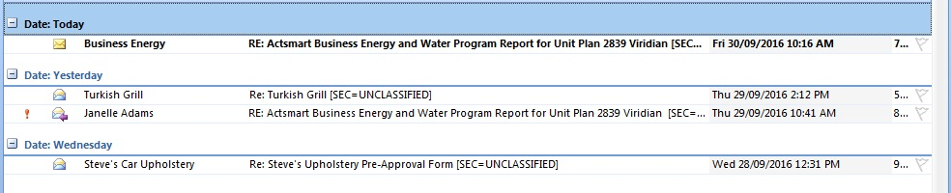

Once they have been looked at (but not necessarily actioned) the bolding disappears

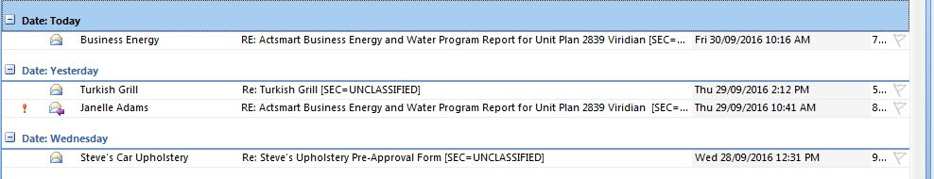

The emails should remain in the Inbox until they are completely actioned, whether this be by the Energy Assessor, Senior Energy Assessor, Manager of the BEW program or anyone undertaking administration of the program.

Once the email has been actioned it is to be filed to ensure it is not actioned again. In this way, the Inbox is free of email clutter and at a glance it can be seen how many emails still require attention.

The mailbox has nine folders in which actioned Inbox emails can be filed, listed below with an explanation of when to use that folder:

- ACT Property Group Approvals: Occasionally Business Energy and Water clients have the ACT Government as their landlords. Confirmation that the ACT Government is happy for a client to upgrade the premises is required prior to the upgrade. Correspondence with the ACT Government to be filed here.

- Lighting Efficiency Webtool: When the Actsmart Lighting Efficiency Webtool (http://actsmart-lightingwebtool.com.au/) has been used an email containing an attached MSExcel .csv is sent to the businessenergy@act.gov.au email address. Once the attachment has been downloaded by the Senior Energy Assessor or Manager, Business Energy and Water Program, the email is filed here.

- Misc Banter Clients: General discussions with clients that have already been registered with the program, incoming emails.

- Misc Banter Tradies: General discussions with tradespersons, incoming emails.

- Pre Approvals: all incoming paperwork associated with the Pre Approval process filed here, including emails with attachments with the Pre Approval forms and quotes.

If a pre-approval for upgrade is declined, the original incoming email is to be filed in the sub-folder “Declined Pre Approvals”.

- Prospective Clients: Emails from clients who have not registered (yet) for the program. Most likely they will be enquiring about the program

- Rebates (forms and Pops): all incoming paperwork associated with the Rebate Claim process filed here, including emails with attachments with the Rebate Claim forms and proof of payment (PoP).

If a Rebate Claim for upgrade is declined, the original incoming email is to be filed in the sub-folder “Declined Rebate Claims”.

- Registrations: All incoming registration forms to be filed here

- Small Business Generic Emails: Anything that is associated with the program that is not directly client related.

Sent Items Management

Once an incoming email has been actioned with a response, or an email is generated that was not prompted by an incoming email such as a report to a client, this email appears in the Sent Items.

In order to make searching for a sent email easier, and to prevent clutter in the sent items, these emails in the Sent Items folder are to be moved into one of ten folders:

- Awards Breakfast: The annual Actsmart Awards Breakfast (held in May) requires emails to be sent to clients that have been through the program and claimed a rebate.

- Misc Banter Clients: General discussions with clients that have already been registered with the program.

- Misc Banter Tradies: General discussions with tradespersons.

- Old Case Followups: Occasionally clients who have not proceeded to an upgrade are contacted.

- Pre Approvals: all outgoing correspondence associated with the pre-approval process filed here, including emails requesting further information and Actsmart’s formal email outlining eligibility and the dollar amounts.

If a pre-approval for upgrade is declined, the outgoing email stating the reasons to the client is to be filed in the sub-folder “Declined Pre Approvals”.

- Prospective Clients: Emails to potential clients who have not registered (yet) for the program.

- Rebates (forms and Pops): all correspondence to clients associated with the rebate claim process filed here.

If a rebate claim for upgrade is declined, the email to the client with the reasons is to be filed in the sub-folder “Declined Rebate Claims”.

- Registrations: All replies to registrations go here including acknowledgement of registration, correspondence regarding appointments and requests for further information

- Reports: All reports sent to clients are filed in this folder

- Sustainability Expo 20XX: In the lead up to the September Sustainability Expos emails are sent to prospective clients and trades to encourage stallholders and attendees.

Disclaimer: This document has been developed by Environment, Planning and Sustainable Development Directorate specifically for its own use. Use of this document and any reliance on the information contained therein by any third party is at his or her own risk and Environment, Planning and Sustainable Development Directorate assumes no responsibility whatsoever.

