Standard Operating Procedure
Business Energy and Water – Calculating Client Savings
Purpose

This Standard Operating Procedure (SOP) sets out procedures for the Business Energy and Water Assessor for the Actsmart Business Energy and Water Program (BE&W Program) to follow when calculating the energy and cost savings for clients.
Scope

This procedure applies to all technical staff involved in the Actsmart Business Energy and Water Program. This includes, but is not limited to, the Lead Assessor for the program, the Actsmart Senior Energy and Water Assessor, the Manager of the Actsmart Business Energy and Water team, and any technical staff such as new employees undergoing training or other technical staff for the purposes of cross-team training.

Non-technical staff are excluded from carrying out client’s savings calculations.

The employees undertaking the calculations of energy and cost savings for client upgrades, and/or entering these into the client database are responsible for being familiar with this SOP and applying it in practice.
Procedure

The purpose of the Actsmart Business Energy and Water Program is to provide a financial incentive to assist small businesses in upgrading inefficient technologies with the aim of reducing their electricity bills and reducing their CO₂ emissions.

The ACT Government’s annual report includes the amount of money and CO₂ that businesses save annually through the Business Energy and Water Program.

Energy savings attributed to businesses are calculated and entered into the database for the purposes of generating the annual report figures. Additionally, the cost of the upgrade is entered into the database so that:

- the dollar amount that has been claimed of rebate is easily available
- future supply and installation costs can be benchmarked against previous installations.

Procedure

It is impossible in this document to provide sufficient detail to cover every upgrade scenario and technology.

It is assumed that an energy assessor has sufficient technical background to understand the basic premise of calculating energy and cost savings and as such, this is what will be documented here along with several worked examples of the more common upgrades including:

- lighting with a straight like-for-like replacement
- lighting with replacement of differing numbers and/or technologies
- HVAC upgrade
- refrigeration upgrade.

The basic premise of the savings, for whatever technology that is upgraded, is to calculate the energy consumption (kWh per year) of the old inefficient equipment, calculate the energy consumption (under the same conditions) of the new efficient equipment (kWh per year) and subtract the latter from the former:

Annual Energy Savings (kWh per year) = Annual Energy Consumption_{OLD EQUIPMENT}
– Annual Energy Consumption_{NEW EQUIPMENT}

Where the

Annual Energy Consumption _{Z EQUIPMENT} =
(Total Wattage (W) x Annual Operating Hours) ÷ 1,000

And the

Annual Operating Hours = Daily Operating Hours x Number Days Operation per Year
OR
Annual Operating Hours = Weekly Operating Hours x Number Weeks Operation per Year

And the

Total Wattage = sum of all equipment upgraded x individual component wattage

And from this the dollar savings is easily calculated by:

Annual cost savings ($ per year) = Annual Energy Savings (kWh per year) x
electricity tariff ($ per kWh)

Example 1: Lighting Upgrade with a Straight Like-for-Like Replacement

Assumptions: Original fixture is a twin 1.2m T8 fluorescent lamp. Each lamp wattage = 36W + 9W ballast losses = 45W total lamp
50 fixtures were upgraded = 100 lamps
Replacement is individual LED lamps at 18 watts each: the original troffer remains insitu
Business operates 8 hours per day, 5 ½ days per week, 50 weeks per year, including public holidays
Average electricity tariff = $0.23 / kWh

Manual Calculations

Annual Operating Hours = 8 x 5.5 x 50 = 2,200 hours per year
Total Wattage_{OLD EQUIPMENT} = 2 x (36 + 9) x 50 = 4,500 watts
Total Wattage_{NEW EQUIPMENT} = 2 x 18 x 50 = 1,800 watts
Annual Energy Consumption_{OLD EQUIPMENT} = 4,500 x 2200 ÷ 1000 = 9,900 kWh per year
Annual Energy Consumption_{NEW EQUIPMENT} = 1,800 x 2200 ÷ 1000 = 3,960 kWh per year
Annual Energy Savings (kWh per year) = 9,900 – 3,960 = 5,940 kWh / year
Annual cost savings ($ per year) = 5,940 x 0.23 = $1,366.20 per year

Report Tool Calculations

To calculate the savings illustrated above every time a rebate claim has come in is double handling. In generating the report for the client these calculations will already have been carried out in the MS Excel spreadsheet, and this can be used as the basis for the calculations.

Make a copy of the report tool for the client and save it in the same directory (folder) with the name “Savings Calculations”. Open the Savings Calculations MSExcel spreadsheet.

Remove from the recommendations all of the lighting fixtures that were not upgraded. In the example below halogen lights were originally recommended for upgrade but not carried out. Thus the “Yes” for upgrade has now been changed to “No”.

Note that off the Excel tool many of the calculation details are not shown, just selected information. Note also the Average Total Hours Day is not 8, but an average for the 6 working days per week the business is open, which is of 8 (hours per day open) x 5.5 (days per week open) ÷ 6 (6 out of the 7 days per week open) = 7.33 hours per day.

Enter also the actual supply and installation costs of the upgrade, on a per unit basis. In this case the electrician charged the client $45 per lamp (including GST) for supply and $25 per lamp (including GST) for the installation.

Lighting Before

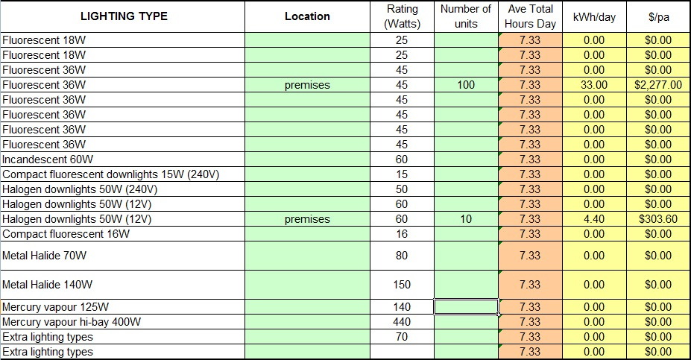

Lighting After

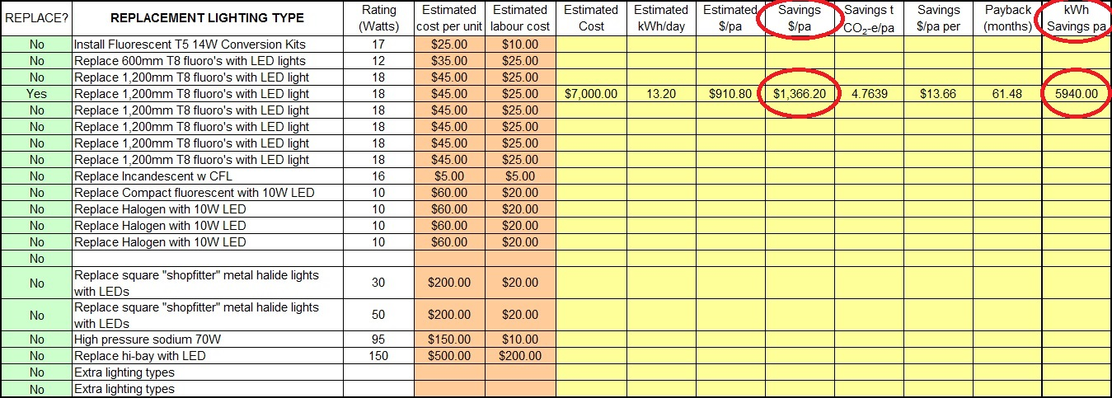

It can be seen from here that the dollar savings and kWh savings can be directly read from the tool.

Lighting with Replacement of Differing Numbers and/or Technologies

Occasionally lighting is upgraded with alternative technologies that are not directly comparable. For instance, twin fluorescent lamps are removed from the ceiling and two small downlights are installed instead, and a reduced number are installed.

In this case manual calculations will need to be carried out as the Excel tool cannot account for differing numbers of replacement fittings. Where the “number of units” is showing in the top above, this number is used in the calculations in the bottom picture. As such, the tool cannot be used.
Assumptions: Original fixture is a twin 1.2m T8 fluorescent lamp. Each lamp wattage = 36W + 9W ballast losses = 45W total lamp
50 fixtures were upgraded
Replacement is two LED lamps per twin T8 at 10 watts each, but only 90 installed
Business operates 8 hours per day, 5 ½ days per week, 50 weeks per year, including public holidays
Average electricity tariff = $0.23 / kWh

Manual Calculations

Annual Operating Hours = 8 x 5.5 x 50 = 2,200 hours per year
Total Wattage_{OLD EQUIPMENT} = 2 x (36 + 9) x 50 = 4,500 watts
Total Wattage_{NEW EQUIPMENT} = 10 x 90 = 900 watts
Annual Energy Consumption_{OLD EQUIPMENT} = 4,500 x 2200 ÷ 1000 = 9,900 kWh per year
Annual Energy Consumption_{NEW EQUIPMENT} = 900 x 2200 ÷ 1000 = 1,980 kWh per year
Annual Energy Savings (kWh per year) = 9,900 – 1,980 = 7,920 kWh / year
Annual cost savings ($ per year) = 7,920 x 0.23 = $1,821.60 per year

Excel Calculations Spreadsheet

“Pricing and Energy Calculations - Template” located in “R:\Sustainability Programs\Business\Energy and Water Programs\Small Business Energy and Water\Tools and templates” has been setup to calculate energy savings where they cannot be carried out in the Excel tool.

Enter the original lighting information in the bolded areas – what was there, the wattage, the number of fittings and the daily “on” hours. Also populate # days per year the business is open (50 x 5.5 in this case) and the electricity tariff.

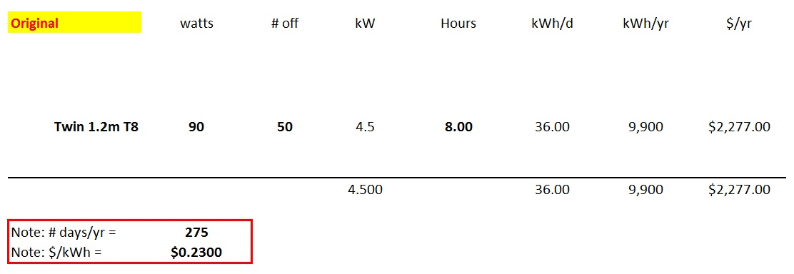

Enter in the replacement type of lights, the wattage and number of these.

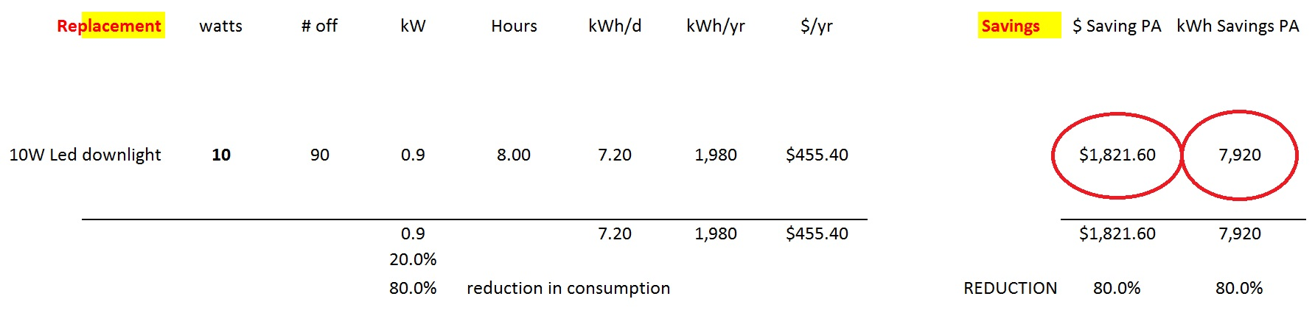The dollar and kWh savings are calculated and shown in the red circles above.

HVAC Upgrade

Lighting upgrades can be reasonably well defined in their consumption savings due to the known reduction in wattage and close approximation of run times.

Unless measurements are carried out before and after the upgrade, HVAC upgrades tend to be a bit more “rubbery” in their savings due to:
- often unknown input specifications on existing equipment (old equipment with no specifications nameplate, located in hard to access places, etc)
- unknown cycle times
- unknown runtimes (seasonal turn on/off times)
- varying internal temperatures affecting workloads.

Estimations of these lead to errors. However, reconciliation of the electricity bills with modelled consumption does minimise this.

The Excel tool can be used to estimate the HVAC savings.

HVAC before

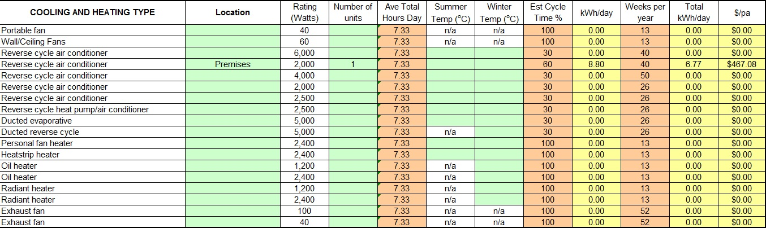

These “before upgrade” estimates have the following information:

- 2,000w input consumption (always the input consumption)
- 7.33 hours per day use (= 8 hours per day and 4 hours on Saturday) for
- 40 weeks of the year (6 months winter and 13 week summer)
- estimated cycle time of 60% - it’s an old unit that is running inefficiently.

HVAC after

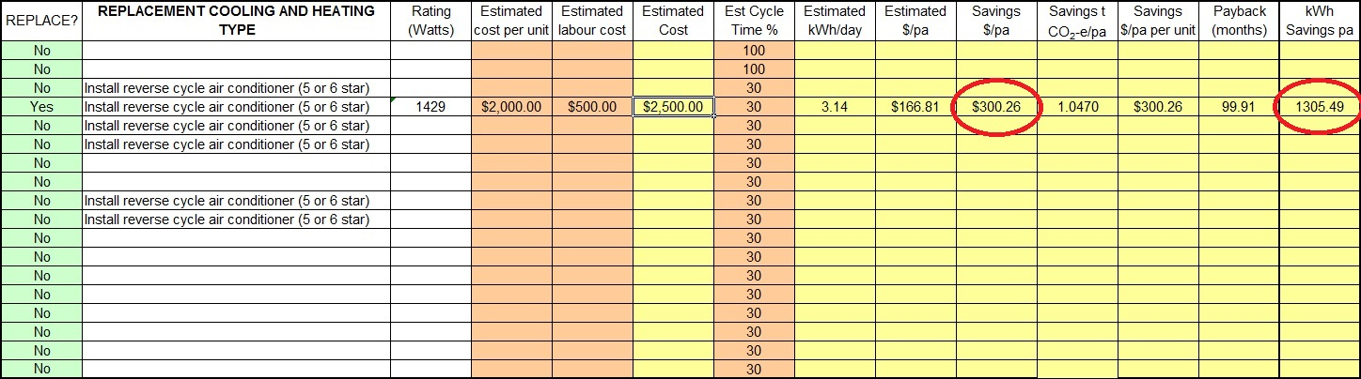

These “after upgrade” estimates have the following information:

- 1429 W input consumption. This should be the actual consumption off the equipment specifications.
- 40 weeks of the year (6 months winter and 13 week summer)
- estimated cycle time of 30% - it’s a new unit that is running efficiently.
- no operating usage – it is assumed the same patterns of use ie 7.33 hours per day and 40 weeks per year.
The cost savings and kWh savings can be read straight off the tool (see the red circles above).

A manual calculation can also be undertaken to estimate the savings, using the basic premise of “energy consumption before upgrade” minus “energy consumption after upgrade”.

Refrigeration Upgrade

The Excel tool can be used for estimating savings for refrigeration upgrades.

In this example a 350w domestic 500L refrigerator (old, with an estimated cycle time of 60%) is replaced with a new refrigerator of the same size consuming 250 watts (taken from the unit specifications) with a cycle time of 30% (assumed, due to it being new).

The cost and kWh savings are taken from the usual place.
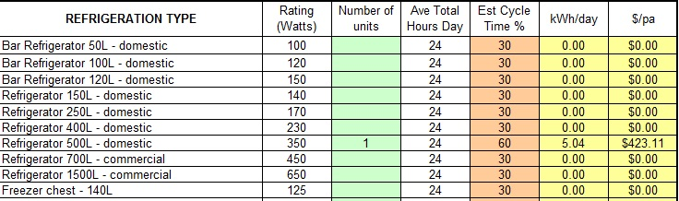

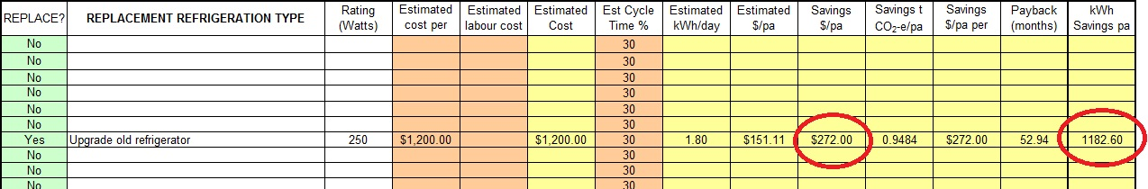

Disclaimer: This document has been developed by Environment, Planning and Sustainable Development Directorate (EPSDD) specifically for its own use. Use of this document and any reliance on the information contained therein by any third party is at his or her own risk and EPSSD assumes no responsibility whatsoever.

Such as the same daily/weekly hours of operation, the same number of days per year the business is open and the same cost of electricity.
If specifications for the input consumption are not known, estimations of the input consumption can made by assuming the old heat pump has a COP of 2.5 and a new one a COP of 3.5. Thus new consumption = old consumption x 2.5/3.5

