Standard Operating Procedure
Business Energy and Water – Processing Rebate Claim Forms
Purpose

This Standard Operating Procedure (SOP) sets out procedures for the Business Energy and Water Assessor for the Actsmart Business Energy and Water Program (BE&W Program) to follow when processing a rebate claim form.
Scope

This procedure applies to all staff involved in the Actsmart Business Energy and Water Program. This includes, but is not limited to, the Lead Assessor for the program, the Actsmart Senior Energy and Water Assessor, the Manager of the Actsmart Business Energy and Water team, and any staff that take part of the administration of the program assessment such as new employees undergoing training or other staff (technical and non-technical) for the purposes of cross-team training.

The employees undertaking the processing of rebate claim forms for client upgrades are responsible for being familiar with this SOP and applying it in practice.
Procedure

The purpose of the rebate claim process in the Business Energy and Water Program is the following:

- To ensure the upgrade at the client’s premises has been:
  - undertaken in accordance with the pre-approved scope of works
  - paid in full
- To provide confirmation to the staff generating the Accounts Payable Invoice Cover Sheet that the rebate claim is ready for payment.

Procedure

The Rebate Claim Form

The Rebate Claim Form is a confirmation from the client that the upgrade work at their premises has been completed and been paid for. It can be submitted by the client, or by a supplier on their behalf, but the form must be signed by the client. Proof of full payment of the contractor’s invoice should be attached to the Rebate Claim Form.

The Rebate Claim Form looks like this:
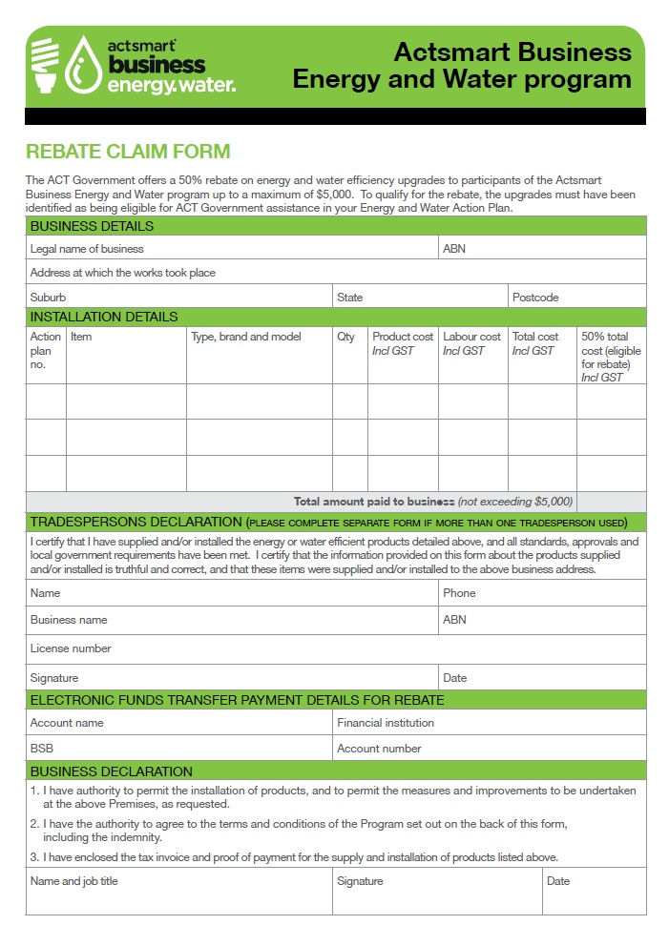

Check that:

- all necessary “Business Details” have been entered
- ideally the “Installation Details” will have been filled in as per the form – the upgrade items corresponding to the action plan number with all of the other information completed. Note that in reality it is fine if the client puts in this section “Please see attached quote”.
- the “Tradespersons Declaration” has been completed in full by the tradesperson
- the “Electronic Funds Transfer Payment Details for Rebate” has been completed by the client – this is the bank account details to which the rebate is paid
- the form has been signed and dated by the authorised person – check the signature against that on the registration form.
If the form has been emailed then print out a copy for the paper file, and save a copy of the form in the client’s electronic folder. Save the file as “case number - client name - Rebate Claim Form” or “Proof of Payment”, depending on which document it is (for example “395 - Joe’s Electronics - Rebate Claim Form”).

It may be worth creating a new sub-folder within the client’s electronic folder named “Rebate Claim for X” where X is the type of upgrade – lighting, HVAC, refrigeration etc. If the form has been posted scan it in colour and save it in the client’s electronic folder. File the hardcopy.

Ensure two hardcopies exist – one for the finance team and one for the client folder.

If the critical business information details are not complete, contact the client by email/phone and ask them to send you a completed form or the information that is missing (bank account details for instance) and write these in. If you are writing in this information from an email from a client, do the following:

- attach a printout of the email with this information from the client so that finance knows it is a legitimate entry by Actsmart
- save a copy of this email from the client in the client’s electronic folder for future reference.

It is important to create a sub-folder when you expect the client to undertake several upgrades of differing equipment at different times. Having all of the rebate claim documents along with the registration form, report, assessment tool and the pre-approval forms in the one folder can become cluttered and harder to find documents when you need to.

The Attached Proof of Payment

The client MUST attach a proof of payment to the tradesperson with the rebate claim form – set aside the form and ask for this to be sent through if they have not included it.

The proof of payment can come in several different formats – a tax invoice from the tradesperson showing “paid in full” and/or “$0” outstanding balance at the bottom; a cheque for the payment; or an electronic funds transfer (EFT) receipt.

It is not necessary for the client to send through the quote with the rebate claim form – just the form itself and some sort of proof of payment.

If the Payment/Tax Invoice/etc differs from the Pre-Approved Funds

Occasionally the payment made to the tradesperson is different to that which was quoted by the tradersperson in the pre-approved process. For instance, a quote may be accepted by the client for $4,000 being eligible for $2,000 in rebates and the actual cost of the upgrade was $4,500 giving rise to a potentially higher rebated amount.

It is to be acknowledged that physical upgrades can be a fluid process and during the fitout unforseen items may occur. For instance, the electrician in a lighting upgrade has to warrant the troffer fittings including the tombstones the LED lamps will fit into. During the initial inspection he may be happy with the quality of the fittings but during the fitout they fail and he has to replace/upgrade them.

In these cases Actsmart should contact the tradesperson to discuss what had changed and to ensure that the work is eligible for the rebate. Contact the client also. If the work is nominally an eligible item (eg replacing old troffers with new ones) then accept the change to the scope and the pricing and increase the rebate amount. If the work is not nominally eligible of the rebate (eg the client has requested some general maintenance on other equipment) then contact the client and indicate this additional amount falls outside the scope of the program.

There is little that can be done retrospectively to avoid this. When you contact the tradesperson, ask that in future if anything different happens during the fitout, give you a call and discuss what the financial consequences are and whether the work is a nominally eligible item under the program. In this way the pre-approved amount can be adjusted.

Finalising the Rebate Claim

Once you have checked the Rebate Claim Form and accompanying proof of payment, and it satisfies the requirements of the program, provide this documentation to the Manager to generate the Accounts Payable Invoice Cover Sheet which will be sent to the finance team for payment.

Email the client to let them know that the rebate claim has been processed and that the funds should appear in the nominated bank account within 30 days. Thank them for their participation in the program and invite them to join the Actsmart Business Recycling program if they are interested. Draft suggested text is as follows:

I have processed your Rebate Claim Form and Proof of Payment. Your rebate should appear in the nominated bank account within 30 days.

Thanks for participating in the Actsmart Business Energy and Water Program. Please spread the word about it! The webpage for the program is here: http://www.actsmart.act.gov.au/what-can-i-do/business/business-energy-and-water-program

Finally, I invite you to register for the Actsmart Business Recycling program, which has the potential to save you money by reducing your waste-to-landfill costs. You can also become accredited with Actsmart and be able to display our logo on your premises as recognition of your outstanding work in reducing your resource consumption and waste. If you’re interested in finding out more about this program, email actsmartbusiness@act.gov.au or check out the website at: http://www.actsmart.act.gov.au/what-can-i-do/business/actsmart-business-recycling-program.

Alternately, if you would like me to I can pass your details on to our Actsmart Business Recycling team and they will contact you directly – just let me know if you would like me to do this.

All the best with your energy efficiency upgrades!

Regards,

[assessor name]

Disclaimer: This document has been developed by Environment, Planning and Sustainable Development Directorate (EPSDD) specifically for its own use. Use of this document and any reliance on the information contained therein by any third party is at his or her own risk and EPSDD assumes no responsibility whatsoever.

Occasionally this does not need to be completed. For instance, if a client purchases a refrigerator to upgrade an old one, there is no requirement for a tradesperson to install the unit, so this section remains empty

