Standard Operating Procedure
Business Energy and Water – Process Pre-Approvals
Purpose

This Standard Operating Procedure (SOP) sets out procedures for the Business Energy and Water Assessor for the Actsmart Business Energy and Water Program (BE&W Program) to follow when processing a pre approval form.
Scope

This procedure applies to all staff involved in the Actsmart Business Energy and Water Program. This includes, but is not limited to, the Lead Assessor for the program, the Actsmart Senior Energy and Water Assessor, the Manager of the Actsmart Business Energy and Water team, and any staff that take part in the administration of the program assessment such as new employees undergoing training or other staff (technical and non-technical) for the purposes of cross-team training.

The employees undertaking pre-approvals of client upgrades are responsible for being familiar with this SOP and applying it in practice.
Procedure

The purpose of the pre-approval process in the Business Energy and Water Program is to ensure:

- rebate funds are being used the best effect by ensuring the client is using sound equipment in their upgrade
- the client is getting value for money from contractors
- funds are accrued in the finance database for the client’s upgrade.

It is anticipated that by going through the pre approval process, once the Rebate Claim comes into us, we already know what is going in, and we are happy with the upgrade.

Procedure

The Pre Approval Form

The Pre Approval Form is a proposal for work that the client wants done. It can be submitted by the client, or by a supplier on their behalf, but the form must be signed by the client. A quote for the work should also be attached to the pre-approval form.

The Pre Approval Form looks like this:
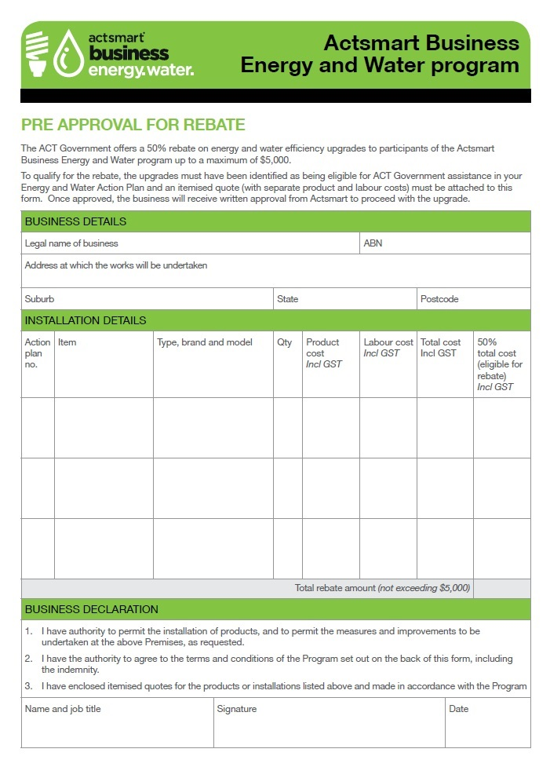

Check that:

- all necessary “Business Details” have been entered
- ideally the “Installation Details” will have been filled in as per the form – the upgrade items corresponding to the action plan number with all of the other information completed. Note that in reality it is fine if the client puts in this section “Please see attached quote”, as long as the quote is attached and has the appropriate information (see “The Attached Quote” below)
- the form has been signed and dated by the authorised person – check the signature against that on the registration form
If the critical business information details are not complete, contact the client by email/phone and ask them to send you a completed form.

If the form has been emailed then print out a copy for the paper file, and save a copy of the form in the client’s electronic folder. It may be worth creating a new sub-folder within the client’s electronic folder named “Pre-Approval for X” where X is the type of upgrade – lighting, HVAC, refrigeration etc. If the form has been posted scan it in colour and save it in the client’s electronic folder. File the hardcopy.

It is important to create a sub-folder when you expect the client to undertake several upgrades of differing equipment at different times. Having all of the pre-approval documents along with the registration form, report, assessment tool and (ultimately) the rebate claim form in the one folder can become cluttered and harder to find documents when you need to.

The Attached Quote

The client MUST attach a quote with the application – set aside the form and ask for this to be sent through if they have not included it.

The quote should have a minimum of information:

- electrician’s details – phone number, address, ABN, sometimes their (electrical) licence number. A logo is always welcome to indicate the electrician is a legitimate business
- make and model of the equipment to be installed. This is to ensure specifications can be sourced (wattages) at a later stage and to benchmark the component pricing against known pricing
- pricing broken into the supply of equipment and the installation of the equipment.

You can call the client and request information if it has not been included (tech specs, pricing breakdowns, etc). Alternatively, to save the client the hassle and to avoid double handling, you can approach the electrician/tradesperson directly and request the information. This does not endorse the tradesperson as the preferred tradesperson as the client has indicated to Actsmart this is their choice of trades by submitting the quote. If you get further information from the tradesperson/client write this on the quote and scan the quote and put it in the electronic file for future reference.

Check the pricing against known similar upgrades, check that the technology is appropriate to their needs, and that it is in accordance with what was recommended in the report.

- If the quote looks reasonable, proceed to the next step.
- If the quote looks high take note of the following: Actsmart cannot reject a client’s choice to use a tradesperson. If the client wishes to proceed with the tradesperson we are obliged to accept this and rebate the eligible item. Actsmart can indicate to the client that “the pricing is higher than we normally see come through the program” and “we suggest you obtain further quotes to ensure the best price for your upgrade has been achieved.”

Sign Off and Contacting the Client

Once satisfied the work is eligible for the rebate, sign the pre-approval form that goes into the hardcopy file.

Email the client with the following information:
- the work they have submitted is eligible for the Actsmart rebate
- state the dollar amount the work is eligible for
- copy any Actsmart administration staff into the email – they have to add the accrued amount to the finance database
- as a matter of courtesy you can copy the contractor (electrician say) into the email. This gives them the knowledge they can contact the client and proceed with the work. This does not compromise the integrity of the program (vis-à-vis endorsing a preferred contractor) since in submitting the quote to Actsmart the client has told us “this is the contractor I wish to go with.”

Disclaimer: This document has been developed by Environment, Planning and Sustainable Development Directorate (EPSDD) specifically for its own use. Use of this document and any reliance on the information contained therein by any third party is at his or her own risk and EPSDD assumes no responsibility whatsoever.

Actsmart does not “approve” quotes, nor do we “endorse”, “sanction” or “authorise” work and quotes. What we do is to ensure the work is eligible for the rebate. Always use the word “eligible” when referencing the client’s rebate.

