Elm Leaf Beetle in the ACT factsheet

Elm Leaf Beetle (Xanthogaleruca luteola) can be a significant pest for elm trees. It was introduced from Europe to Victoria in Australia in 1989. Elm Leaf Beetle (ELB) is now well established throughout south-eastern Australia and the ACT.

Life cycle (Figure 1)
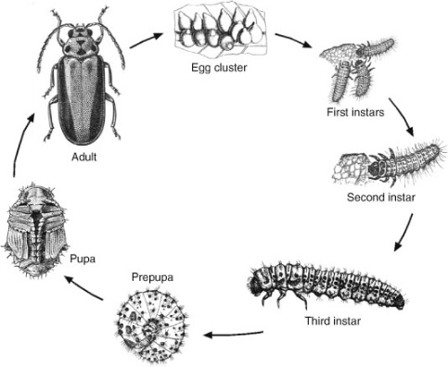

How can Elm Leaf Beetle affect elms?
The ELB feeds on the leaves of most elms from the adult to third instar stages of its life cycle. (Figure 1) Several years of heavy ELB infestation and associated defoliation can impact on a tree’s health and condition, which can lead to its decline.
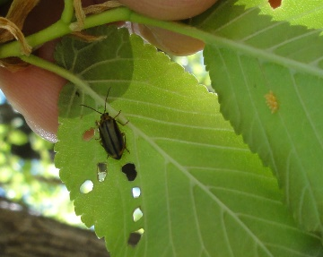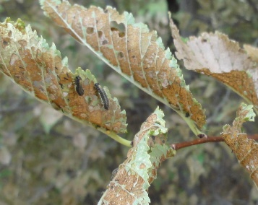
Photo 1 Photo 2
Adult beetles are 6-8mm long and vary between yellow and green colouring. The adult beetles overwinter in sheltered spaces such as mulch areas, bark layers of other trees and in and under houses. When they emerge in spring the adult beetles start feeding on the new leaves. The adults chew through leaves and create what is called a ‘shot hole’ pattern and they lay yellow eggs in small clusters on the underside of the leaf (Photo 1).
The larvae emerge from the eggs and commence feeding on the leaf (Photo 2). This skeletonising of the leaf reduces the ability of the tree to photosynthesise. Leaves first appear brown and then become curled and ‘crispy’.

What can I do?

Caring for the tree
Results have shown that trees in good health and condition are less likely to be heavily infested with ELB. Improving a tree’s health and condition can be achieved by:
- watering the tree during stressful periods
- fertilising and mulching the tree
- avoiding compaction of soil over the root zone

Non-Chemical methods of treatment

Banding
For small tree numbers trunk banding is the simplest way of breaking the ELB life cycle and reducing the number of beetles on a tree. Commercial bands can be sourced from horticultural suppliers and can be applied throughout the growing season.
Banding is not a viable option for large tree numbers because the number of beetles that drop from the canopy and do not move down tree trunks is large enough to sustain a viable population.

Biological treatment methods
Biological predators of ELB are still being trialled and are not currently available in Australia. These include a small wasp (Oomyzusgallerucae) and a fly (Erynniopsisantennata). A natural bacterium (Bacillus thuringiensis) has been trialled previously in Australia and may become available as a biological control option in the future.
The ACT Government will continue to work with all states and agencies in identifying and trialling biological controls.

Chemical methods of treatment
There are a number of chemicals registered for the control of Elm Leaf Beetle that can be applied by stem or soil injection or as a foliar spray. However, such chemicals may have the undesirable effect of eliminating natural predators and other fauna.
Any chemical treatments should be undertaken by a qualified chemical operator holding a minimum certificate III in chemical applications.

