
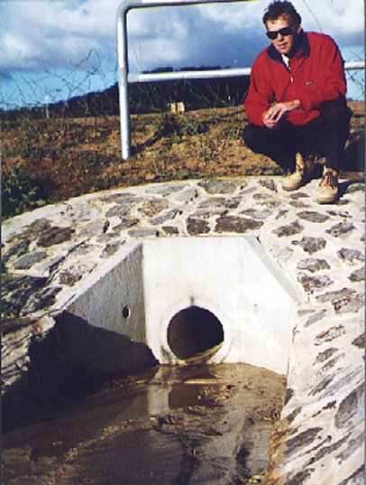
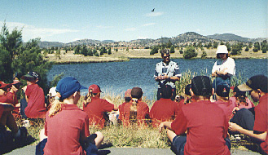
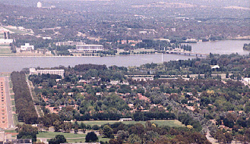
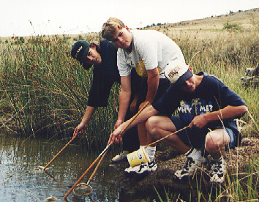

ACT Water
Report
2002–2003


ACT Water
Report
2002–2003

FURTHER INFORMATION

Complete data for all of the sites reported is available from
the Internet under the Environment ACT Website at:

 http://www.environment.act.gov.au/airandwater/waterquality.html

Should you wish to seek further information in relation to
this report, please contact:

 Lucy Wildman

Environment Protection

Environment ACT

Telephone: 6207 2144
Facsimile: 6207 6084
E-mail: lucy.wildman@act.gov.au

© Australian Capital Territory, Canberra 2003

This work is copyright. Apart from any use as permitted under
the Copyright Act 1968, no part may be reproduced without the written permission from Customer Services and Information, Department of Urban Services, ACT Government, GPO Box 158, Canberra City ACT 2601.

Disclaimer: Environment ACT does not warrant that the data is free from errors.

Published by Environment ACT (EMC 03/1042)

Environment ACT Helpline: 6207 9777

Environment ACT Website: www.environment.act.gov.au

Ministerial Foreword


The successful management of our catchments in the ACT is vital for the sustainability of the ACT’s precious waterways and the prosperity of the Canberra region.

The ACT Water Report 2002 – 2003 provides important information about our waterways and the impact of the urban, rural, forestry and conservation land practices in the ACT.

This year, the report examines the way our catchments and waterways have been put under significant strain from the devastating impacts of drought and fire. Just as the bushfires in January 2003 challenged our community, these extreme events have tested the capacity of our local aquatic environment.

The report also provides comment on the way in which we use our waterways, from recreation to irrigation.

Biological monitoring indicates the water quality of these streams is affected by the concentration of pollutants, particularly in urban areas, resulting from low rainfall and low flows. In rural areas, streams previously considered pristine are showing significant deterioration as a result of the impact of sedimentation following the bushfires in January 2003.

Past experience shows with some intervention the aquatic health of these bushfire affected streams can be improved, but it is important to monitor the process and report progress to the community.

In addition to the monitoring undertaken by the Government, many community organisations are making a significant contribution to care for our waterways through a comprehensive community monitoring program.

I welcome this report and look forward to following the improvement of our catchments and waterways as they recover from a very difficult year.



Jon Stanhope MLA
Chief Minister and Minister for the Environment
Contents
Executive Summary 1
Introduction 2
Purpose 2
Scope 2
Land Use 2
Climate 3
Streamflow 4
Rivers in the ACT Region 6
Bushfires 6
Protection of Water Resources 7
The Territory Plan Environmental and Use Values 7
Water Quality Standards 7
Water Resource Use 8
Water Quality Monitoring Program 10
Sampling Sites 10
Water Quality Condition 12
Analysis 12
Current Status—Reporting Methodology 12
Water Quality Status 12
Long Term Trend 13
Indicators 14
Biological Monitoring 14
Nutrient Levels 17
Suspended Solids 17
Faecal Coliforms 18
Conductivity/Salinity 18
pH (Acidity and Alkalinity) 22
Ammonia 22
Dissolved Oxygen 22
Chlorophyll ‘a’ 22
Algae Monitoring 23
Figure 13: DO and Chlorophyll 'a' Map Lakes 25
Lakes 26
Lake Tuggeranong 26
Point Hut Pond (Site 270) 26
Gungahlin Pond 27
Lake Ginninderra 27
Rivers 28
Ginninderra Creek 28
Paddy’s River (Site 842) 28
Gudgenby River (Site 901) 29
Murrumbidgee River 29
Molonglo River 29
Water Resources Use 31
Water Related Projects 36
ACT Water Resources Strategy 36
ACT Natural Resource Management Plan 36
New Books on Aquatic Fauna 37
Impacts of the January Bushfires on Fish Communities 37
Upper Murrumbidgee Catchment Coordinating Committee 38
Southern ACT Catchment Group 39
Waterwatch 41
Appendix 1–Long Term Trend 43
Appendix 2–Biological Monitoring Results 44
Appendix 3–Results from Sampling Sites 45

List of Figures
Figure 1: Land Use Map 3
Figure 2: Monthly Average Rainfall in Belconnen Upstream of the Barton Highway 4
Figure 3: Average Monthly Flow in the Murrumbidgee River Near Angle Crossing 5
Figure 4: Average Monthly Flow in Ginninderra Creek Near Charnwood Road 5
Figure 5: Extent of Bushfire 6
Figure 6: Water Catchments' Map 8
Figure 7: AusRIVAS Assessments of Monitoring Sites in the ACT for Spring 2002 15
Figure 8: AusRIVAS Assessments of Monitoring Sites in the ACT for Autumn 2003 16
Figure 9: Total Phosphorous and Total Nitrogen Map 19
Figure 10: Suspended Solids and Turbidity Map 20
Figure 11 Conductivity Map 21
Figure 12: pH and Ammonia Map 24
Figure 13: DO and Chlorophyll 'a' Map 25
Figure 14: Conductivity at Kambah Wetlands and The Dam Wall 26
Figure 15: Total Phosphorus and Ammonia in Point Hut Pond 27
Figure 16: pH and Turbidity at Gungahlin Pond 27
Figure 17: pH at Lake Ginninderra West and Suspended Solids at The East Arm 28

List of Tables
Table 1: Water Quality Standards (Ref: Environment Protection Regulations 1997) 7
Table 2: Flow Percentiles for River Sampling 10
Table 3: Macro invertebrate Sites 11
Table 4: Licences to Take Groundwater by Catchment 31
Table 5: Licences to Take Surfacewater by Catchment 32
Table 6: Combined Licences to Take Both Surfacewater and Groundwater by Catchment 32
Table 7: Number and Volume Allocations by Catchment 33
Table 8: Actual Releases from Water Supply Dams Compared with Environmental Flow Requirements for Period 1 April 2001 to 31 March 2002 34
Table 9: Water Drawn for Urban Supply from Cotter and Googong Catchments During 1 April 2001 to 31 March 2002 35

Executive Summary

Environment ACT manages a water monitoring and assessment program for the ACT that includes water quality, streamflow monitoring, and biological monitoring. This information is used to determine whether management strategies used to achieve or maintain the aquatic values set for ACT waters are appropriate.

The report is intended to provide the community with information regarding the state of water resources in the ACT. The assessment approach adopted is designed to move towards a more holistic ecosystem health monitoring system as prescribed by the Murray-Darling Basin Commission’s Sustainable Rivers Audit. It uses biological data to ascertain ecosystem diversity, water quality data to determine trends that may be present and compares these results with the designated environmental and use values and standards set in the Territory Plan and Environment Protection Act 1997 and its regulations. Streamflow monitoring is used to gauge the impact of removing water from the environment for other uses.

Water quality is monitored in the major urban lakes (with the exception of Lake Burley Griffin, a Commonwealth responsibility) and Burrinjuck Reservoir, which is immediately downstream of the ACT. The major rivers and some urban streams are also monitored. River flow is measured at a number of sites throughout the ACT.

The report uses the biological information to report the biodiversity in the rivers. The sampling data is analysed, determining any trends that may be present for the period 1992-2003. The individual data points and median values for the year are considered with reference made to the standards set out in the Territory Plan and Environment Protection Act 1997.

Rainfall and streamflow for the 2002-2003 reporting period was well below the long-term average. This reporting year has seen environmental conditions in water bodies deteriorate due to the negative effects caused by very low rainfall and flows during, as well as leading up to the reporting period. This is despite the relatively good long term condition, and good compliance with standards. This is particularly noticeable in the biological data. The impacts on water quality in the urban areas that derive from land development with urban run-off carrying suspended sediment and nutrients have been exacerbated, and further impact could be predicted to occur in the next reporting period after significant rain events have washed accumulated pollutants into the water bodies.

Toward the end of the reporting year, major bushfires occurred in the Canberra region, affecting a large proportion of the ACT’s land area and catchments. Biological monitoring in Autumn 2003 showed significant levels of impairment, attributable in part to the bushfires. The physio-chemical data was yet to show significant effects expected. This is primarily due to no high flow sampling being conducted after the fires, as the only significant rain event, did not convert to adequate flows at preselected sampling sites. Subsequent annual reports should give a better picture of the overall condition of the ACT’s water bodies after the fires.

Despite drought and fire effect, Canberra’s lakes, Lake Ginninderra and Lake Tuggeranong, have fair water quality with a discernible improvement in water quality conditions through the length of both lakes, and thus in the water that flows out into our creeks and rivers. Point Hut Pond and Gungahlin Pond have comparatively poor water quality with elevated levels of turbidity and suspended solids. Runoff from residential development in the Point Hut catchment is the most probable cause. Lake Ginninderra and Gungahlin Pond have high pH readings, attributable to drought effect.

The Water Resources Act 1998 came into full effect in December 1999 and requires assessment of river flows, and licensing of water abstractions. Since that time considerable progress has been made implementing the provisions of the Act. Most notably, all water use, except stock and domestic use from surface water is now required to be licensed. This includes all use from bores. The pressure on these resources has increased during the reporting period, with an increase in the application to construct bores and an increase in applications for licences to take water, particularly in urban areas.
Introduction

Purpose

This report is intended to provide the ACT community with information on the state of the ACT’s water resources for the year 1 April 2002 to 31 March 2003. To establish a statistically significant analysis of trends, the analysis includes data for the period 1992 to 2003.

The report is divided into four main sections. The first introduces the report and provides background information for interpreting the water quality data. The second section discusses water quality condition. The indicators used are introduced and results discussed for the lakes and rivers in light of the Territory Plan and Water Quality Standards. The third section provides monitoring information collected in administering the Water Resources Act 1998, which came into full effect on 11 December 1999. Finally, a brief discussion on projects undertaken by community groups in the ACT during the reporting period is also presented.

Scope

The report focuses on the major waterbodies of the ACT with the exception of Lake Burley Griffin. Water use from the Cotter catchment is included in this report but, in view of the previously undisturbed nature of the catchment, water quality monitoring is not discussed. However, as part of its licence to take water, ACTEW is undertaking a major monitoring program in the Cotter and Queanbeyan water supply catchments. It encompasses physical, chemical, biological, and fish components and together with Environment ACT is supporting a major investigation into environmental flows being undertaken by the Cooperative Research Centre for Freshwater Ecology. The study design of this investigation has been amended to include impacts of drought and fire. Outcomes from this study will be included in future water reports. Drinking water quality, which is the responsibility of ACTEW and the Chief Health Officer, is not part of this report.

Lake Burley Griffin is a Commonwealth responsibility and is the subject of an annual report produced by the National Capital Authority.

Land Use

There are four major land uses in the ACT (see Figure 1). In normal circumstances, conservation land use tends to have a minimal impact on water quality. As a result of the January 2003 bushfires, soil erosion and sediment movement presents a potential impact on the water quality of previously unimpacted water bodies. Plantation forestry and rural use can have significant impacts on water bodies where these activities result in soil erosion or the release of agricultural chemicals and animal waste. Urban use has the greatest potential for impact on water quality per unit area. Materials entering urban waterways, which are likely to impact on the health of our waterways, include fertilisers and other chemicals, organic matter, soil, oil, and sewage effluent. Urban areas are also susceptible to drought as the pollutants entering waterways are concentrated, impacting on local ecosystems.

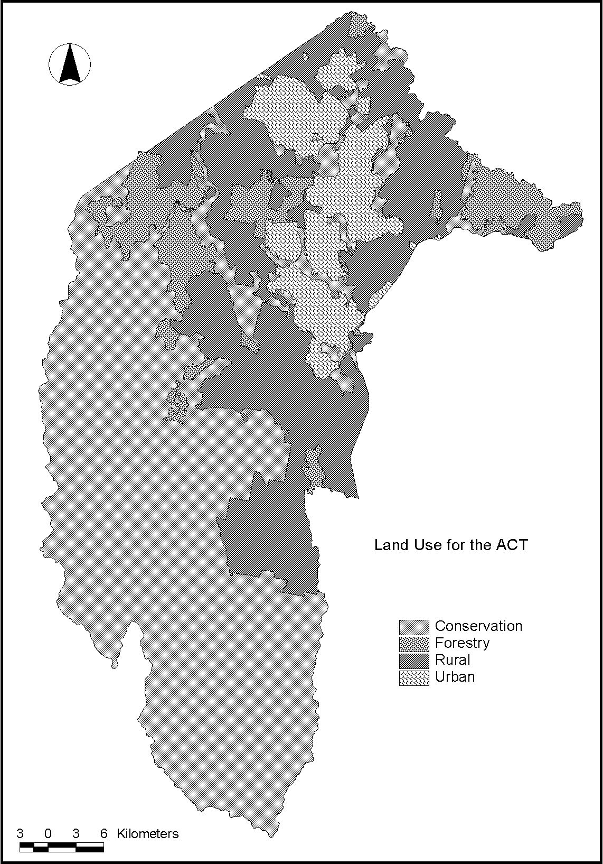
Figure 1: Land Use Map

Climate

Rainfall in the ACT is strongly affected by the landform. In the mountainous region to the west of the Murrumbidgee River, annual average rainfall ranges from 800-1000 mm. The flatter tablelands on which Canberra is built are in a rain shadow area and the annual rainfall reaches 600-700 mm. In this reporting year this rainfall ranged between 330 and 370 mm, which is well down on the average.

Rainfall is measured at numerous sites in the ACT. Figure 2, which represents the urban area in the ACT, displays rainfall for a site near the Barton Highway. Presented areas both the long-term average monthly rainfall on data collected since 1992, and the monthly rainfall for the 2002-2003 reporting period.

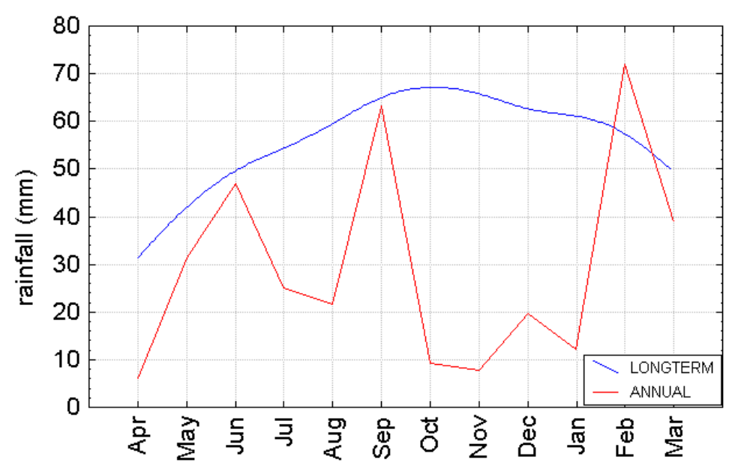
Figure 2: Monthly Average Rainfall in Belconnen Upstream of the Barton Highway

The long-term average annual rainfall, since 1992, in Belconnen at the Barton Highway site is 666 mm. The annual rainfall for this reporting period, 1 April 2002 to 31 March 2003, was significantly lower at 354 mm. This follows previous years of lower than average rainfall, and higher than average temperatures combining so that drought was officially declared on the 22nd of November 2002. The monthly average rainfall is consistently lower than the long-term average, with the exception of the average monthly rainfall for February 2003, which was similar to the average.

Streamflow

The monthly average streamflow showed further evidence of the drought conditions that dominated in this reporting year with flow consistently falling below the long-term average and in some cases, no flow was recorded for significant periods. This includes the flow into the ACT via the Murrumbidgee River, which stopped in January and February 2003 and was very low for a significant portion of the reporting year. At this time, the flow out of the ACT comes almost exclusively from the Lower Molonglo Water Treatment Plant.

Mean monthly flow in the Murrumbidgee River near Angle Crossing was below average throughout the reporting year, with the exception of April (see Figure 3). Total average monthly flow for 2002-2003 was approximately 52 GL, which is significantly less than the 334 GL long term average.

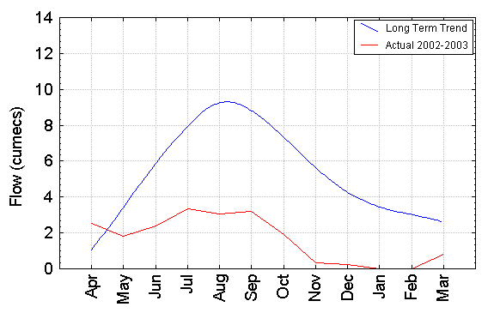
Figure 3: Average Monthly Flow in the Murrumbidgee River Near Angle Crossing

Urban areas react more quickly to rainfall with a greater proportion of rainwater being converted to run off due to the large impervious surface areas. Figure 4 shows runoff in Ginninderra Creek downstream of Belconnen. Runoff closely follows the rainfall shown in Figure 2. Rural subcatchments with less impervious area respond more slowly to rainfall events. However the dominant feature in this urban catchment were the low flows over the reporting period: 1.1 GL/year compared to a long term 4.6 GL/year calculated on the flows since 1972.

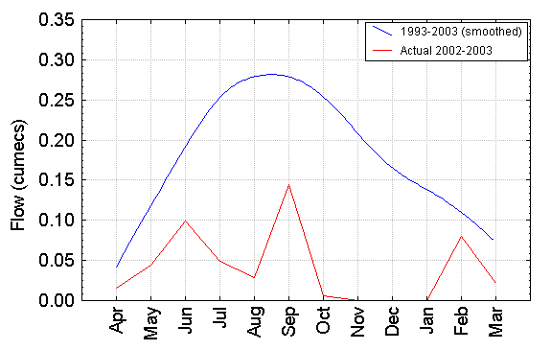
Figure 4: Average Monthly Flow in Ginninderra Creek Near Charnwood Road

Rivers in the ACT Region

A number of the rivers and streams that flow through the ACT originate in NSW. The catchment boundaries of other major rivers in the ACT form part of the ACT/NSW border.

The Murrumbidgee River originates well to the south of the ACT. Tantangara Reservoir diverts its headwaters to the Tumut River and the river is further regulated downstream of the ACT at Burrinjuck Reservoir. The Molonglo River and Queanbeyan River rise to the south-east of the ACT, with both draining through Lake Burley Griffin to the Murrumbidgee River.

The Cotter catchment forms the western boundary of the ACT and the Naas and Gudgenby catchments form the southern and south eastern boundaries.

Bushfires

A major event within this reporting period that impacted significantly on water quality was the January Bushfires. The fires had a significant effect on a large proportion of the water catchments in the ACT, including the areas around our reservoirs. More information is provided in the Environment ACT Bushfire Recovery Plan. Figure 5 shows the extent of the Bushfire within catchments throughout the ACT region.
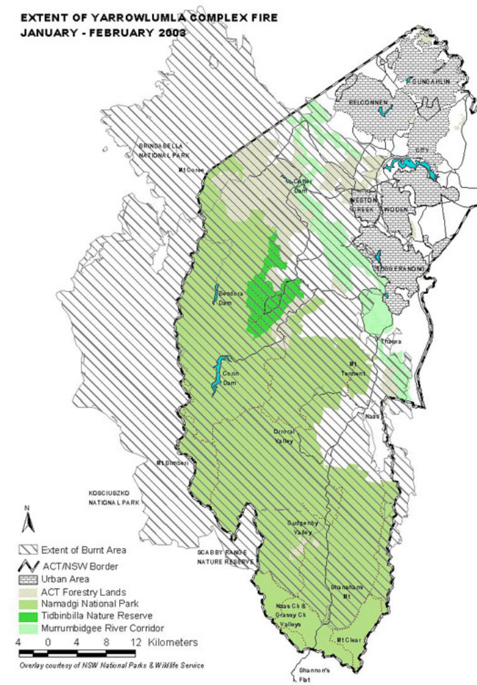
Figure 5: Extent of Bushfire

Protection of Water Resources

The ACT Government seeks to manage waterways so that sustainable and appropriate water conditions are attained. This includes an integrated catchment approach to planning, development controls, the licensing of end of pipe discharges and regulation of non-point source discharges through the requirements of erosion and sediment control plans. Urban stormwater management infrastructure such as gross pollutant traps, water quality control ponds, wetlands and vegetated floodways are designed and managed to reduce urban impacts on water quality, as is an increasing emphasis on improved urban design. These measures are designed to ensure that water quality is suitable for designated uses.

The Territory Plan Environmental and Use Values
Appendix 1, Water Use and Catchment Policies of the Territory Plan, sets the permitted uses and protected environmental values for the waterways in the ACT. The Plan identifies three types of catchments: drainage and open space; water supply; and conservation. Uses such as maintenance of ecosystems, recreation and water supply are designated for streams, lakes and rivers within each of these types of catchments. Within each catchment type there will be a designated primary value, and a range of other uses are permitted which are generally compatible with, but secondary to, the primary value.

Water Quality Standards
Water quality standards are identified in Schedule 4 of the Environment Protection Regulations 1997. These regulations contain tables that list the necessary water quality to support each of the water uses referred to in the Territory Plan. Table 1 provides examples of some of the water quality standards for certain water uses.

Table 1: Water Quality Standards (Ref: Environment Protection Regulations 1997)

 | Water Use
Indicator | Water based recreation—swimming  (REC/1) | Water based recreation—boating  (REC/2) | Water supply—stock  (STOCK) | Water supply—irrigation  (IRRIG) | Aquatic habitat—wetland  (AQUA/1 to AQUA/6)
Total Phosphorus (mg/L) | < 0.1 | < 0.1 |  |  | < 0.1
Turbidity (NTU) | Not objectionable | Not objectionable |  |  | <10 – <30
Suspended Solids (mg/L) |  |  |  |  | <12.5 – <25
Chlorophyll ‘a’ (µg/L) | < 10 | < 10 | < 10 |  | <2 – <10
faecal coliforms (cfu/100mL) | ≤ 150 | ≤ 1000 | ≤ 1000 | ≤ 1000
Dissolved Oxygen (mg/L) |  |  |  |  | >4
Acidity (pH) | 6.5–8.5 | 6.5–8.5 | 6.5–9.2 | 4.5–9.0 | 6–9
Total Dissolved Solids (mg/L) |  |  | < 3000 | < 500

Water Resource Use
The Water Resources Act 1998 came into full effect in December 1999, providing the Territory with the tools to effectively and sustainably manage its water resources. The Act provides for the preparation of Environmental Flow Guidelines that establish the methods used to identify flows necessary to protect all ACT waterbodies.

The Act also requires the preparation of a Water Resources Management Plan which, on a catchment basis, describes the water resources of the Territory, quantifies environmental flows on the basis of the Environmental Flow Guidelines, identifies water available for use, and allocations which can be made over the next 10 years. Water catchments boundaries used for this purpose are set out in Figure 6. Both the guidelines and the plan are disallowable instruments that came into effect in December 1999 and February 2000 respectively.

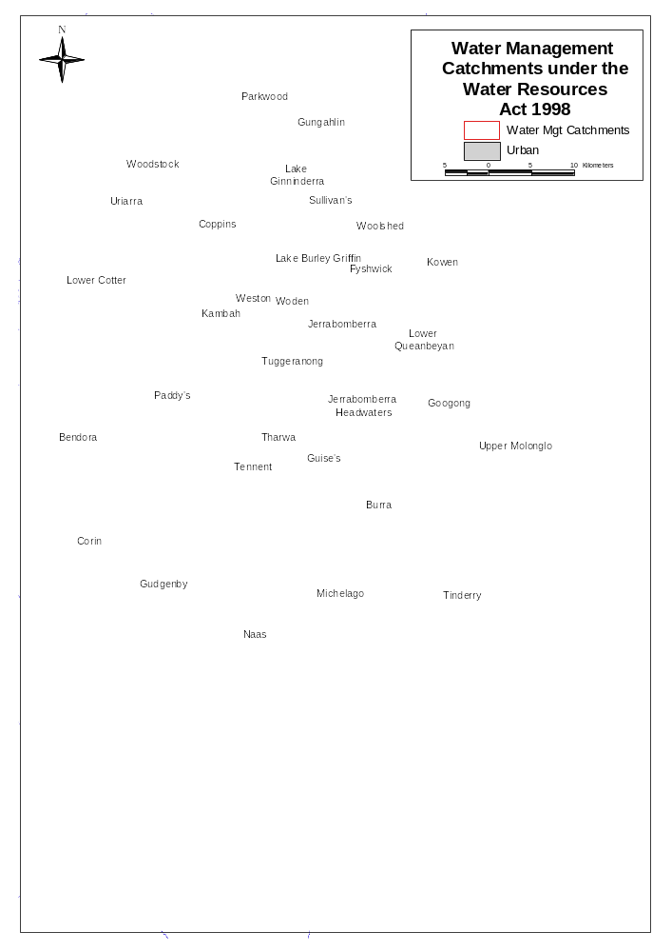
Figure 6: Water Catchments' Map
The Water Resources Management Plan is currently being reviewed by the Water Resources Task Force. Please refer to the ACT Water Resources Strategy section on page 36 of this document for more information. The Environmental Flow Guidelines are due for review in 2004.

Appropriate environmental flows are maintained through water allocations and licensing. Water allocations are only issued in accordance with the Water Resources Management Plan and thus ensure that the total quantity of water that could be used from ACT water resources is sustainable. Licence conditions are used to ensure that water allocations are only taken from ACT water resources when and where the water is available (in accordance with the Environmental Flow Guidelines). These measures ensure the Territory’s water resources are controlled appropriately.

Water Quality Monitoring Program

Environment ACT manages a water monitoring program for the ACT that includes the collection of water quality, streamflow and biological data. The monitoring program is based on regular sampling of lakes and rivers. Such information is used to determine whether waters in the ACT are of appropriate quality and if the management strategies used to achieve or maintain such water quality are adequate. The information is not intended to identify specific pollution incidents but rather provide information about changes to water quality over time.

The data for this report is sourced from Environment ACT’s water monitoring program, other government agencies and from authorised dischargers, including Lower Molonglo Water Quality Control Centre and Queanbeyan Sewage Treatment Plant.

Sampling Sites
Sites are located so as to be representative of stream and lake conditions in the ACT. It is not possible to monitor all sites and all parameters of interest, consequently those considered most representative of environmental conditions are selected with the intention of generalising to similar areas. The site locations can be seen on the water quality indicator maps Figure 7 and Figure 8, for biological sampling and Figure 9 to Figure 13 for water quality sampling.

The major urban lakes (with the exception of Lake Burley Griffin — a Commonwealth responsibility) are sampled eight months of the year August, October to March and May. The sampling program for lakes is not flow related.

The ACT Government also monitors Burrinjuck Reservoir. The ACT's impact on the Murrumbidgee River is not identifiable downstream of Burrinjuck Reservoir as a result of the Reservoir's size and the residence time of water in it. There are presently further studies being undertaken by ActewAGL into the continuing effects of the bushfires and drought.

A separate program to monitor blue-green algae in Canberra’s lakes is undertaken during the summer months by Environment ACT.

A flow based sampling process has been adopted for the stream water quality monitoring program. This method is a more cost effective characterisation of water quality than time based monitoring, because streamflow is the major determinant of quality. Samples are collected within four flow percentile groupings (see Table 2). The 5th percentile flow is the flow exceeded only 5% of the time and represents very high flow; conversely the 90th percentile flow indicates very low flow.

Streamflow is measured at a number of sites throughout the ACT. This information is valuable for interpreting water quality data. Most of the pollutants that wash off the land do so during rainfall events. In conjunction with water quality monitoring, streamflow allows for the calculation of pollutant loads in our lakes and rivers.

Table 2: Flow Percentiles for River Sampling
Flow Percentile Group | Number of Samples
5–29 | 2
30–49 | 2
50–69 | 2
70–89 | 2

Rivers were sampled six times during this reporting period. In addition to the requirement to sample within flow percentile groups, there is a requirement to ensure there is a reasonable time period between each sample. The aim of this strategy is to provide a fully representative assessment of river health over time by taking account of the impact of flow on water quality. As in the previous reporting year, the full range of samples were not taken as the flow was not adequate for high flow percentile samples.

The biological health of rivers was assessed using stream animals (macro invertebrates) as indicators. The selection of test sites was based on potential and known impacts from rural degradation, urban runoff, discharge of treated sewage effluent, trace metal contamination, habitat degradation, sedimentation and river regulation. The three reference sites were selected from those sampled during development of the ACT component of the National River Health Program (NRHP). The ten test sites and three reference sites were sampled in October 2002 and April 2003 (see Figure 7 and Figure 8).

Table 3: Macroinvertebrate Sites
Site No | Location | Site Type
40 | Murrumbidgee River at Angle Crossing | Reference
53 | Murrumbidgee River at Halls Crossing | Test
20 | Gudgenby River at Smiths Road Crossing | Test
58 | Tuggeranong Creek downstream of Lake Tuggeranong | Test
10 | Paddy’s River at Murray’s Corner | Reference
15 | Tidbinbilla River at Paddy’s River Road | Reference
242 | Molonglo River at Sutton Road Bridge | Test
70 | Molonglo River at Coppins Crossing | Test
235 | Queanbeyan River below Queanbeyan Cemetery | Test
246 | Jerrabomberra Creek at Hindmarsh Drive | Test
189 | Yarralumla Creek at Cotter Road Bridge | Test
195 | Ginninderra Creek | Test
64 | Ginninderra Creek | Test
Water Quality Condition

The Water Quality Condition in the ACT is generally good. In this reporting year it was stressed by extreme events, drought and fire. The Urban areas appear to have a greater effect from drought conditions, as pollutants are not diluted. Across the ACT there were less breaches of standards during the reporting year, particularly of measures determining sediment levels, which may be an effect of stabilising catchments, but also low flows will have reduced the amount of sediments entering waterways.

Analysis

Current Status—Reporting Methodology
The condition of water bodies is reported using a number of methods, which are outlined below. A review of the performance within the reporting year as well as the longer term trend is presented.

When assessing sites all the data collected since flow based sampling began in 1992 in considered. The long term performance of indicators is analysed with reference to flow, seasonality and time using the method set out in detail in Appendix 2.

The performance of each indicator is then considered for the reporting year 2002-2003. Median values were used in conjunction with statistical dispersion to consider conditions at each site, in relation to standards. The median is seen as the most useful measure of the ‘average’ condition as it is less affected by extremely high or low values than is the mean. The mean is strongly biased toward the infrequent extreme conditions that may occur in water bodies. Any significant variation of median from previous sampling years is noted. In this, and the previous reporting year, there was significantly low flow, and so the full quota of high flow sampling were not undertaken. The medians have been considered with reference to this fact.

The low flows that occurred throughout the reporting year have also resulted in the typically strong relationship between indicators that measure nutrient and sediment concentrations and flow has not been apparent. The flow based sampling system usually incorporates samples taken in a representative number of low medium and high flow events. However, in the case of the 2002 2003 reporting year the requisite number of medium and high flows did not occur, so that the usually strong relationship between flow and some indicators has been less apparent. In previous reports the method for predicting exceedences of the standard has been to correlate concentration with flow percentile, in this report the number of exceedences incidences has been used.

Water Quality Status
The condition of water quality at the monitoring sites can be assessed by comparison of actual concentrations with concentrations listed in the water quality standards (see Table 1).

The data for the various indicators has been presented on a number of maps. Sites have been coded as good, fair or poor. A site is classified good when it compares well with the standards for the particular indicator. A fair classification indicates the value is on the threshold of the standards, with perhaps one or two exceedences, and a poor classification shows that a site noticeably exceeds the standards on numerous occasions.

Long Term Trend
Trend analysis of data available between 1992 and 2003 has been carried out for sites with sufficient data for trends to be detected. This period corresponds with flow based monitoring of rivers and creeks. Prior to this period, monitoring was carried out at regular intervals with no reference to flows, and it is not appropriate to compare these data.

All of the trend graphs have had a statistical test applied to determine if trends are significant. Statistical analysis was used on sites to determine the influence of flow as well as time on the concentration. The trendline produced is a product of that time component at the median flow. A detailed explanation of the method used is outlined in Appendix 1 and a scatter plot of all indicators at all sites is provided in Appendix 3. For the remaining river indicators and all lake sites, indicator concentrations have been plotted against time.

Indicators

Biological Monitoring
The biological component of the ACT Water Quality Monitoring Program is based on the macro invertebrate monitoring undertaken using the AUSRIVAS protocol. It involves collecting samples from stream edges from ten test sites and three reference sites in the ACT region during Spring 2002 and Autumn 2003. An AUSRIVAS predictive model developed as part of the National River Health Program (NRHP) conducted under the Natural Heritage Trust has been used to assess these sites providing a measure of biological health.

The measurement presented in this report, O/E Site Band (five categories shown below) gives an indication of overall site condition. Sites at which more animals are missing are assessed as more impaired. The impacts are ranked as follows:

X Above reference
A Equivalent to reference sites
B Slightly impaired
C Moderately impaired
D Severely impaired

The results for Spring 2002 and Autumn 2003 are summarised in Figure 7 and Figure 8, refer to Appendix 2 for tabular results. There is significant biological impairment recorded in both the Spring and Autumn samples. Urban activity, agricultural and forest activities resulting in sediment addition leading to habitat degradation are thought to be a major cause of degradation.

The Spring 2002 sample shows the reference sites maintained a Band A rating, even though there was a drought. These sites fall on the Murrumbidgee River, which has a larger volumetric flow, and more resilience to the drought conditions. Tuggeranong, Ginninderra and Jerrabomberra Creeks and Queanbeyan and Molonglo rivers all indicated serious levels of impairment. These sites fall into rural urban and industrial zonings, which seems to indicate that the effect of the low flows and prolonged drought conditions, is being exacerbated by these land uses.

The Autumn 2003 sample occurred after the January bushfires. This combined with the worsening drought can be seen in the results from the majority of sites, including the reference sites, 10 15 20 and 40, which demonstrated impact form the fires. The urban sites, which have experienced significantly low flow, continue to experience severe impairment.
Potential impacts suggested by the CRC for Freshwater Ecology are:
- extensive bush fires immediately around and in the catchments of sites, and localised storm events have contributed detrimental levels of chemicals, nutrients, sediment and organic detritus to the waterways;
- drought conditions are concentrating nutrients and or hazardous chemicals and toxins (levels of these inputs may not actually be elevated it is the lack of dilution causing concentration effects within the streams);
- infrequent rains mean urban and rural runoff events contain proportionally greater levels of detrimental sediments and pollutants;
- drought and low flow conditions are exacerbating effects of organic decomposition within the creeks and creek sediments; and
- fine sediment deposition is effectively ‘choking’ both the habitat and the sensitive taxa.
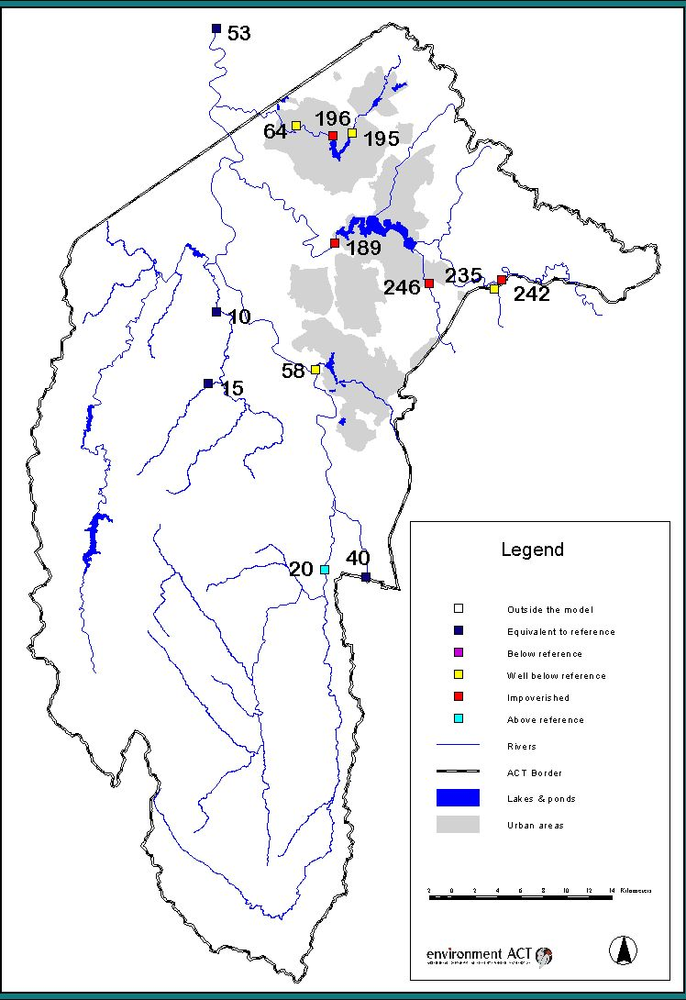
Figure 7: AusRIVAS Assessments of Monitoring Sites in the ACT for Spring 2002

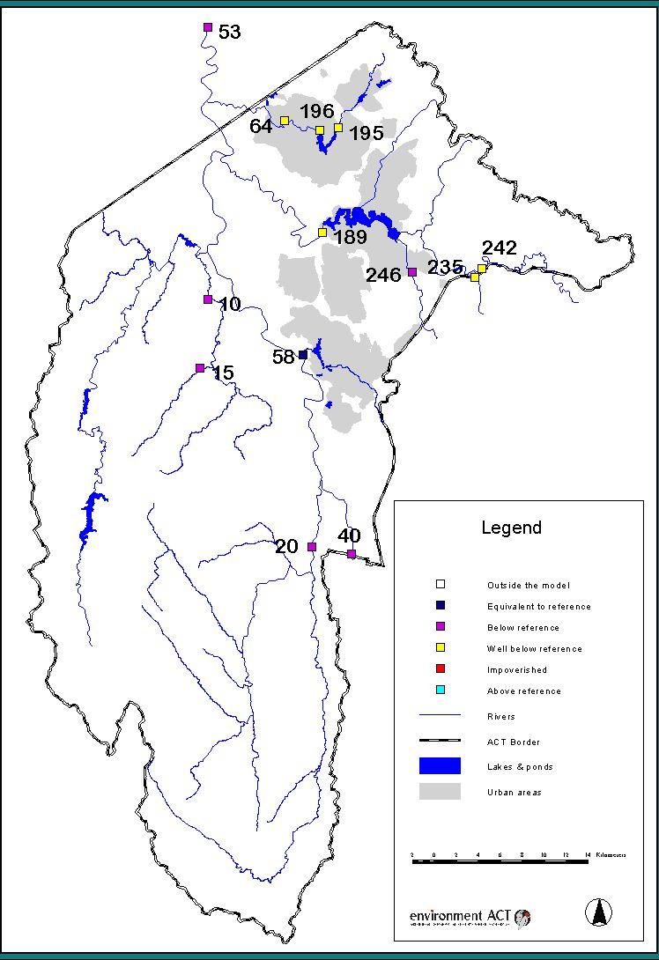
Figure 8: AusRIVAS Assessments of Monitoring Sites in the ACT for Autumn 2003

Nutrient Levels
Nutrients are a natural component of all water bodies, but increases in their supply often have undesirable effects, including the eutrophication of aquatic ecosystems. Eutrophication is the presence of an abnormally high quantity of aquatic plant life and can include toxic algal blooms. This can also produce other unwanted side effects e.g. low dissolved oxygen levels in the water. The two most important plant nutrients for aquatic ecosystems are phosphorus and nitrogen.

In ACT water bodies phosphorus is the nutrient that commonly determines the amount of algae that can occur. Total phosphorus is the sum of dissolved and particulate phosphorus in the water. The standard is 0.1 mg/L (see Table 1) for both Aquatic Health as well as Recreational use. Median values ranged from 0.013 mg/L at Act’s Northern border to 0.085 mg/L at Lake Tuggeranong near Kambah Wetland (Site 248), shown in Figure 9. The phosphorus level at Molonglo River at Camp Sturt exceeded standards on a number of occasions. However, in other areas there a downward trend was recorded in phosphorus levels.

Lake sites all recorded a mild downward trend for phosphorus concentration over time. Readings in the river sites were all in a similar range or lower than previous years. Two exceedences were recorded, one at Uriarra Crossing and another at Paddy’s River.

There is no standard for total nitrogen for the ACT. Nitrogen is not generally a limiting factor in algal growth in regional waters and it is non-toxic to other organisms. Total nitrogen median values ranged from 0.2 mg/L at a number of sites to 19 mg/L at Sturt Island (Site 401) on the Molonglo River as shown in (see Figure 9). This is considerably higher that the next median of 5.3 at the Northern Border (Site 224), which is down stream of Site 401.

The levels of nitrogen measured at Sturt Island and the Northern Border are typical of waters downstream of a sewage treatment plant where plant discharge forms a high proportion of streamflow. In situations where nitrogen is limiting, research indicates a potential for the growth of nitrogen fixing blue-green (scum and toxicant forming) algae. In these situations, the discharge of nitrogen in sewage effluent will discourage the growth of nitrogen fixing blue-green algae. In addition, the discharge of nitrogen can have a beneficial effect by restricting the release of phosphorus from lake or reservoir sediments.

In this context, management and discharge authorisation arrangements in the ACT concentrate on minimising the input of phosphorus to waterways as a priority with nitrogen reduction encouraged as a second priority.

Suspended Solids
All streams and rivers naturally carry some suspended material as organic and inorganic particles of varying sizes. Most land uses and activities have the potential to increase suspended solids concentrations in streams. An increase in the concentration of suspended solids can have two major impacts on aquatic ecosystems. Firstly, higher concentrations of suspended solids reduce the light penetration of water, slowing plant growth and changing the type of algae present. Secondly, increases in suspended solids concentrations ultimately result in increased sedimentation in streams and lakes, choking habitats for bottom dwelling organisms with sediment.

The standard for suspended solids ranges between 12.5 for the aquatic habitat value of mountain streams and 25 mg/L for lowland streams and urban lakes (see Table 1). The standard of 25 mg/L was applied to all river sites as they are all categorised as lowland streams.

Suspended solids median values ranged from 2.1mg/L at Lake Ginninderra Dam to 30.3 mg/L at Point Hut Pond (Site 270) (see Figure 10). This latter site has consistently had poor results on this indicator, in this reporting year the samples exceed the standard for more than half the samples taken. The cause of the high results is most likely due to development in the immediate catchment. The reduction in medians levels could be due to the stabilising catchment, but also to the lack of high flow samples taken in the reporting year.

Turbidity
Turbidity, or opacity of a water body is related to the suspended solids concentration but also includes colouration. A stream may have very low levels of suspended material but be strongly coloured, for example the tannin rich streams in Namadgi National Park. Turbidity has an important ecological effect in determining the depth to which light penetrates the water, affecting plant growth and changing the type of algae present.

Turbidity data are reported in Nephelometric Turbidity Units (NTU). To provide a sense of scale, water with a turbidity of 1 NTU is crystal clear, water at 5 NTU has a tiny trace of discolouration, and water at 100 NTU is brown and opaque. The standard is less than 10 NTU for rural streams and rivers and less than 30 NTU for urban lakes and ponds (see Table 1).

Median turbidity values ranged from 3.6 NTU on Gudgenby River (Site 901) to 53 NTU at Point Hut Pond (Site 270) as shown in Figure 10. The high turbidity at this site corresponds to the elevated suspended solid levels also experienced there.

Of all indicators, turbidity exceeded the standard most. However, turbidity median values and exceedences are generally lower than in previous years at the problem sites. This could be due to improvements in the conditions that cause excessive turbidity, but is also attributable to the limited number of rainfall events in the reporting year, which in normal circumstances are the cause of high turbidity readings, from sediment being washed into waterways.

Faecal Coliforms
Bacteria occur naturally in all waterbodies. The presence of faecal coliforms in a water sample may be an indication that human or animal faeces have contaminated the water and that harmful, less easily detectable pathogens such as Cryptosporidium and Giardia may be present. High levels of faecal coliforms are not necessarily a problem for aquatic ecosystems. Faecal coliforms generally do not infect aquatic organisms, and may serve as a food source.

The presence of high numbers of faecal coliforms is a problem for some human uses of water bodies, particularly water supply and recreation involving bodily contact. This report looks at bacterial levels in water used for primary and secondary contact recreational use, but does not deal with the quality of drinking water.

Results are expressed as colony forming units (cfu) per 100 mL. The standard for water based recreation–swimming is 150 cfu/100 mL and for boating and secondary contact is 1000cfu/100ml (see Table 1). These standards apply to individual sites depending on their classification in the Territory plan.

Faecal coliform levels generally compared favourably with the standard designated under in the Environment Protection Regulations. This provides some indication that land use planning and the quality of the ACT’s sewage system are protecting recreational opportunities. There were single exceedence incidents at Uriarra Crossing and at Paddy’s River.

Conductivity/Salinity

Salinity has been measured using two different methods, Total Dissolved Solids (TDS) and Conductivity. Both are measures of the salts present in the water body. The measurement of 100uS/cm of conductivity is equivalent to approximately 64 mg/L of TDS. In the majority of lake sites and some sites on the Murrumbidgee River a long term downward trend is recorded. However the drought conditions that prevailed in the reporting year have meant that medians, in the lakes in particular, are higher than previously recorded. The highest conductivity was recorded at Ginninderra Creek at 440 uS/cm² and the minimum at Paddy’s River 85 uS/cm². There were no exceedences of standards recorded in the reporting year, and levels are significantly lower than when you would expect adverse effects from salinity to occur.
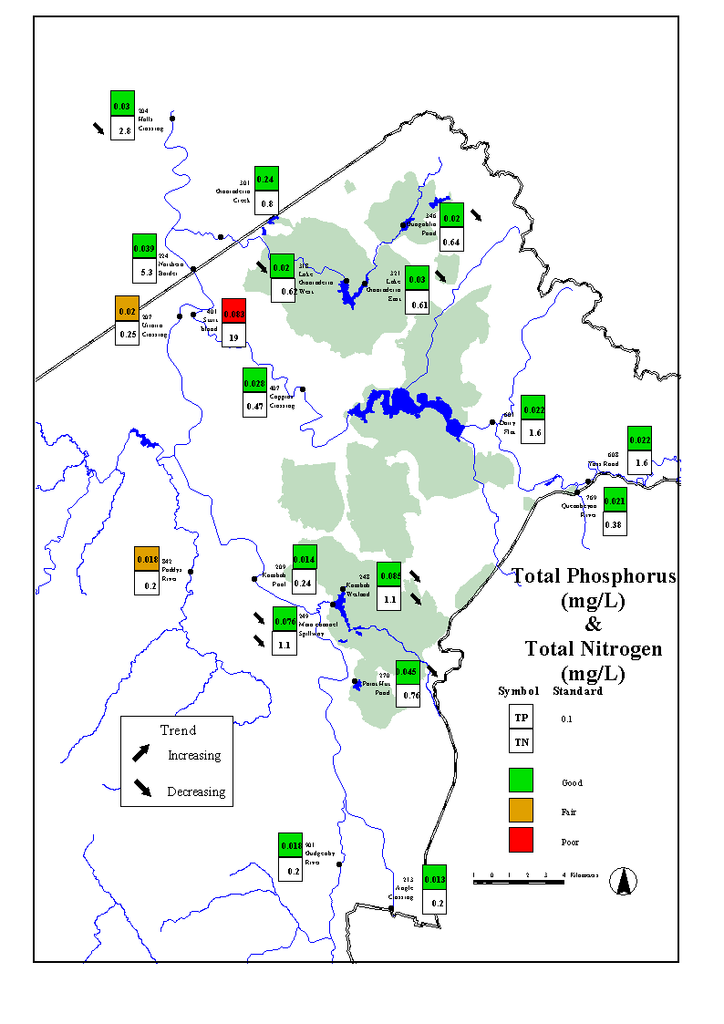
Figure 9: Total Phosphorous and Total Nitrogen Map
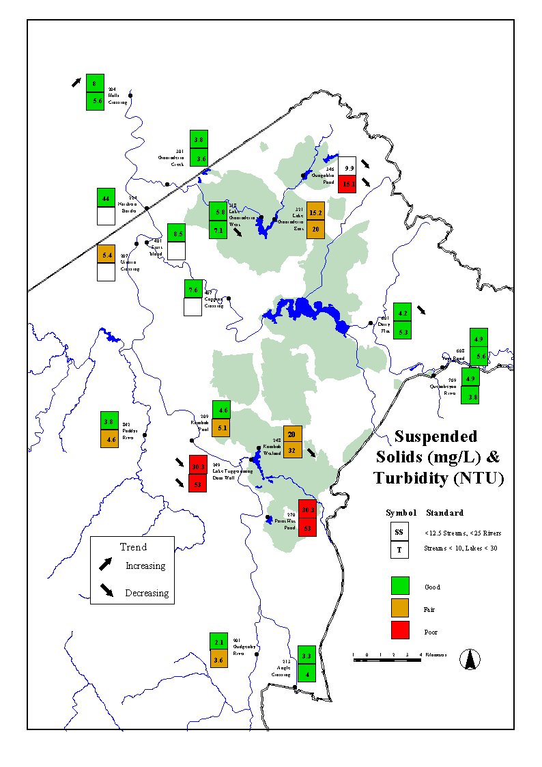
Figure 10: Suspended Solids and Turbidity Map
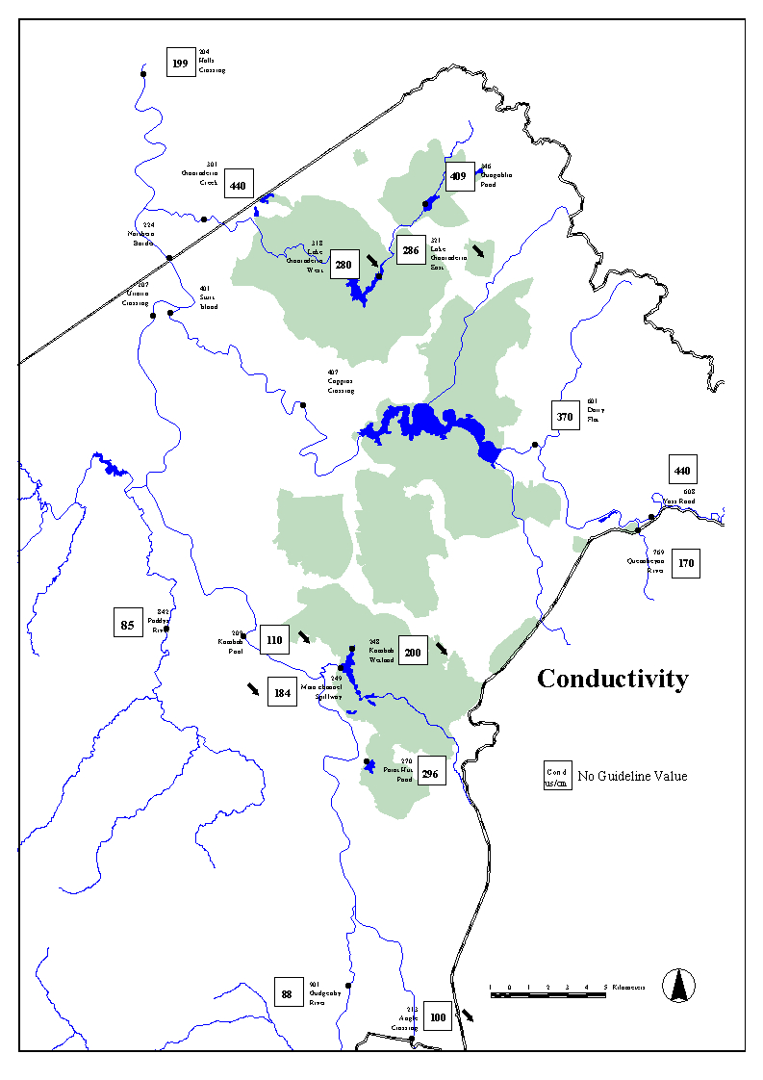

Figure 11 Conductivity Map
pH (Acidity and Alkalinity)
The pH refers to the degree of acidity or alkalinity of the water. A pH of 7 is neutral. A value above 7 indicates that the water is alkaline and a pH below 7 indicates acidic conditions.

The levels for pH at the majority sites are good with few samples falling outside regulations, pH 6.5–9 for rural streams and rivers and pH 6–9 for urban lakes and ponds (see Table 1). Many sites also show a decreasing trend with pH levels improving, approaching neutral, in the long term data. However, samples taken in Lake Ginninderra and Gungahlin pond are demonstrating upward trends in pH, readings exceeding the standards on multiple occasions. This may be attributable to a rising water table caused by drought conditions in combination with localised geological conditions.

Ammonia
Ammonia concentrations are generally related to the level of organic material in water as well as the presence of conditions conducive to the conversion of nitrogen compounds to ammonia. Levels of ammonia in streams may also be increased by discharges high in ammonia. The toxicity of ammonia (un-ionised component) is a function of the pH and the temperature of the water.

Ammonia median levels were generally low across all sites, with median ammonia concentrations ranging from 0.004 mg/L at Uriarra Crossing to 0.057 mg/L in Lake Tuggeranong at the dam wall as shown in Figure 12. The highest values a found in lakes, particularly Lake Tuggeranong and Point Hut Pond. The standard is calculated from a table and is dependent on the pH and temperature of the water at the time of the sample.

Dissolved Oxygen
Dissolved Oxygen (DO) is a measure of the oxygen in the water available to aquatic organisms. It is important for the maintenance of aquatic organisms as changes in DO can affect the species present. Low levels of DO can stress fish, which can lead to fungal infections and disease or result directly in fish kills. Levels of DO are affected by turbulence, temperature (colder water can hold more dissolved oxygen), photosynthesis (during periods of sunlight algae and other water plants produce oxygen while in darkness they consume oxygen) and the level of biochemical oxygen demand.

With the exception of Molonglo River at Suttons Road Bridge, the majority of samples compared favourably with the lower limit of 4mg/L standard, which is applicable at all sites. Median DO concentrations ranged from 3.1 mg/L at Molonglo River at Suttons Road Bridge, where the standard was not met for the majority of samples to 12 mg/L at Paddy’s River as shown in Figure 13. There was also one breach of the regulations at Ginninderra Creek at Parkwood. The drought conditions and corresponding lack of flow could be affecting these sites.

Chlorophyll ‘a’
Chlorophyll ‘a’ is the plant pigment that gives algae their green colour, and is commonly used as a measure of the quantity of algae present (algal biomass). This measure can therefore serve as a useful indicator of the extent to which an ecosystem has been affected by nutrient inputs. There is no standard for streams and rivers in the ACT while a standard of less than 10 μg/L applies for urban lakes and ponds.

Chlorophyll ‘a’ is measured in micrograms per litre (μg/L). To provide a sense of scale, water with a chlorophyll ‘a’ concentration of 1 μg/L will be clear, a concentration of 20 μg/L will be slightly green, and 100 μg/L very green and possibly with algal scums on the surface.

Median Chlorophyll ‘a’ concentrations ranged from 0.8 μg/L at Gudgenby River to 15 μg/L at Halls Crossing on the Murrumbidgee River as shown in Figure 13. Chlorophyll standards were exceeded on a number of occasions at Kambah Wetland and Molonglo River at Suttons Road Bridge where an increasing trend was also experienced as well as one minor exceedence at Point Hut Pond.

Algae Monitoring
Blue-green algae are simple microscopic plants that live either in water or damp areas. They are usually found in low numbers. However, when environmental conditions are favourable their numbers increase rapidly creating a ‘bloom’.

Blue-green algae occurs naturally in most ACT water bodies, but usually in low numbers. Given the right environmental conditions, which includes warm weather, low rainfall and high nutrient levels, then algae may multiply rapidly to high levels.

Warm weather combined with other environmental conditions resulted in a low to medium level alert to be issued on the 28th of March 2002, for the Molonglo Reach, which included the water ski area.
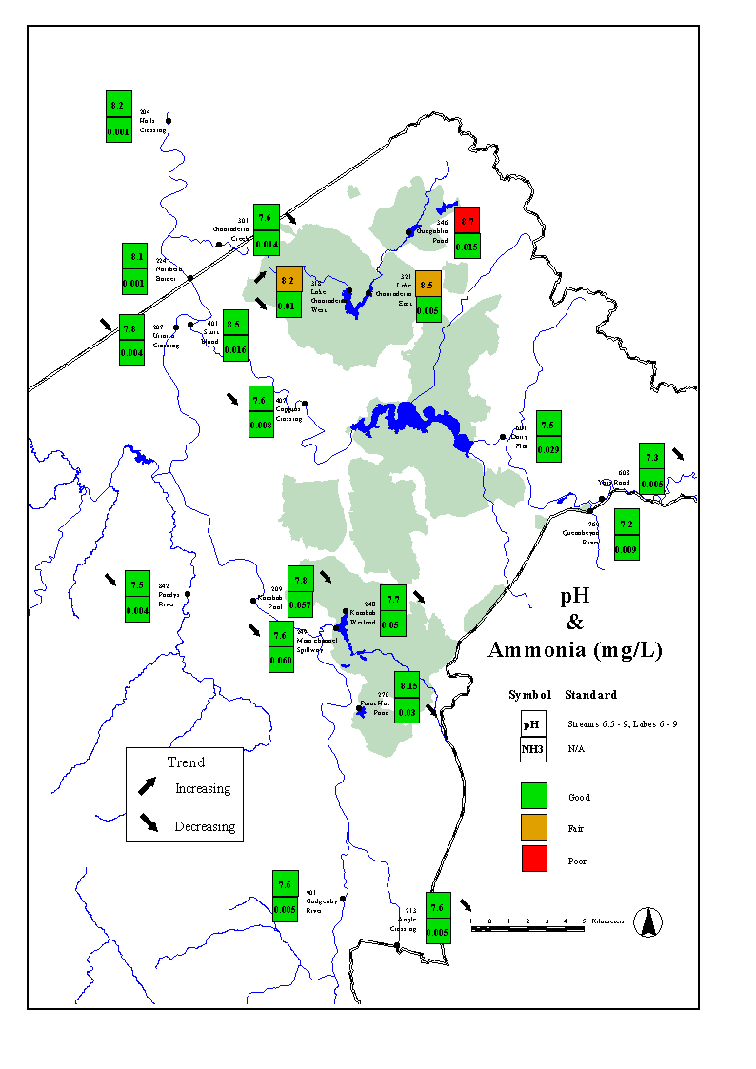
Figure 12: pH and Ammonia Map

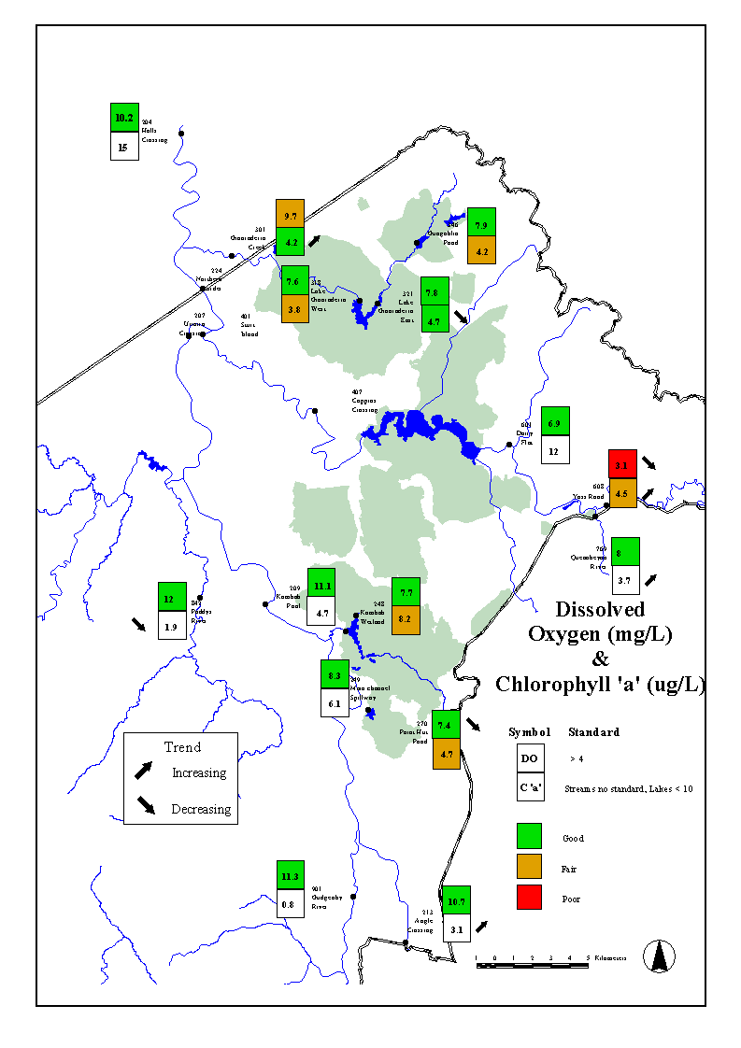
Figure 13: DO and Chlorophyll 'a' Map
Lakes

Lake Tuggeranong
Two sites are monitored in Lake Tuggeranong, one at the Kambah Wetland (Site 248), which is near the northern inflow to the lake and the other at the dam wall (Site 249).

Data collected since 1992 indicate trends for turbidity, suspended solids and conductivity decreasing at both sites. However, the conductivity readings although downward in the long term are higher in the reporting year, reflecting the drought conditions that were present in the ACT. There was also a downward trend in nutrient readings for total nitrogen and phosphorus at both sites (see Appendix 3).

The median values have also primarily remained steady since the 2002-2003 reporting year for most parameters. Turbidity median values are lower, 31.6 from 151mg/L in the previous reporting period at Kambah Wetland and 53 compared with 151 mg/L at the dam wall. The medians for conductivity were 200us/cm and 184us/cm in this reporting year up from 165us/cm and 147us/cm recorded in the previous reporting period.
There was one exceedence recorded in Kambah wetland for both Suspended Solids and Turbidity, which represents an improvement on exceedences levels from previous reporting years. There were also three exceedences recorded at Kambah Wetland for Chlorophyll ‘a’, which is an increase on previous reporting years.

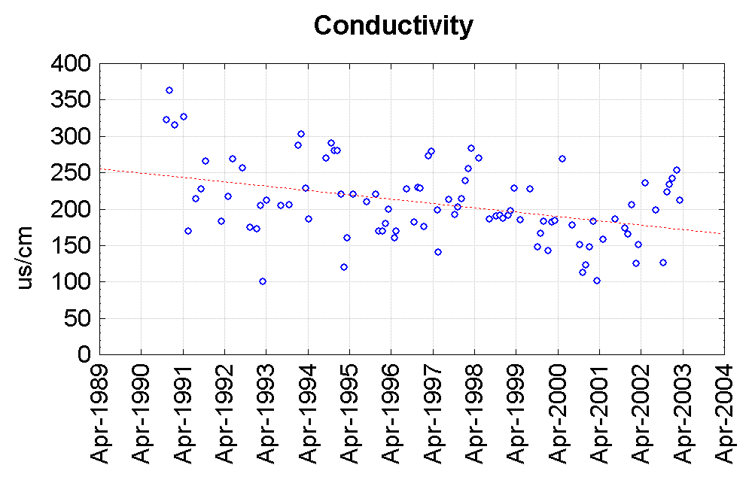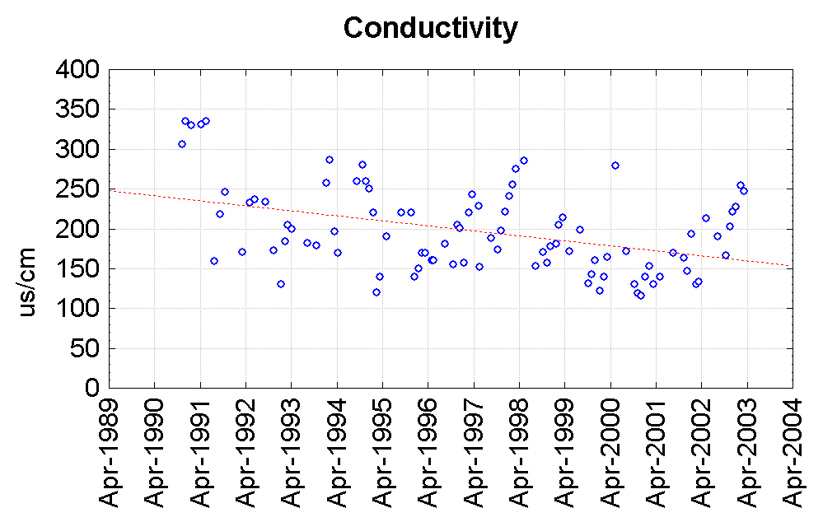
Trend Line
Trend Line

Figure 14: Conductivity at Kambah Wetlands and The Dam Wall

Point Hut Pond (Site 270)
Water quality in Point Hut Pond is traditionally poor when compared with the standards set for its designated uses in the Territory Plan and other lake sites in the ACT. However, conditions seem to be stabilising with fewer exceedences than in previous reporting periods. Nutrient levels continue to decrease, Total Phosphorus and Ammonia both recording downward trends (see Figure 15). There is also a decreasing trend for the dissolved oxygen present.

Point Hut Pond had the highest median value of all sites for turbidity and suspended solids. Five of the eight samples of suspended solid samples exceeded the standard. The medians for all parameters except Chlorophyll ‘a’ and Conductivity were down on the previous reporting period.

Residential development in the catchment continues to affect the water quality in Point Hut Pond. The other major factor in this reporting year was the low flows.

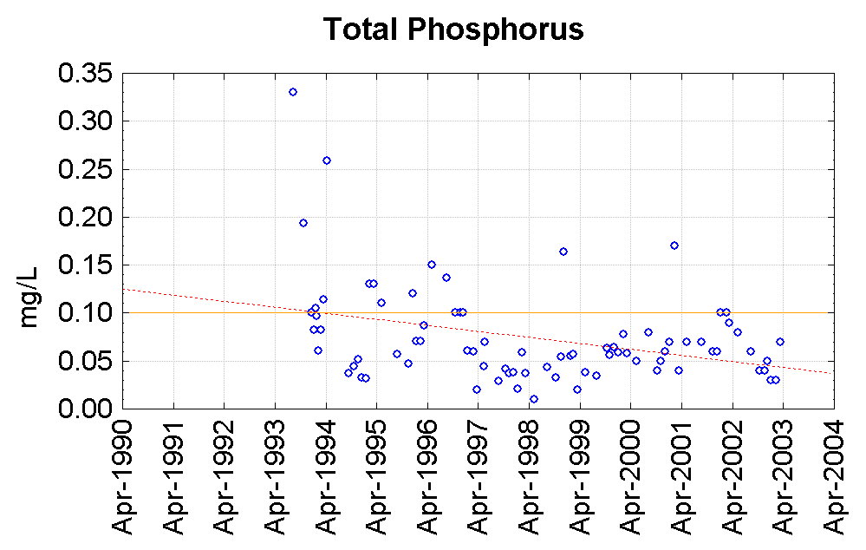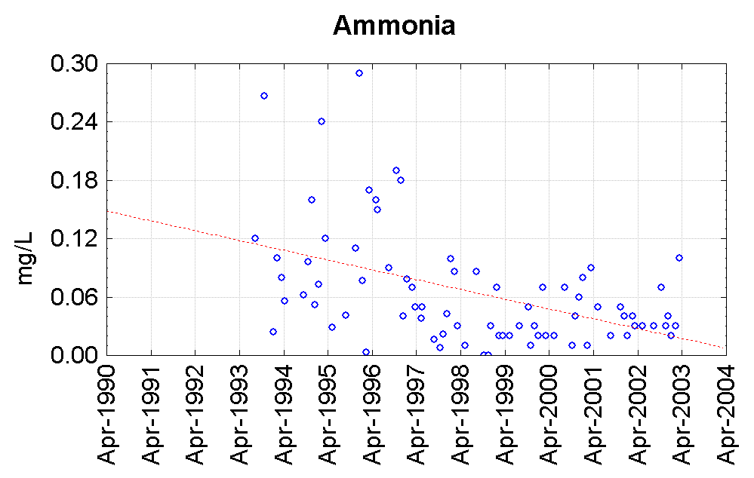
Trend Line
Upper Limit
Trend Line

Figure 15: Total Phosphorus and Ammonia in Point Hut Pond

Gungahlin Pond
Water quality in Gungahlin Pond (Site 346) is fair with downward trend in Turbidity and Phosphorus levels. However, there is an upward trend in pH and numerous exceedences in both Turbidity and pH readings. Turbidity median value of 19 NTU exceeds the 10 NTU standard (see Figure 16).

There is still a significant level of development occurring upstream of this pond, which may be adversely effecting water quality. However, the reduction in suspended solids concentrations and is expected to continue as the catchment stabilises after the extensive development during previous years. Development controls and sediment retention ponds upstream of Gungahlin Pond also contribute to the improving water quality. The high pH is a likely result of a rising water table caused by drought and localised soil conditions.

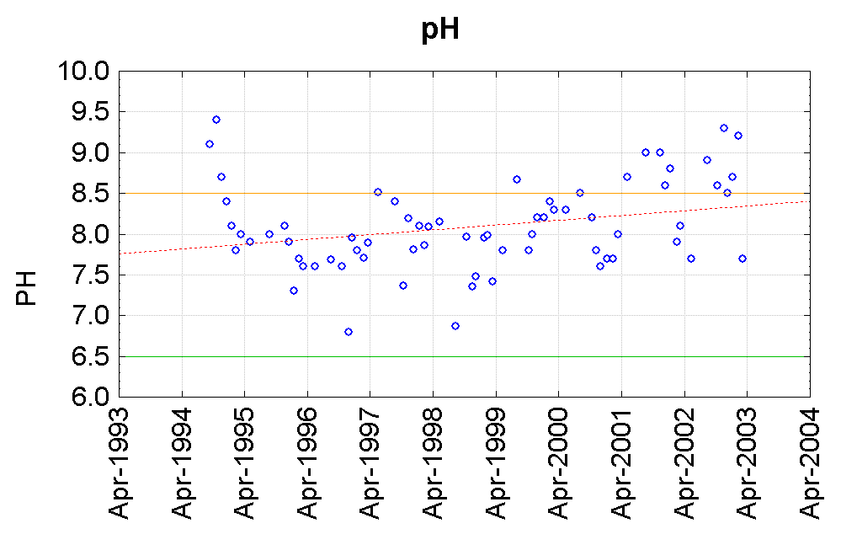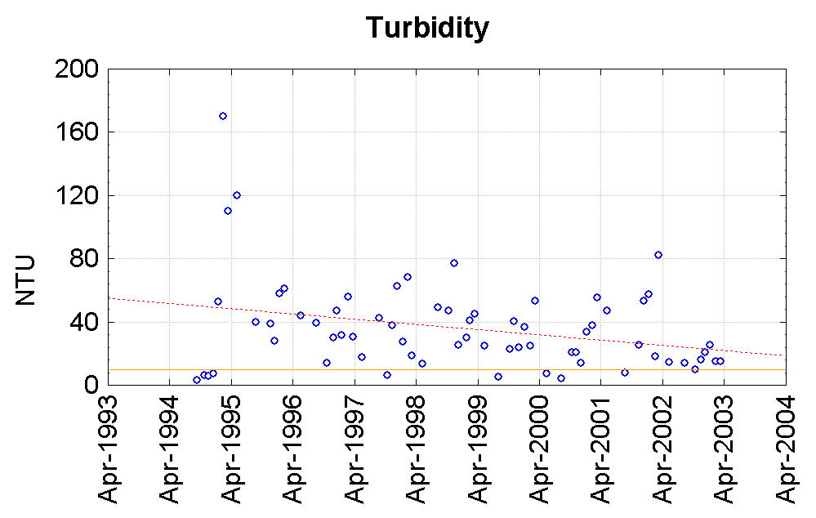
Trend Line
Upper Limit
Lower Limit
Trend Line
Upper Limit

Figure 16: pH and Turbidity at Gungahlin Pond

Lake Ginninderra
Two sites are monitored in Lake Ginninderra, one near the inflow in the East Arm (Site 321) and the other at the outflow dam wall, or West Arm (Site 318). Water quality in the lake was good and generally better than the other lakes monitored. At both sites the data shows significant downward trends in total phosphorus and conductivity, although the conductivity medians were up for the reporting year. There was also an improvement in turbidity suspended solids and ammonia at the Dam, however, pH at the Dam wall is showing an upward trend (Figure 17).

Exceedences were recorded at both sites for pH, the east arm site recording its first ever exceedences in that parameter. A Chlorophyll ‘a’ exceedence was recorded at the Dam and turbidity and suspended solids exceedences were recorded at the east arm, although these are reduced from previous years.

The improvement experienced between the inlet and outlet indicates that Lake Ginninderra is improving the water flowing through the lake. The turbidity levels in Gungahlin pond may affect the turbidity levels in the East Arm.

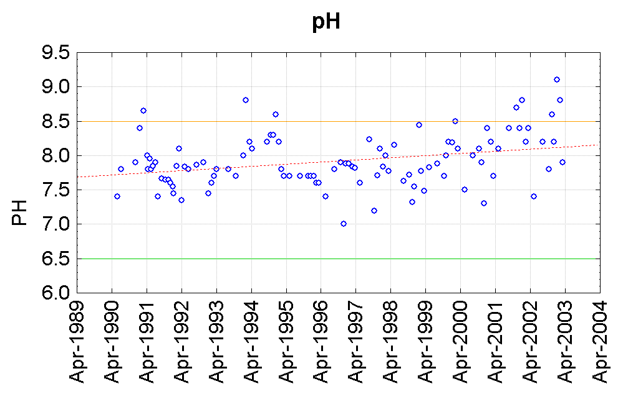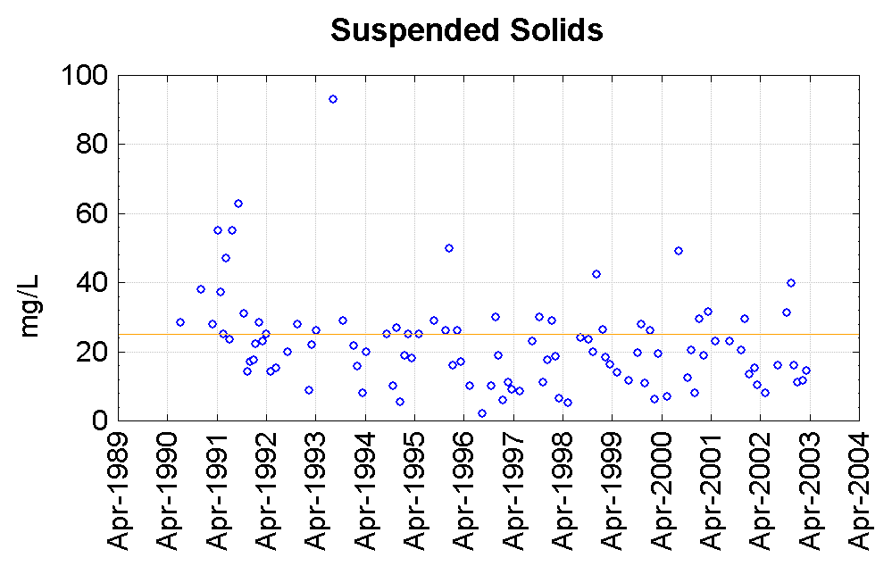
Trend Line
Upper Limit
Lower Limit
Upper Limit

Figure 17: pH at Lake Ginninderra West and Suspended Solids at The East Arm

Rivers

Ginninderra Creek
The monitoring site for water quality in Ginninderra Creek is at Parkwood (Site 301) below the confluence with Gooromon Ponds Creek downstream of the lake. The biological monitoring sites in Ginninderra Creek are Baldwin Drive bridge (Site 195), downstream of Lake Ginninderra (Site 196) and Latham (Site 64).

In both Spring 2002 and Autumn 2003 the sites were showing well below reference or impoverished levels in the macroinvertebrate sampling. This is a reflection of the low flows and drought conditions in the area. Significant trends were difficult to identify on long term data owing to a change in collection frequency in 1996.

The physio/chemical results show relatively good with median values down or in a similar range for most parameters. The conductivity median has increased from 300 uS/cm in the previous reporting year to 440 uS/cm, indicating worsening conditions dues to low flow and drought. The improvements in other parameters are indicative of conditions as the catchment stabilises after extensive urban development in Gungahlin, as will as the continued stabilisation and regeneration after the willow removal program which was conducted between 1998 and 2001. There were no recorded exceedences in suspended solids, which were a problem in the past. There were two recorded breeches of standards for turbidity and one for dissolved oxygen.

Paddy’s River (Site 842)
Paddy’s River catchment is a combination of rural, forestry and conservation land uses. It was affected by the January bushfires. This is reflected in the AUSRIVAS data at Murray’s Corner (Site 10), a reference site which shows an ‘A’ rating in Spring 2002, and as below reference in Autumn 2003.

Median values remained constant or decreased for most parameters. However, the conductivity median was 85 μS/cm up from the previous years sample of 64 μS/cm, this is reflecting the low flow conditions that were present in the reporting year. Exceedences were generally lower than in previous years, one for both Turbidity and Faecal Coliforms represents an improvement. The February sample recorded exceedences for both Faecal Coliforms as well as Total Phosphorus occurred. The stock fences to prevent stock access were down for this sample, which may have contributed to this poor reading. Also, increased readings for Ammonia, Conductivity and Chlorophyll ‘a’ were recorded, indicating the effects of a particularly dry period preceding the sample. An initiative to improve water quality implemented by the Paddy’s River Landcare group, to limit access of stock to the river, is a possible explanation for a decreased number of standard exceedences, particularly in turbidity and faecal coliforms parameters. However, data collected by the Waterwatch community group show high turbidity readings at some other sites along the river, attributable to continued stock access to the river, particularly in drought conditions.

Gudgenby River (Site 901)
The Gudgenby River drains a rural catchment dominated by native forest, it is a fire affected site. The biological monitoring at Smiths Road Crossing (20) result was above reference for Spring 2002 and below reference for Autumn 2003. The effect of the drought were not as apparent in the reference site in Spring 2002 sample, however, the above reference reading could be indicative of this river being more resilient than other sites to the drought or that it is experiencing mild levels of impairment due to nutrient enrichment.

There were no exceedences of standard during the reporting period and the median values were down or in a similar range to previous years, except conductivity, which had increased from 78 uS/cm to 88 uS/cm an indication of the drought low flow conditions occurring in the reporting year.

Murrumbidgee River
The Murrumbidgee River runs through the ACT entering at Angle Crossing (213) in the south and is sampled at a number of locations including Kambah Pool (209), Uriarra Crossing (207), the Northern Border (224) and Halls Crossing (204), which is in NSW, downstream of the ACT. The biological monitoring sites for the Murrumbidgee are Angle Crossing (40) and Halls Crossing (53).

The biological conditions at both sites for Spring 2002 were band A. However, by Autumn 2003 these sites recorded a significant impairment in the micro-organisms in the Murrumbidgee. Angle Crossing is a reference site, which are chosen for their undisturbed nature, which indicates that the drought and fire have been adversely affecting the Murrumbidgee before it enters the ACT.

The physio/chemical analysis of the Murrumbidgee River shows relative resilience to the drought conditions. Most medians are in a similar range to previous years. Downward trends at both 209 and 213 were identified in both pH where the values are approaching neutral and conductivity. Also, site 204 recorded a downward pH trend.

Most water quality parameters along the river comply with the standard. Exceedences occurred at site Uriarra Crossing 207 in Total Phosphorus, Suspended Solids and Faecal Coliforms. There was also one exceedence for turbidity at Kambah Pool.

The typically good water quality experienced in the Murrumbidgee River indicates that land use and management practices, which include sediment retention ponds, authorised discharges and building development controls are effective in minimising the impact that Canberra has on the Murrumbidgee. The adverse effects of the drought, while dramatically reducing flows in the river, have been minimised. However, this report does not incorporate the sediment entering waterways after the January Bushfires, as there had not been a significant rain event before the end of the reporting year.

Molonglo River
The Molonglo River is sampled at two sites above Lake Burley Griffin, Dairy Flat (Site 601) and Yass Road (Site 608), and two sites below the Lake, Coppins Crossing (Site 407) and Sturt Island (Site 401) before it enters the Murrumbidgee River. The biological monitoring site is at Sutton Road Bridge (Site 242).

The biological condition for the reporting period was extremely impaired rating Band D in Spring 2002 and C in Autumn 2003. This poor result, which improved marginally in Spring, can be attributed to the concentration of pollutants and deterioration of conditions caused by very low flow conditions.

Site 608, at Sutton Road Bridge fared poorest falls outside the ACT jurisdiction in terms of regulations. However, the dissolved Oxygen reading in the majority of cases is below the 4 mg/L, which indicates poor water quality. There was also an increasing trend recorded for Chlorophyll ’a’. A number of Phosphorus exceedences were recorded at site 401 at camp Sturt. The other parameter of note is conductivity or total dissolved solids, which recorded increased medians at all sites, which could be predicted given the low flow conditions.

Water quality in the Molonglo River downstream of the Lower Molonglo Water Quality Control Centre (LMWQCC) appears to have fared better than other sites during the conditions during the extreme conditions of the reporting year. This could be due to the constant flow out of the facility at a time when the flow entering the ACT was very low.

A standard of 1000 cfu/100 ml faecal coliforms applies to all sites on the Molonglo. This standard was not exceeded during the reporting period, which shows an improvement from previous years where faecal coliforms, especially at sites downstream of the lake, were a cause for concern.

Water Resources Use

To provide for effective management of water resources the Environment Protection Authority has determined that all licensed water use is to be measured. Thus all licences include a standard condition requiring the installation of a water meter (or some other approved measuring system). This is not always a straightforward matter due to the location and nature of existing infrastructure, difficulties in the supply of equipment, and personal circumstances of individual licensees. While the majority of licensees have now installed meters some follow up is still required particularly in on-going maintenance of meters.

Details of licences and allocations issued and water use are provided in Table 4 to Table 6. The catchments referred to in the tables are shown in Figure 6.

Table 4: Licences to Take Groundwater by Catchment
Catchment Name | Licensed Volume |  | Annual use 1/04/2001 to 31/03/2002
Catchment Name | No of licences | ML | ML
Coppins | 1 | 3 | 171.2
Fyshwick | 9 | 59 | 107.94
Guises | 2 | 4 | 2.15
Jerrabomberra-Narrabundah/Symonston zone | 5 | 120 | 8.1
Woden Creek zone | 0 | 0 | 0
Eastern Catchment zone | 0 | 0 | 0
Kambah | 2 | 11 | 8.51
Kowen | 2 | 6 | 0.6
Lake Burley Griffin | 31 | 41 | 4.9
Lake Ginninderra | 3 | 17.5 | 51.3
Naas | 1 | 2 | 1.7
Parkwood | 3 | 10 | 11.1
Sullivans | 3 | 19.5 | 6.5
Tharwa | 4 | 25 | 21.2
Tuggeranong | 2 | 6 | 9
Upper Molonglo | 1 | 2 | 0
Weston | 2 | 8 | 0.8
Woden | 2 | 186 | 119.1
Woolshed | 2 | 6 | 0
Total | 75 | 526 | 524.1

Table 5: Licences to Take Surfacewater by Catchment
Catchment Name | Licensed Volume |  | Annual use reported for period 1/04/2001 to 31/03/2002
Catchment Name | No of licensed | ML | ML
Fyshwick | 8 | 92 | 121.2
Gudgenby | 1 | 2 | 5
Gungahlin | 1 | 309 | 248.5
Kambah | 1 | 192 | 173.2
Lake Ginninderra | 2 | 184 | 217.8
Paddys | 2 | 66 | 22.8
Parkwood | 1 | 10 | 10
Tharwa | 2 | 18 | 18
Tuggeranong | 1 | 42 | 37.8
Uriarra | 1 | 8 | 0.1
Woden | 1 | 2 | 1.5
Woolshed | 2 | 30 | 24.2
Corin | 1 | 29700
Bendora | 1 | 21000 | 22666
Tinderry | 5 | 10280 | 437
Googong | 1 | 1200 | 44043
Burra | 1 | 1600
Total | 32 | 64735 | 68026.1

Table 6: Combined Licences to Take Both Surfacewater and Groundwater by Catchment

Catchment Name | Licensed Volume |  | Annual use5 reported for period 1/04/2001 to 31/03/2002
 | No of licences | ML | ML
Fyshwick | 1 | 18 | 0.25
Gudgenby | 1 | 24 | 5
Sullivans | 2 | 295 | 125.4
Uriarra | 1 | 10 | 25.3
Woolshed | 2 | 182 | 7.5
Jerrabomberra | 1 | 126 | 103.3

There has been a large increase in groundwater licences during this reporting period, with that trend set to continue into the next reporting year. These increases, particularly in urban subcatchments, are likely due to the implementation of water restrictions on potable water use. As the increase is due to recent bores installations, annual use figures have not varied greatly as there are minimal use readings for these new bores at the time of reporting.

It is anticipated that several of the urban subcatchments will reach full allocation within the next reporting year.

Table 7: Number and Volume Allocations by Catchment
Catchment Name | No of allocations | Total Volume(ML)
Bendora | 1 | 21000
Burra | 1 | 1600
Coppins | 1 | 1
Corin | 1 | 29700
Fyshwick | 9 | 107
Googong | 1 | 1200
Gudgenby | 3 | 19
Gungahlin | 2 | 310
Jerrabomberra | 2 | 25
Kambah | 1 | 192
Kowen | 1 | 2
Lake Burley Griffin | 2 | 3
Lake Ginninderra | 5 | 201
Michelago | 1 | 2
Naas | 1 | 1
Paddys | 3 | 79
Parkwood | 1 | 12
Sullivans | 3 | 298
Tennent | 1 | 1
Tharwa | 4 | 53
Tinderry | 5 | 10280
Tuggeranong | 2 | 42
Uriarra | 3 | 21
Weston | 1 | 6
Woden | 2 | 39
Woolshed | 4 | 137
Total | 61 | 65331.29

As with an increase in water use licences, new allocations have been issued within this reporting period. However, the increases are not proportional simply because the majority of new licences are for groundwater use on leases that pre-date the implementation of the Water Resources Act 1998, and therefore an allocation is not required to be issued for these licences. The majority of new allocations relate to licences to take water from surface water sources.
Table 8: Actual Releases from Water Supply Dams Compared with Environmental Flow Requirements for Period 1 April 2001 to 31 March 2002
Date | Outflow | Corin Dam | Bendora Dam | Cotter Dam | Googong Dam
April | Actual | 3835 | 811 | 1177 | 601
 | Required | 595 | 1016 | 1451 | 588
May | Actual | 5050 | 1289 | 1818 | 940
 | Required | 676 | 1154 | 1648 | 851
June | Actual | 859 | 1409 | 2697 | 874
 | Required | 855 | 1459 | 2084 | 1104
July | Actual | 1323 | 3109 | 5167 | 1436
 | Required | 1808 | 3086 | 4408 | 1475
August | Actual | 4011 | 4134 | 5295 | 1899
 | Required | 3016 | 5148 | 7353 | 1691
September | Actual | 3099 | 6748 | 9441 | 1372
 | Required | 3594 | 6134 | 8762 | 784
October | Actual | 5731 | 4602 | 5865 | 546
 | Required | 2751 | 4695 | 6706 | 404
November | Actual | 4190 | 1942 | 2285 | 138
 | Required | 1056 | 1802 | 2574 | 1
December | Actual | 3755 | 914 | 1007 | 23
 | Required | 547 | 905 | 1293 | 1
Jan-03 | Actual | 1609 | 142 | 149 | 30
 | Required | 150 | 218 | 292 | 1
February | Actual | 1810 | 270 | 1205 | 107
 | Required | 176 | 240 | 343 | 1
March | Actual | 741 | 404 | 606 | 233
 | Required | 181 | 246 | 353 | 142
Total | Actual | 36013 | 25774 | 36890 | 8198.6
 | Required | 15405 | 26103 | 37267 | 7043

Table 8 figures are taken from the monthly reports provided from ACTEW Corporation Limited to the Environment Protection Authority, which are a condition of their licence to take water. Whilst comparison of the actual releases against the required releases in Table 8 shows that there are more than a dozen occurrences when the actual values are lower than the required values, the majority of these are not considered breaches of the licence based on a ± 20% tolerance volume which is currently allowed to take into account the size of the release valves.

A low actual release from the Bendora dam in August 2002 was due to valve maintenance work. This work was undertaken with the approval of the Environment Protection Authority, therefore this low actual release is not considered a breach of the licence.

Following a request from ACTEW under their licence conditions, environmental flow releases from the water supply dams were reduced below the ‘normal’ requirements in December 2002 to ‘demonstrated need requirements’. This meant that the flow that was required to be released was either half the ‘normal’ flow required to be released, or half of inflow, whatever was less. This reduction was undertaken in accordance with the Environmental Flow Guidelines.

The January bushfires also prevented access to the valves, hence January figures for Bendora and the Cotter Dams where actual is lower than released are not breaches of licence conditions. As a result of the bushfires and the burnt Cotter bridge, a temporary road crossing was built upstream of the stream gauge, which is located near the former Cotter Kiosk. This change in flow from the road structure has resulted in erroneous gauge readings for the Cotter Dam from February 2003 onwards.

Table 9: Water Drawn for Urban Supply from Cotter and Googong Catchments During 1 April 2001 to 31 March 2002
 | Cotter  [ML] | Googong  [ML] | Total  [ML]
April | 3771 | 1317 | 5088
May | 3641 | 898 | 4539
June | 878 | 2848 | 3726
July | 2433 | 1533 | 3966
August | 1980 | 2179 | 4159
September | 0 | 4631 | 4631
October | 780 | 5554 | 6334
November | 2545 | 5389 | 7934
December | 1505 | 5436 | 6941
January | 2623 | 5272 | 7895
February | 1926 | 4417 | 6343
March | 584 | 4569 | 5153
Total | 22666 | 44043 | 66709

There has been a significant shift in the source of water drawn for urban supply in this reporting year, with supply from Googong accounting for the majority of urban water supply. Initially this was due to drought and reduced inflows, but then the bushfires within the Cotter water supply catchment lead to increased sediment moving into the reservoirs. Corin Dam was removed from the water supply in February 2003. A storm in late March 2003 impacted on water supply from Bendora. This shift to Googong supply continued into the next reporting year.

Overall, the volume of water drawn for water supply has marginally increased.
Water Related Projects

ACT Water Resources Strategy

Think water, act water—a draft strategy for sustainable water resource management is intended to provide long-term guidance to the management of water resources for Canberra and the region.

The draft strategy has been developed by the Water Resources Taskforce within Environment ACT working with other ACT Government agencies and with input from the community.

Think water, act water focuses on how to meet targets outlined in Water ACT—a draft policy for sustainable water resource management, including the following:
- Between 2003 and 2013—12 per cent less water usage per capita and the use of treated effluent (reclaimed water) increased from 5 per cent to 20 per cent.
- By 2023—25 per cent less water usage per capita (compared with 2003).
- The level of nutrients and sediments entering ACT waterways is no greater than from a well-managed rural landscape.
- Reduce the intensity and volume of urban stormwater flows so that the runoff event that occurs on average once every 3 months is no larger than its predevelopment size.

The draft strategy addresses a range of issues, including:

- variables affecting the future of the ACT’s water resources (population growth, climate change, bushfire impact);
- water supply options;
- water use efficiency;
- water quality;
- water sensitive urban design;
- catchment management;
- riparian zone management; and
- education and community partnerships.

In addition to setting the direction for future water resource management in the ACT, Think water, act water also considers how what happens in the ACT affects water management across the region and downstream of the ACT.

Think water, act water will be released for public comment for two months late in the year. Once finalised, it will be tabled in the Legislative Assembly as the Water Resources Management Plan under the Water Resources Act 1998.

ACT Natural Resource Management Plan

The ACT signed a bilateral agreement with the Australian Government on 27 March 2003 for the delivery of the Natural Heritage Trust in the ACT over the next five years. The agreement acknowledges that natural resource outcomes, including those relating to water, are best achieved at the regional scale and that investment needs to be targeted. The agreement further requires that the ACT’s regional body, the ACT Natural Resource Management Board (which was formed by expanding the membership of the ACT NRM Advisory Committee) prepare an integrated NRM plan as a basis for guiding future investment, including funding from Australian Government programs. The plan was drafted during the year and includes, as required by the bilateral agreement, specific targets relating to water quality, biodiversity, soil health, salinity and community building.

It is envisaged that the Plan will be finalised early in 2004 and accredited by Territory and Australian Government Ministers as the basis for future NRM investment in the Territory.

New Books on Aquatic Fauna

In December 2002 Environment ACT published two books on the aquatic fauna of the local region. The first book, Fish in the Upper Murrumbidgee Catchment: A Review of Current Knowledge provides information on the distribution, abundance, conservation status and ecology of fish species in the catchment and highlights conservation and management issues affecting aquatic habitats. It is a 92 page document including 26 colour photos of native and exotic fish species. The book is intended to be a resource document for schools, catchment groups and anyone with an interest in fish. The book has been distributed to all secondary schools and catchment management groups within the Upper Murrumbidgee Catchment and is available from ACT Government libraries. The book will soon be on the Environment ACT website.

The second book is Wet and Wild: A Field Guide to Freshwater Animals of the Southern Tablelands and High Country of the ACT and NSW. This field guide covers all vertebrates and selected mega-invertebrates likely to be found in the region extending from Goulburn in the north to Albury in the south, and from Gundagai to Braidwood. Fish, frogs, waterbirds, reptiles, mammals and some bugs are all covered with information on identification, habitat and ecology, threats, distribution and abundance. Broad aquatic habitat types are described as well as a general introduction to each faunal group. The target audience is students, naturalists, fisherman and the general public, with the aim being to foster an interest in aquatic environments. Each species is illustrated with full colour photograph, with an extensive bibliography of general and local references provided for each species. This 262 page book with 170 colour photos is available at $34.95 RRP from bookshops at Tidbinbilla Nature Reserve and Namadgi National Park, as well as commercial bookshops such as the university Coop Bookshops, and the Australian National Botanic Gardens bookshop, Dymocks etc. It is also available directly from Environment ACT.

Impacts of the January Bushfires on Fish Communities

Following the January bushfires, the fish community in a variety of streams was sampled to examine the impacts of the fires. There have been few studies in Australia on the effects of fire on aquatic fauna, and only a single published study on the effects of fire on fish. In order to gain some appreciation of the impacts of the fires on aquatic communities, a sampling program was undertaken at a number of burnt sites in the ACT and surrounding NSW. In order to try and differentiate the impacts of the fires from the impacts of the severe drought being experienced, a number of unburnt sites were also sampled.

A total of 31 sites were sampled, covering a range of stream sizes, altitudes and fire severities. Some sites were unburnt, but were sampled in order to provide some insight into the effects of the drought. All of the sites had pre-fire information available, although for some sites this information was collected more than 10 years ago.

It was apparent that at most sites the abundance of fish had dropped dramatically, with the majority of individuals captured from unburnt sites. It was also obvious that some species declined at unburnt sites as well as burnt sites. Whilst no formal analysis has been conducted on this data yet, it appears that the interaction between drought, fire and species is variable depending on stream size and altitude. Trout have been more severely impacted at lowland sites than upland sites, and also in smaller rather than larger streams. This is intuitively sensible as smaller streams are more prone to drying, and lowland streams more likely to have reached lethal water temperatures in reduced summer flows.

Numbers of the threatened species Two-spined Blackfish were reduced by approximately 70% when compared to data collected in 2001. Numbers of this species at an unburnt reference site (Goobarragandra River) increased by 30% since 2001, indicating that the drought has probably not played a significant role in the decline, and that fire was responsible. At one burnt site, the abundance of this species dropped by 99%

Although fish are rarely directly affected by bushfires (i.e. bushfires rarely burn individuals or heat streams sufficiently to kill fish), there is considerable potential for indirect fire impacts to affect fish communities. Secondary impacts of bushfire on aquatic communities can include:
- sedimentation from denuded catchments following rain events;
- a decrease in dissolved oxygen concentrations as organic material (leaves, ash) washed into streams following rain events begins to decompose;
- chemical changes in water quality as ash is deposited in streams;
- increased algal growth due to increased nutrient load;
- changes to streamflow patterns as upland swamps and bogs (sponges/filters) are damaged and rainfall runoff increases with no vegetative cover remaining; and
- impacts from the loss of the riparian (streamside) vegetation including:
- loss of food resources because there is no insect fall from overhanging vegetation
- increase in water temperature due to lack of shade
- increase in algal abundance due to increase in light reaching the stream

The major implications of the fires for ACT fish species are the threats posed by increased sedimentation of streams. Streams of particular concern in the ACT are those in the Cotter catchment where populations of four threatened fish species are known to be present, (Macquarie Perch, Trout Cod, Two-spined Blackfish, Murray River Crayfish) along with the rare Southern Leaf-Green Tree Frog Litoria nudigitus which is only found in two locations in the ACT, both on the Cotter River. Macquarie Perch and Two-spined Blackfish are particularly sensitive to sediment addition as they deposit adhesive eggs on the substrate. Blackfish are only found in the Cotter River in the ACT where they are found in the main channel and larger tributaries throughout the catchment. They are almost totally dependant on the presence of interstitial spaces (crevices) in cobbles and boulders, where they breed, feed and seek refuge from predators. When these crevices fill up with sediment, the blackfish cannot survive. This is clearly demonstrated in the Cotter River below Cotter Dam, where the lack of flows has resulted in sediment accumulation and the disappearance of blackfish.

As well as the effects of the bushfires on streams, there were severe impacts on riparian (streamside) vegetation, as well as upland wetland communities. A more comprehensive report of the impacts of the fires on aquatic communities is included in the report Wildfires in the ACT 2003: Report on the Initial Impacts on Natural Ecosystems which can be viewed on the Environment ACT website.

Upper Murrumbidgee Catchment Coordinating Committee

The Upper Murrumbidgee Catchment Coordinating Committee (UMCCC) produced a resource book in February 2003, which provides much sought after information for owners of small acreage farms and bush blocks. The book titled Look After your Natural Assets – landcare for the bush block and small acreage farms in the Upper Murrumbidgee catchment is a revised and expanded edition of the book Look After your Natural Assets originally produced by the Geary’s Gap / WamboinLandcare Group.

The book is designed to be distributed by local government within the Upper Murrumbidgee catchment, including the ACT, and provides useful information about many natural resource management issues facing new and existing rural residential/small acreage landholders including water resources management, bushfire preparation for your block and invasive species control. It also provides useful contact details for getting further information. Publication of this booklet was funded in part by Environment ACT.

Southern ACT Catchment Group

In early 2000, Environment ACT released a framework for the future management of natural resources in the ACT. The Integrated Catchment Management (ICM) Framework for the ACT was developed in consultation with a range of community and Government organisations. The framework recognises that integrated management of our resources is the most effective way of dealing with environmental issues. It also acknowledges the integral role played by the community in natural resource management.

In response to community concerns for the integrated management of southern ACT environs, a jointly funded project between the NHT and Environment ACT was initiated in 2001 to assist community groups to develop and implement sub-catchment plans in southern ACT. The Tuggeranong-Tharwa and Weston-Woden Sub-catchment Plans are the first catchment wide planning efforts to be undertaken in the area.

The planning process provided the impetus for the formation of the Southern ACT Catchment Group (SACTCG) who quickly assumed responsibility for the implementation and further development of both plans. The SACTCG is a ‘group-of-groups’ with membership total of 27 Landcare, Parkcare, Waterwatch and other community groups in Southern ACT, concerned with the integrated management of the local environment.

Both plans have been developed in close association with all interested community, Government and industry groups and are regarded as blueprints for future action in southern ACT. They form the basis from which future environmental investment in the region is to be procured, targeted and implemented. The SACTCG has stipulated that both plans will be reviewed continuously to ensure that the community’s concerns are always represented for the entire life of the plans, from now to the year 2010.

Recently, the SACTCG has been involved in the development of a rural sub-catchment plan for South-West Rural ACT. Upon completion, the major strategies and actions from this plan will be considered alongside those from the Tuggeranong-Tharwa and Weston-Woden plans, in an annual ‘works action planning session’ that will guide the SACTCG's activities in the following calendar year.

Riparian Fencing in South-West Rural ACT – EnviroFund $27,000

The project was developed to assist rural lessees to protect and enhance existing riparian vegetation communities, protect streambanks from erosion and to link riparian ecosystems to remnant vegetation in the sub-catchment. The project will also enable the re-establishment of those riparian fences and off-river stock watering points destroyed in the January 18th fires that destroyed some 120,000 ha of the ACT and devastated much of south-west rural ACT.

The project aims to re-establish 15 km of stock proof fencing in the riparian corridors of south-west rural ACT and 10 off-river stock watering points.

WaterPOINT – EnviroFund $10,000

ACT Waterwatch and the SACTCG are currently working in collaboration with the Cooperative Research Centre for Freshwater Ecology (CRCFE) to develop a community monitoring network (which was going to be called WaterPOINT) to monitor the ecological affects of the January 18th bushfires on our waterways. The network had a name change, and is now affectionately known as C.A.M.P.F.I.R.E: Community Assessment Monitoring Program for Impacted River Ecology.

The SACTCG was aware of the importance of water quality monitoring in affected areas, starting as quickly as possible, before any rain events. Little is known about the impacts of fire on aquatic ecosystems generally, and nothing about its effect on the local catchments that have burnt. Consequently we are endeavoring to find out;

How urban and rural streams have been affected by fire in their catchments?
How long it takes streams to recover from such impacts?
What are the implications for stream ecology? and
What are the implications for human uses?

The SACTCG has put together an efficient 101 person team to undertake water quality monitoring in a quick and confident manner at strategic sites throughout the catchment area. The team will monitor pH, EC, turbidity, dissolved oxygen, ortho-phosphate, and macro-invertebrates. SACTCG facilitates training, data collection through the website and all the necessary equipment through the EnviroFund grant. At present volunteers have devoted over 350 hours to the monitoring strategy, established 35 monitoring sites utilising components of the 10 Waterwatch kits provided by SACTCG.

Riparian Restoration Fund – Restoration of Yarralumla Creek $3,000

In mid 2002, the ACT Equestrian Association approached Environment ACT in regards to the worsening condition of the lower reach of Yarralumla Creek. The Association was referred to the SACTCG, to assess whether or not we would be interested in investigating the feasibility of restoring the creek environs. In June 2002, the catchment group was granted funds to employ a consultant to assess the creek and provide management recommendations. At present the SACTCG is negotiating with Canberra Urban Parks and Places (CUPP) and Environment ACT to acquire funding for the next stages of the creeks rehabilitation—willow and woody weed removal and some engineering works.

Returning Life to Tuggeranong Creek – Community Partnerships Program $40,000

The Building a Tuggeranong Catchment Community project was a project that received funds from the previously titled Community Renewal Program. The project sponsored a feasibility study of restoring a remnant section of Tuggeranong Creek that runs through the Tuggeranong Homestead site, from which natural water flow has been cut off by the stormwater system. The study was completed in late 2002 and has highlighted some engineering challenges and their associated costs, to return natural water flow or ‘life’ to the culturally significant creek. The project will involve re-establishing water flow though the creek to achieve a number of educational, heritage restoration, aesthetic and environmental benefits.

As noted previously, the project will involve re-establishing water flow though the creek to achieve a number of educational, heritage restoration, aesthetic and environmental benefits. The project will target Aboriginal Youth and the wider Indigenous community as well as non-indigenous youth and the ‘landcare’ community of southern ACT. The site will be used to highlight the important cultural connection between the Tuggeranong Creek and Homestead site and the Indigenous and non-indigenous community. Considerable effort will also be made to highlight the environmental importance of urban wetlands in the ACT landscape, in terms of a natural filter of stormwater and urban run-off, prior to it reaching the Murrumbidgee River. Returning the creek to a natural flowing system will also assist Environment ACT and the Indigenous community protect culturally significant sites that are perhaps under threat from un-controlled pedestrian traffic through the site.

Pending Approval – FrogsEye: Identifying Potential Urban Wetland Sites in Southern ACT – EnviroFund $15,000

This project will assist the Southern ACT Catchment Group (SACTCG) implement Strategy B, Action 3 of the Weston-Woden Sub-catchment Plan and Strategy B, Action 1 of the Tuggeranong-Tharwa Sub-catchment Plan, both of which state ‘Identify appropriate sites for the construction of urban wetlands to re-use stormwater, improve biodiversity values and water quality’.

The Frogs Eye Project, will contract a consultant to identify potential urban wetland sites throughout the urban portions of the Weston, Woden, Tuggeranong and Tharwa Sub-catchments. The study will form part of an urban waterway restoration strategy aimed at restoring and maintaining the economic, ecological and social systems in the urban environs of Southern ACT. To this end, the SACTCG acknowledges that the restoration of these systems can only be achieved by initiating processes that are designed in a manner that involves the community, hence the project will have an education and skills transfer focus. The outcomes from the Frogs Eye Project will form the first step towards the adoption of a long-term aim to ecologically restore the highly engineered tributaries in the urban sub-catchments to more ‘natural’ waterways and wetlands, that are specially designed to meet the needs of an urban community.

Waterwatch

Waterwatch is a community water quality-monitoring program that aims to equip local communities with the skills and knowledge to become involved and active in the protection and management of their waterways and catchments.

Waterwatch is federally funded through the Natural Heritage Trust and is locally administered by Environment ACT. There are three part-time Waterwatch Coordinators who are employed by three different employers in three separate work locations: Lake Tuggeranong College, ActewAGL and the Ginninderra Catchment Group.

The Waterwatch network is made up of individuals, community and school groups who undertake a variety of biological and habitat assessments as well as physical and chemical tests to build up a picture of the health of their waterways and catchment.

Waterwatch groups have initiated many positive, community based conservation activities such as creek restoration, willow removal, removing litter from waterways eradicating weeds, drain stencilling, development of habitats, reducing the use of pesticides, fertilisers and other pollutants.

This year Waterwatch has been involved in many exciting new and ongoing catchment programs and groups including:

CAMPFIRE
In January 2003 bushfires scorched over 160,000 hectares or 70% of the ACT and impacted huge areas across the entire Upper Murrumbidgee region. A project that has had real success since these fires is affectionately known as C.A.M.P.F.I.R.E. Community Assessment Monitoring Program For Fire Impacted River Ecology. Working in collaboration with the Cooperative Research Centre for Freshwater Ecology (CRCFE) Waterwatch has developed a community monitoring network that is monitoring the ecological affects of the bushfires on our waterways. CAMPFIRE volunteers collect water quality information from over 20 bushfire affected site across the ACT. Data collected as part of the CAMPFIRE project can be found on the environment ACT web site: www.environment.act.gov.au/airandwater/waterwatchact.html

Frogwatch
Waterwatch volunteers have undertaken the first ever Upper Murrumbidgee Frogwatch Census as part of the 2002 National Water Week activities. The Frogwatch Census involved an assessment of the types and abundance of frogs living in our environment. Frog species are widely recognised as indicators of environmental health and their presence can indicate the long term health of a catchment. Results of the Community Frogwatch Census are available on the Environment ACT website.

Internet Data Entry
The Southern ACT Catchment Group in collaboration with Waterwatch ACT has developed a new on-line data entry system. Volunteers can now enter water quality monitoring results on-line through the SACTGC website. www.sactcg.org

Urban Wetlands
Waterwatch groups continue to monitor the impacts of new urban constructed wetlands in the Tuggeranong and Sullivans Creek and Ginninderra catchments.

Quality Assurance/Quality Control (QA/QC)
Waterwatch provides QA/QC training and monitoring activities aimed at improving the accuracy of community water monitoring. Mystery solution testing is supported through Ecowise ENVIRONMENTAL, which is a NATA registered laboratory.

National Waterweek
National Water Week is an annual event held each year across Australia. National Water Week encourages everybody to get involved and help protect and conserve our precious water resources.

Macroinvertebrate (Water Bug Surveys)
Waterwatch Groups collect Macroinvertebrate data during the spring and Autumn Water Bug snapshot.

Race Around the Catchment (RATC) Photographic Competition.
RATC celebrated 10 years of the Waterwatch network by encouraging Waterwatch groups to submit a photograph that reflects the beauty of Australia’s waterways and local catchment.

Getting Involved in Waterwatch
If you are interested in improving the health of your local waterway and meeting or forming a group of likeminded individuals you should begin by contacting the Waterwatch Facilitator.

The Waterwatch web site is located at www.act.waterwatch.org.au and features information on Waterwatch, resources, contact details and a library of relevant publications and fact sheets.

The Waterwatch Information Network is a regular information e-mail, which promotes Waterwatch, and water quality issues in the Upper Murrumbidgee Catchment. Membership is free and open to all people with an interest in catchment health. Contact Waterwatch ACT for more information.

Nigel Philpot
ACT Waterwatch Facilitator
Environment ACT
Tel: 02 6207 2246
Fax: 02 6207 6084
Email: nigel.philpot@act.gov.au.

Appendix 1–Long Term Trend

Trend analysis for flow dependent indicators was conducted by using multiple regression to relate concentration to the independent variables time, flow and seasonality.

The criteria for determining a significant long term trend are as follows:

- the coefficient for time in the regression must be significant; and
- the overall significance of the regression must be < 0.05.

If the coefficients for flow, seasonality or both are not significant, these variables are removed from the regression.

The value for R² is also important when interpreting the relationship and is used as an indication of how well the model is predicting the concentration. As R² approaches 1 the trend has a higher correlation with the data points. In the sites monitored the R2 is usually below 0.5, as there is a relatively large variation.

If a trend is identified it takes the following form:

C = B_{Date}X_{Date} + B_{Flow}X_{Flow} + B_{Seas}X_{Seas} + I

Where:
C = Concentration of parameter
I = Y Intercept
B_{Date} = B weight for Date
B_{Flow} = B weight for Flow
B_{Seas} = B weight for Seasonality
X_{Date} = Variable Date
X_{Flow} = Variable Flow
X_{Seas} = Variable Seasonality

The median for flow and seasonality is then substituted into the equation to result in a 2 dimensional trend of concentration verses time, which is represented on the scatter plot as shown in Appendix 4. For further information on the method, please contact Environment ACT.

Appendix 2–Biological Monitoring Results

The Macro invertebrate monitoring results for the Spring 2001 and Autumn 2002 sessions are as follows:

 |  | O/E Site Band
Site | Location | Autumn | Spring
 |  | 2003 | 2002
Test Sites
20 | Smith Crossing | B | X
53 | Halls Crossing | B | A
58 | Downstream of Lake Tuggeranong | A | C
64 | Latham | C | C
189 | Cotter Road bridge | C | D
195 | Baldwin Drive bridge | C | C
196 | Downstream of Lake Ginninderra | C | D
235 | Below Queanbeyan cemetery | C | C
242 | Sutton Road bridge | C | D
246 | Hindmarsh Drive bridge | B | D

Reference Sites
10 | Murray's Corner | B | A
15 | Paddys River Road | B | A
40 | Angle Crossing | B | A
Where:
 | X – Above reference
 | A - Equivalent to reference sites
 | B – Slightly impaired
 | C – Moderately impaired
 | D – Severally impaired

Appendix 3–Results from Sampling Sites

This section contains the scatter plots of data for all sites sampled and the indicators discussed in this report.

Key For Graphs:

Upper limit in the designated environmental and use values and standards set in the Territory Plan and Environment Protection Act 1997

Lower limit in the designated environmental and use values and standards set in the Territory Plan and Environment Protection Act 1997

Trend Line

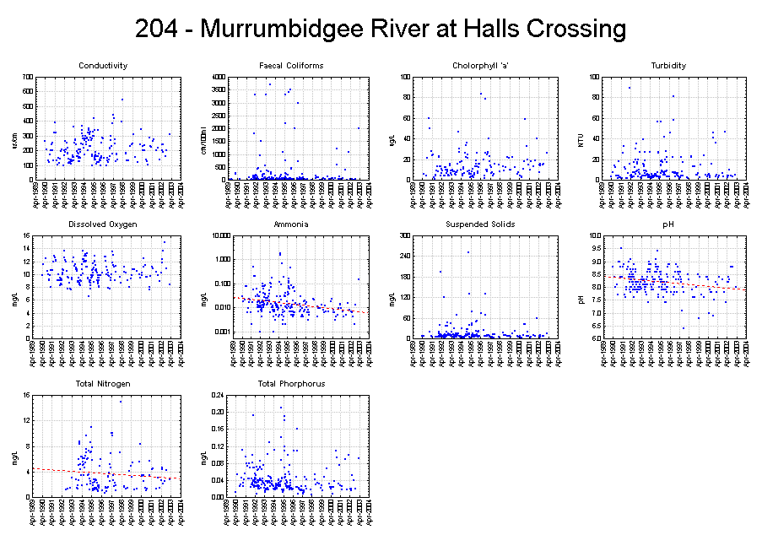
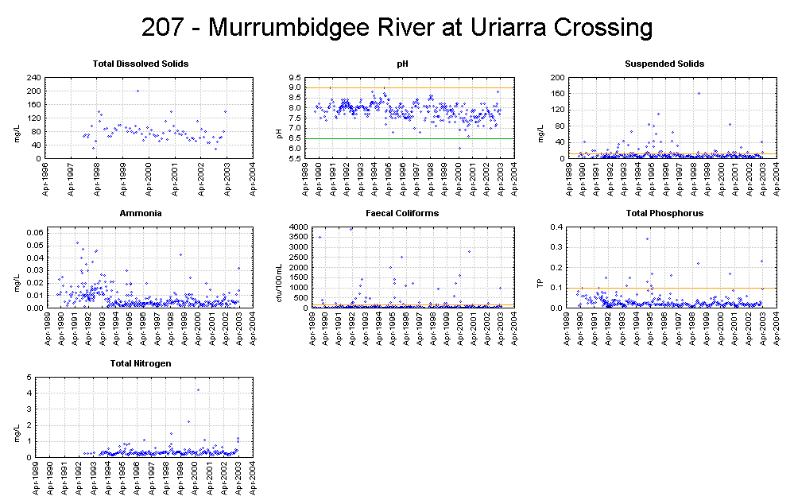
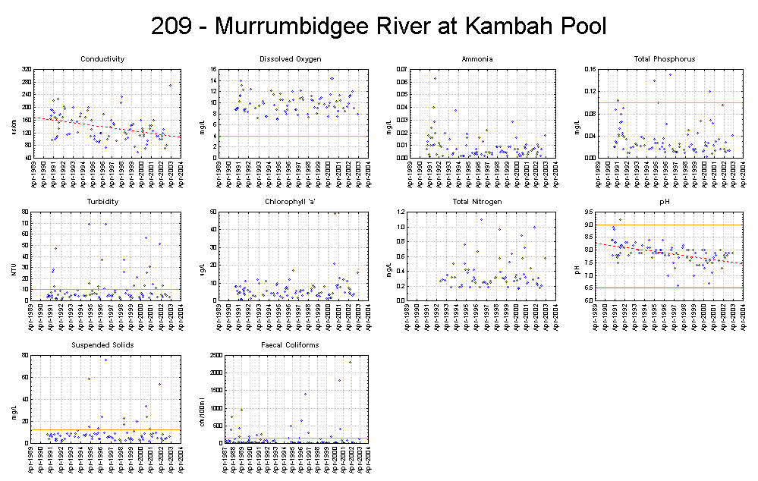
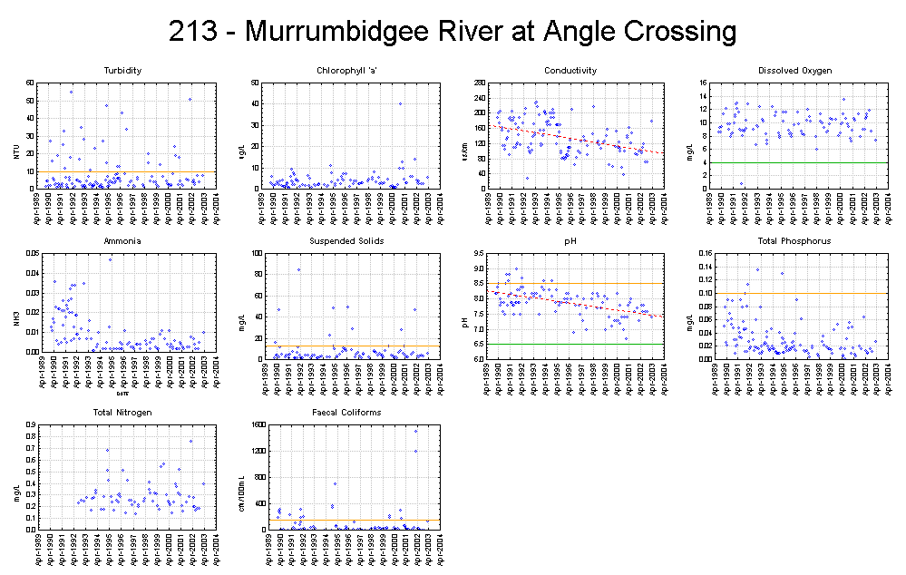
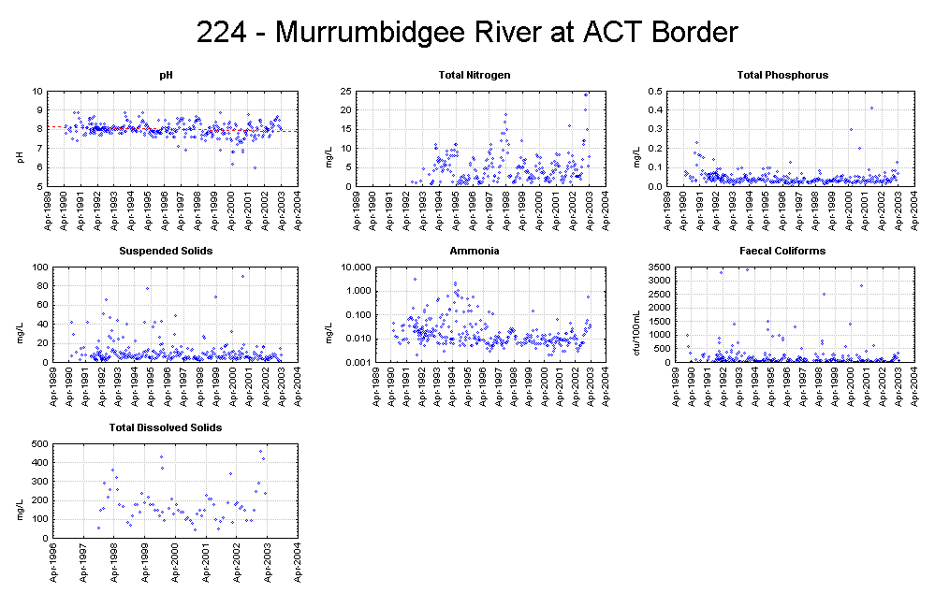
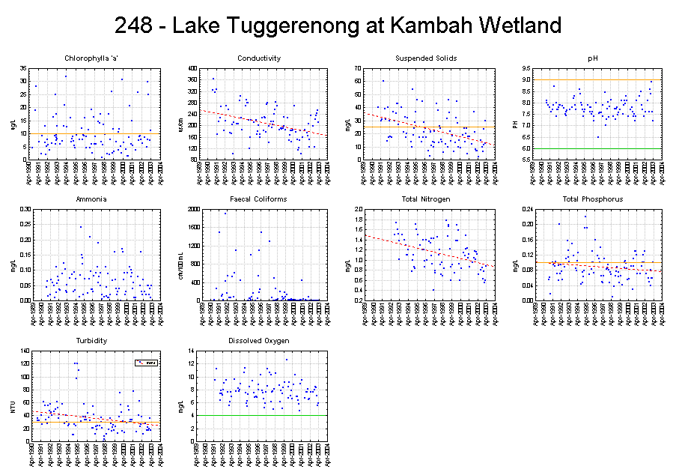
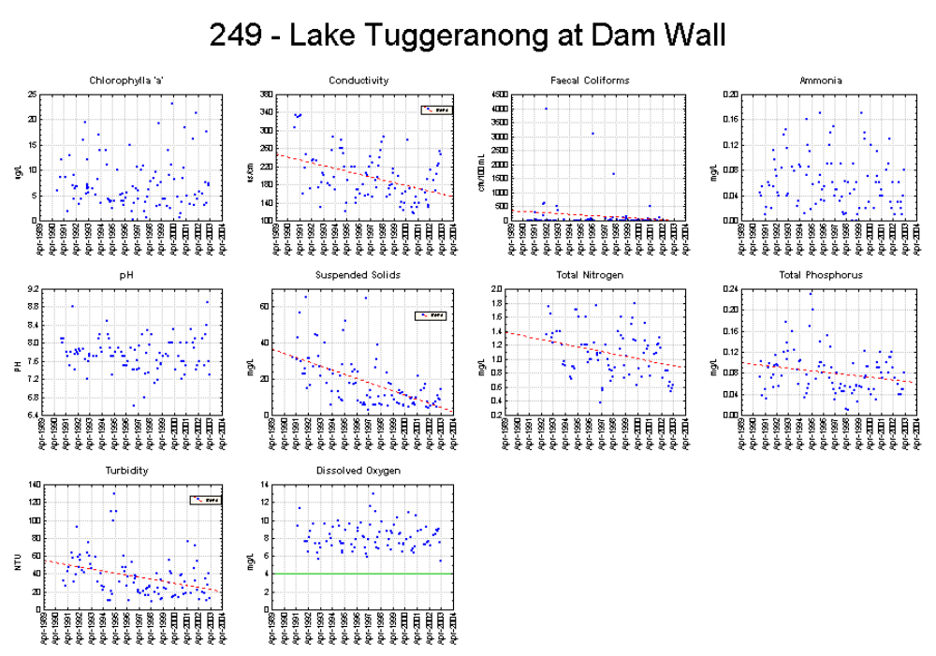
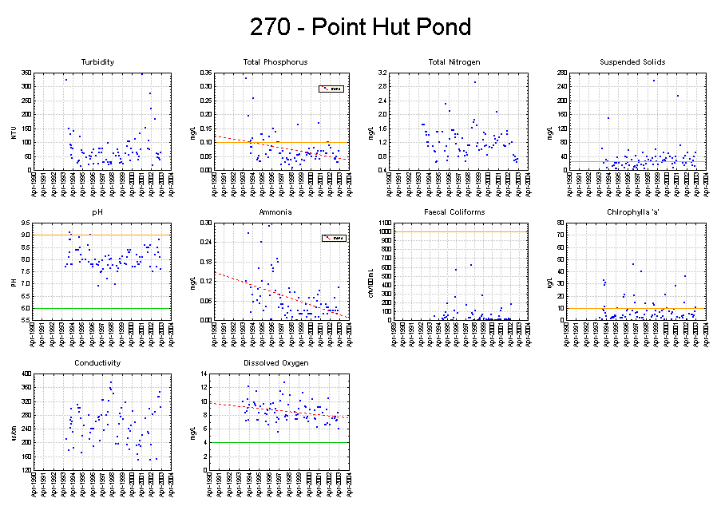
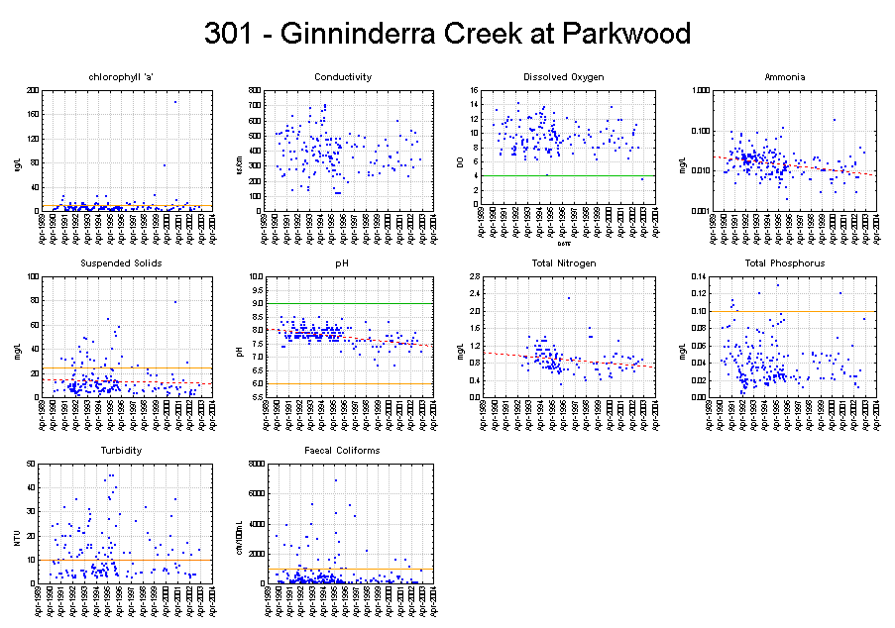
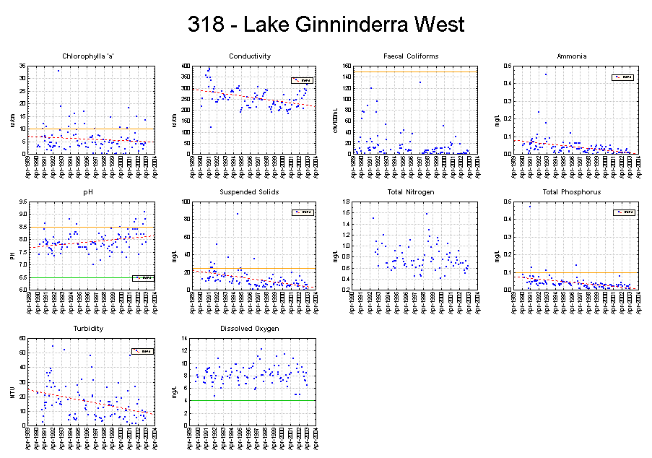
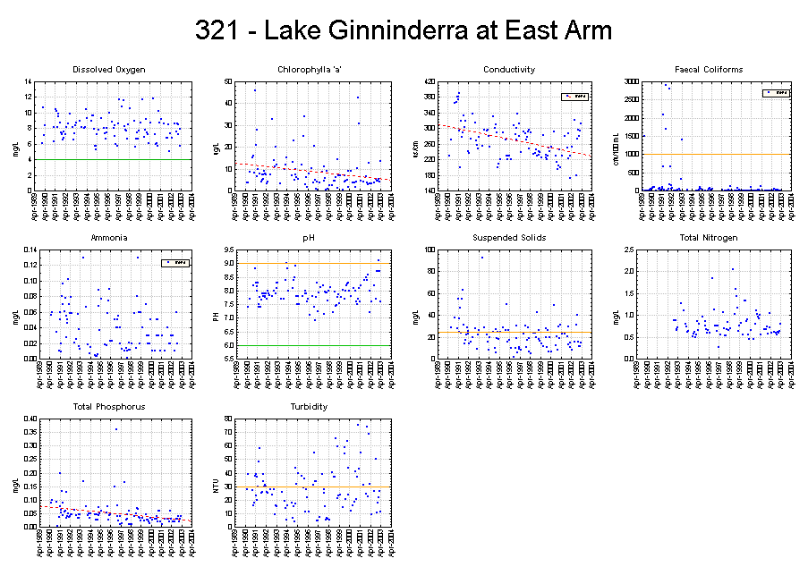
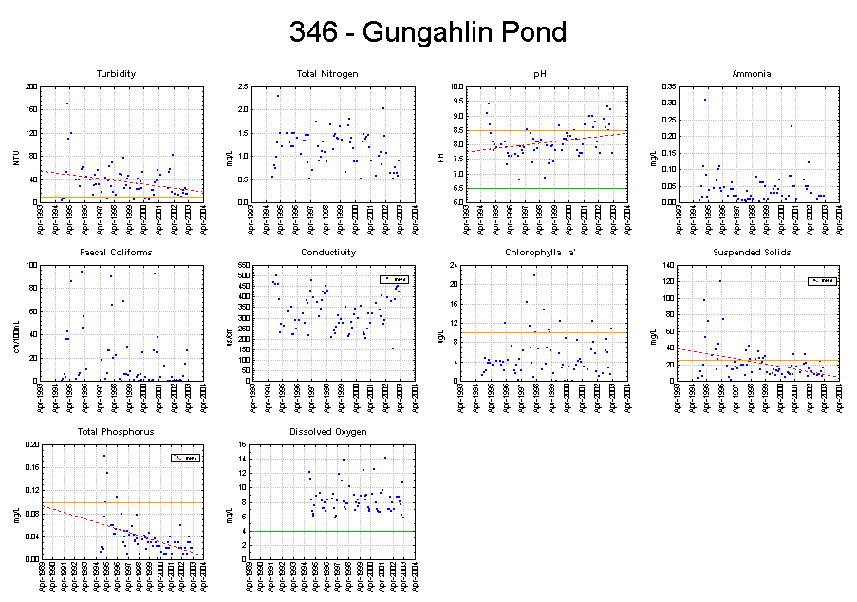
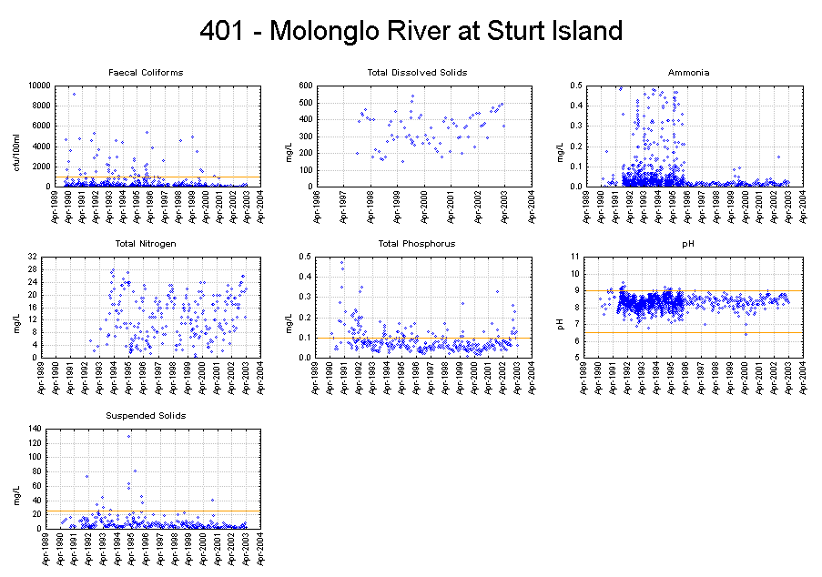
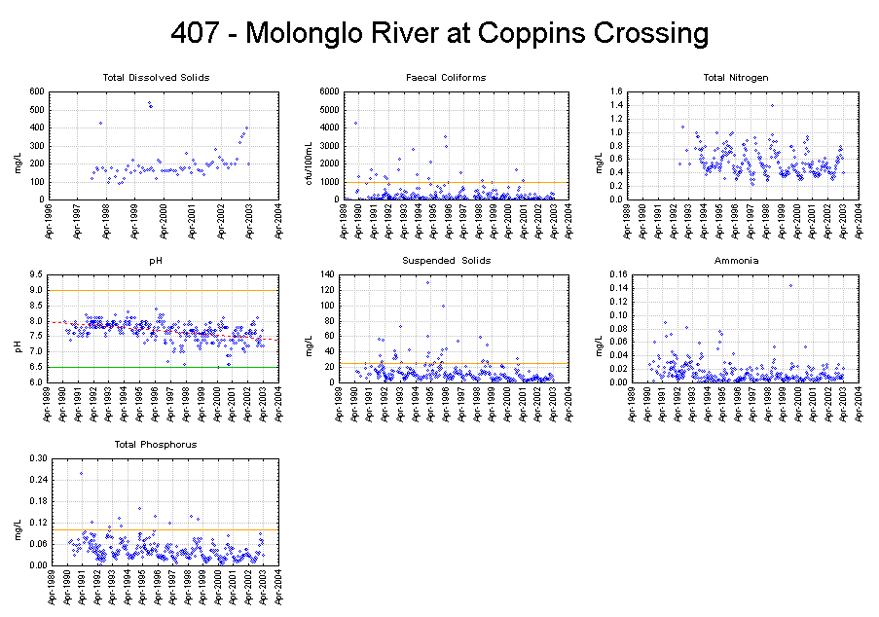
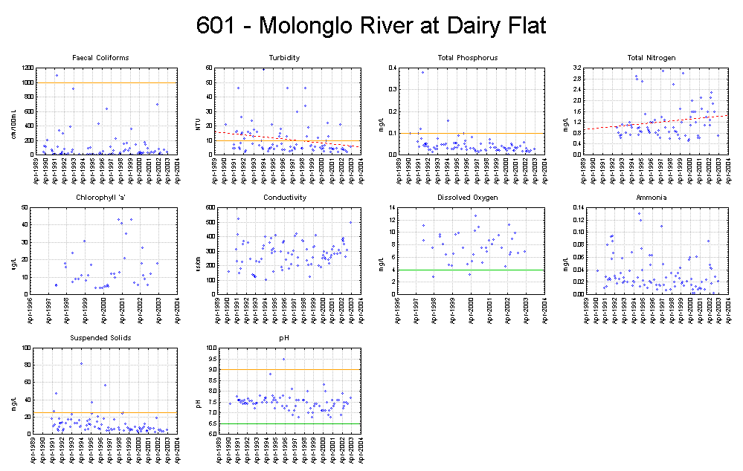
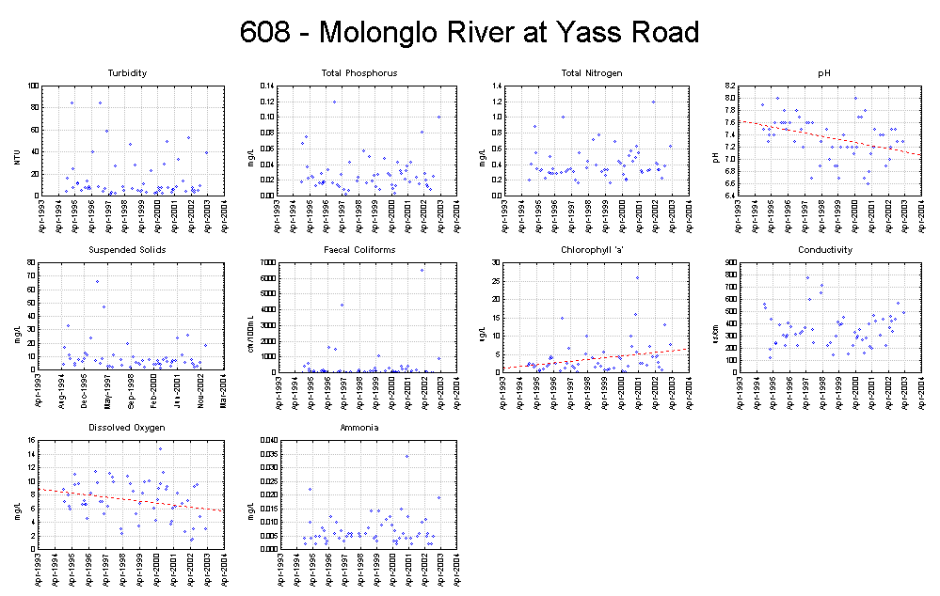
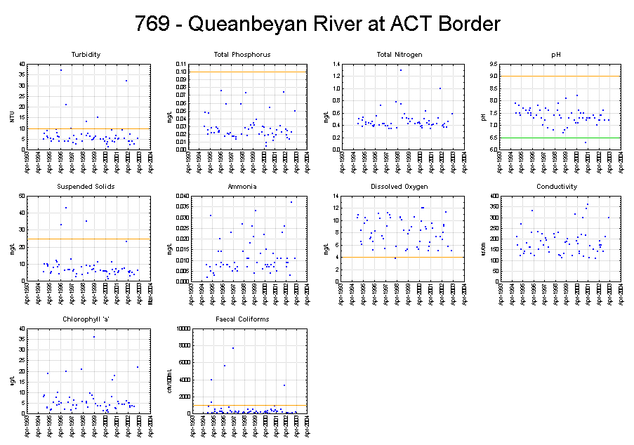
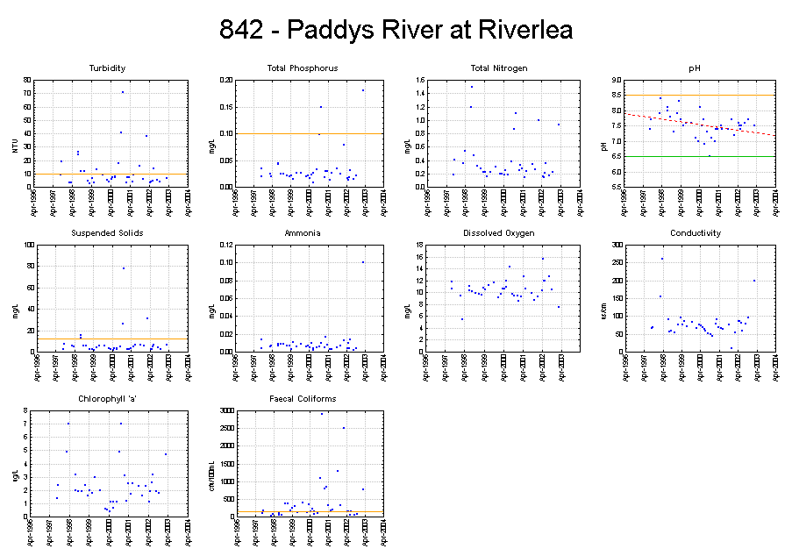
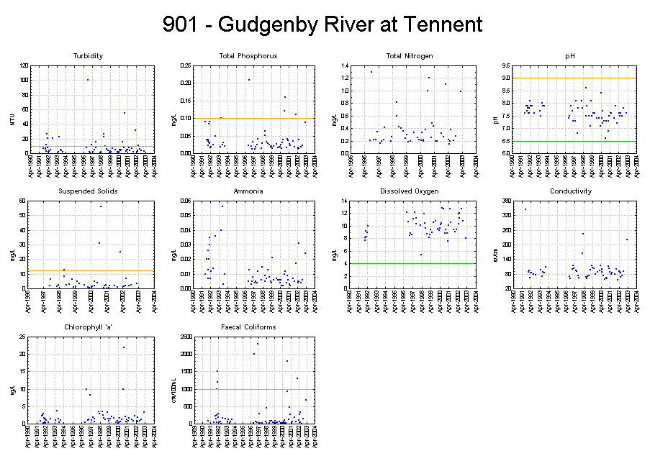

Environment ACT Bushfire Recovery Plan 2003, 27 March 2003.
Macroinvertebrate Component of the Environment ACT Water Quality Monitoring Program, CRC for Freshwater Ecology.
Licensed volume is unlikely to equal actual use in any one year as actual use is averaged over a three year period.
Licensed volume is unlikely to equal actual use in any one year as actual use is averaged over a three year period.
An allocation is not needed where groundwater is taken from a lease that is dated before11 December 1998.
Environment ACT has concerns that the method used to calculate the environmental flow releases for the Cotter River does not accurately reflect true stream flows in the catchment. The method will be reviewed in 2004 as part of the review of the Environmental Flow Guidelines.

