Further Information:

Should you wish to seek further information in relation to this report, please contact:

Greg Keen
Water Unit
Environment ACT
Telephone: 6207 2350
Facsimile: 6207 6084
Email: greg_keen@dpa.act.gov.au

Contents
List of Figures
List of Tables
Executive Summary
Introduction
Purpose
Scope
Landuse
Climate
River and Land Formation
The Territory Plan and Water Quality Guidelines
ACT Government responsibilities in relation to water quality
Monitoring program
Sampling Sites
Water Quality Condition
Analysis
Indicators
Nutrients
Suspended solids
Faecal Coliforms
Turbidity
pH (Acidity and Alkalinity)
Ammonia
Dissolved Oxygen
Chlorophyll ‘a’
Lakes
Lake Tuggeranong
Point Hut Pond
Lake Ginninderra
Gungahlin Pond
Rivers
Ginninderra Creek
Paddys River
Gudgenby River
Murrumbidgee River
Molonglo River
Special Studies
Event Sampling
Ginninderra Creek Investigations
Waterwatch
ACT AusRivas Report
Assessment of Performance of Urban Pollution Control Measures
Appendix 1
Appendix 2

List of Figures

Figure 1: Land Use Catchment Map
Figure 2: Rainfall in Belconnen near Barton Highway
Figure 3: Flow in the Murrumbidgee River at Angle Crossing
Figure 4: Flow in Ginninderra Creek
Figure 5: Total Phosphorus and Suspended Solids Map
Figure 6: Total Nitrogen
Figure 7: Faecal Coliforms and Turbidity Map
Figure 8: pH and Ammonia Map
Figure 9: Dissolved Oxygen and Chlorophyll ‘a’ map
Figure 10: Lake Tuggeranong at Dam Wall
Figure 11: Suspended Solids in Lake Ginninderra
Figure 12: Ginninderra Creek at Parkwood
Figure 13: Suspended Solids in Murrumbidgee River
Figure 14: Total Nitrogen at Sturt Island on the Molonglo River

List of Tables

Table 1: Water Quality Guideline Values
Table 2: Flow Percentiles for Water Sampling

Executive Summary

The Department of Urban Services undertakes a water monitoring program for the ACT which includes water quality and streamflow information. Such information is used to determine whether waters in the ACT are of adequate quality and if the management strategies used to achieve or maintain such water quality are adequate.

This report provides the ACT community with the results of the program and the level of compliance with the ACT Water Quality Guidelines.

Water quality is monitored in the major urban lakes (with the exception of Lake Burley Griffin, a Commonwealth responsibility) and Lake Burrinjuck which is immediately downstream of the ACT. The major rivers and some urban streams are also monitored. River flow is measured at a number of sites throughout the ACT. This information is necessary for interpreting water quality data.

Rainfall for the period was below the long term average, reflecting the extended dry period that was experienced through late summer. As a result, streamflow was also below the long term average in the major streams and rivers.

The report uses the median value for the year as the measure of the average condition. The condition of water quality at the monitoring sites is assessed by comparison of the median value with concentrations listed in the water quality guidelines.

Trend analysis of data available between 1992 - 1997 has been carried out for sites with sufficient data for trends to be detected.

Water quality in the ACT for lakes and streams is generally good. The main impacts on water quality in the urban area are a direct result of land development with urban run-off carrying suspended sediment and nutrients.

In the Lake Tuggeranong and Lake Ginninderra catchments where development is stabilising, trends in turbidity and suspended solids are improving. In the developing catchments of Point Hut Pond and Gungahlin Pond, the water quality is showing signs of the impact of urban development with median turbidity values exceeding the guidelines at both sites.

Water quality in the Murrumbidgee River is quite good showing that the ACT has a minimal impact on the water quality in the river and that management practices appear to be effective in controlling pollution from the ACT. Water quality in the Molonglo River was also quite good with median values complying with the water quality guidelines at all sites monitored.
Introduction

Purpose

This report is intended to provide the ACT Community with information on the water quality in ACT lakes, rivers and streams for the year 1 April 1996 to 31 March 1997. In order to establish a more statistically significant analysis of water quality trends, the analysis has included data for the period 1992 to 1997.

The report is divided into three main sections, the first introduces the report and provides background information for interpreting the water quality data. The second section discusses the water quality condition. The indicators used are introduced and results discussed for the lakes and rivers in light of the Territory Plan and Water Quality Guidelines. The final section briefly discusses special water quality studies in the ACT region.

Scope

The waterways of the ACT are the focus of the report with the exception of the Cotter catchment and Lake Burley Griffin. The water quality of the Cotter catchment is not of significant concern because of the undisturbed nature of the catchment. Lake Burley Griffin is a Commonwealth responsibility and is the subject of an annual report produced by the National Capital Authority.

Landuse

There are four major land uses in the ACT (see figure 1). Conservation land use tends to have a minimal impact on water quality. Plantation forestry and agricultural use can have significant impacts on water quality where these activities result in soil erosion, or the release of agricultural chemicals and animal waste to water bodies. Urban areas have the greatest potential for impact on water quality per unit area. Materials entering urban waterways which are likely to impact on water quality include fertilisers and other chemicals, organic matter, soil, oil, and sewage effluent.

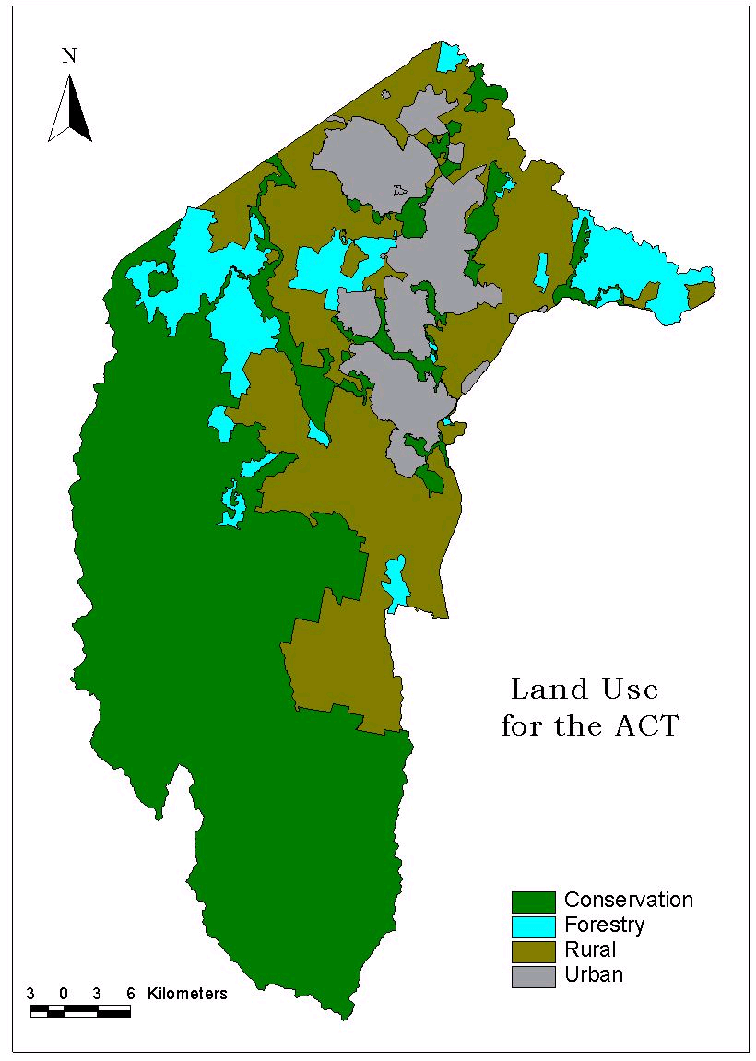
Climate

Rainfall in the ACT is strongly affected by the landform. In the mountainous region to the west of the Murrumbidgee, annual average rainfall ranges from 600 - 800 mm. The flatter tablelands on which Canberra is built are in a rain shadow area, and the annual rainfall reaches only 450 - 550 mm.
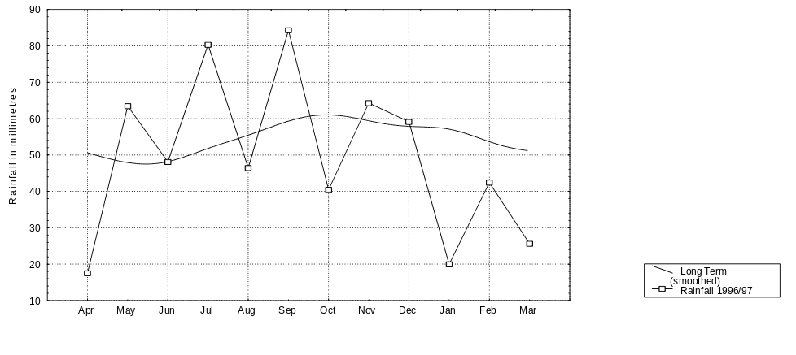
Figure 2: Rainfall in Belconnen near Barton Highway
Rainfall is measured by the ACT Government at a number of sites in the ACT. Rainfall for a site in Belconnen near the Barton Highway is presented in figure 2 and shows both the monthly rainfall over the period as well as the long term average. The long term average rainfall in Belconnen is 649 mm. The annual rainfall for the period was below this at 592 mm. This reflects the extended dry spell that was experienced through late summer.

Stream Flow

Stream flow during the period appeared generally below the long term average. Figure 3 of the flow in the Murrumbidgee River near Angle Crossing shows that the mean monthly flow did not exceed the long term average at any point. It also clearly illustrates the extended dry period that occurred during the summer of 1997. The lower than average flow in the Murrumbidgee River would be due to lower rainfall in the Upper Murrumbidgee Catchment.

In the case of Ginninderra Creek (figure 4), while rainfall for the period is below the long term average, gauged flows in Ginninderra Creek were above the long term average. There are a number of factors contributing to this higher than average flow. However, the major factor is the urbanisation within the catchment, which increases the amount of impervious area (roofs, roadway and other pavement) and associated runoff.
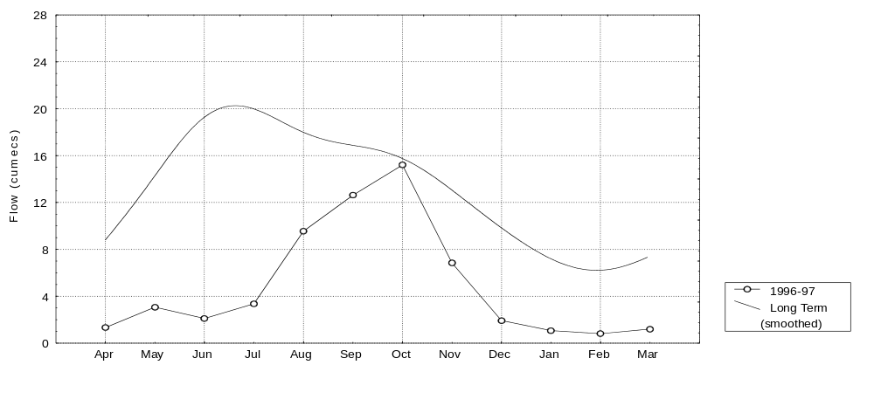
Figure 3: Flow in the Murrumbidgee River at Angle Crossing

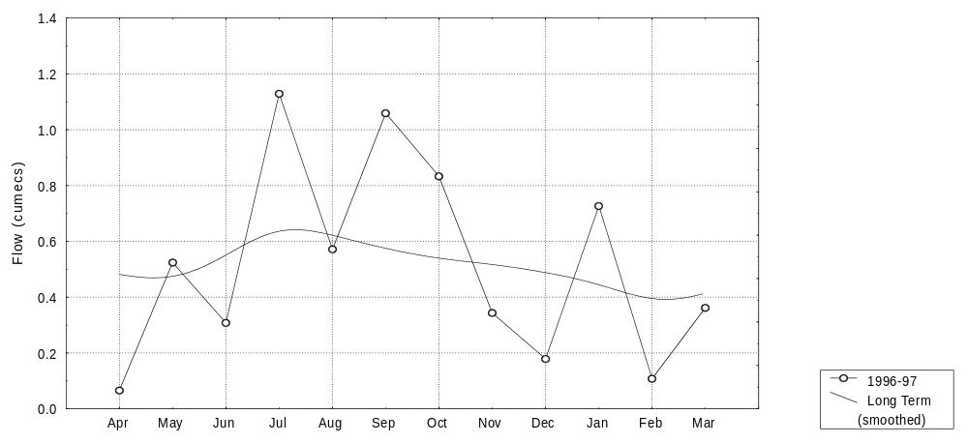
Figure 4: Flow in Ginninderra Creek

River and Land Formation

A number of the rivers and streams which flow through the ACT and National Capital Area (Lake Burley Griffin) arise in NSW. The Murrumbidgee arises well to the south of the ACT, and its headwaters are impounded by Tantangara reservoir. While there is collaboration between governments in an integrated catchment based approach to water and land management across the Upper Murrumbidgee Catchment, the management of flow and quality of waters within NSW and within the National Capital Area are the responsibility of the NSW and Commonwealth Governments respectively.

Soils in the ACT reflect the geology and rainfall. The clay subsoil is easily erodable, leading to surface and gully erosion with significant impacts on downstream water quality. Because of their greater depth, the soils of the lowland areas and valley floors can yield far more sediment than the shallow stony soils of the mountain slopes.

The Territory Plan and Water Quality Guidelines

The Territory Plan sets the designated uses for the waterways in the ACT. The Plan identifies three categories of water use and catchment policies. For each category the primary use or environmental value is identified (that is either conservation, water supply, or drainage and open space) as well as a range of secondary values which can be managed so that they are consistent with the primary value.

Water quality necessary to support the various values is identified in the “ACT Water Quality Guidelines” (ACTPA, Oct 1995). These guidelines are a set of tables which list the necessary water quality to support each of the water uses referred to in the Territory Plan. Table 1 provides examples of the water quality standards for certain water uses.

 | Water Use
Variable | Water based recreation - swimming | Water based recreation - boating | Water supply - stock | Water supply - irrigation | Aquatic habitat - wetland
Total Phosphorus (mg/L) | 0.1 | 0.1 |  |  | 0.1
Turbidity (NTU) | not objectionable | not objectionable |  |  | 10 - 30 (depends on ecosystem)
Suspended Solids (mg/L) |  |  |  | so as not to block irrigation systems | 12.5 - 25 (depends on ecosystem)
Chlorophyll ‘a’ (µg/L) | 10 | 10 | 10 |  | 2 - 10  (depends on ecosystem)
Algal Cells Counts (cells/mL) | 5,000 | 5,000 | up to 10,000 depending on species |  | 5,000  (blue - green algae)
Bacteria (faecal coliforms/100mL) | 150 | 1,000 | 1,000 | 1,000
Dissolved Oxygen (mg/L) |  |  |  |  | >4
Acidity (pH) | 6.5 - 8.5 | 6.5 - 8.5 | 6.5 - 9.2 | 4.5 - 9.0 | 6 - 9  (depends on ecosystem)
Total Dissolved Solids (mg/L) |  |  | 3000 | 500
Table 1: Water Quality Guideline Values

ACT Government responsibilities in relation to water quality

Department of Urban Services have established a water monitoring program for the ACT which includes water quality and hydrographic information. Such information is used to determine whether waters in the ACT are of adequate quality, and if the management strategies used to achieve or maintain such water quality are adequate. The information is not intended to identify specific pollution incidents.

Monitoring program

The data for this report is sourced from the ACT Government water quality monitoring program and licensed dischargers who are required to provide data under licence conditions. The ACT Government program is based on regular sampling for the lakes on a time series basis while river monitoring sampling is based on stream flow, allowing a snapshot of the concentration of the various indicators at specified levels of river flow.

Samples are collected within four flow percentile groupings as indicated below (see table 2). The 5 percentile flow is the flow exceeded only 5% of the time, i.e. very high flow, inversely the 90 percentile flow indicates very low flow.

Flow Percentile Group | Number of Samples
5 - 29 | 2
30 - 49 | 2
50 - 69 | 2
70 - 89 | 2
Table 2: Flow Percentiles for Water Sampling

Flow percentile based monitoring in the case of streams enables a more cost effective characterisation of water quality than time based monitoring, where streamflow is the major determinant of quality.

The ACT Government monitoring program may be divided into two areas - lakes and rivers. The major urban lakes (with the exception of Lake Burley Griffin) are monitored as well as Lake Burrinjuck, which is immediately downstream of the ACT.

The major rivers and some urban streams are also monitored. Not all urban streams are included as many have little flow for most of the year and may not be indicative of general stream condition.

In addition, river flow is measured at a number of sites throughout the ACT. This information is valuable for interpreting water quality data. Most of the pollutants that wash off streets and fields do so during the few intense rainfall events that occur each year. In conjunction with water quality monitoring, river flow allows for the calculation of pollutant loads.

Sampling Sites

Sites are located so as to be representative of stream and lake conditions in the ACT. It is not possible to monitor all sites of interest, consequently those considered most representative of environmental conditions are selected with the intention of generalising to other similar areas. The site locations can be seen on the indicator maps.
Water Quality Condition

Analysis

For individual indicators, the report uses the median value for the year. The median is the middle value in a list of the results ordered from lowest to highest. The median is seen as the most useful measure of the “average” condition as it is less affected by extremely high or low values than is the mean. The mean is strongly biased by the infrequent extreme conditions that may occur in water bodies.

The condition of water quality at the monitoring sites can be assessed by comparison of actual concentrations with concentrations listed in the water quality guidelines described earlier. Appropriate values from the water quality guidelines are shown in Table 1.

The data for the various indicators has been presented on a number of maps. Some sites have been coded as good, fair or poor relative to the guideline value. A good classification is rated where a site is well within the guideline value for the particular indicator. A fair classification occurs where the value is on the threshold of the guideline and a poor classification occurs where a site noticeably exceeds the guideline value.

Trend analysis of data available between 1992 to 1997 has been carried out for sites with sufficient data for trends to be detected. This period corresponds with flow based monitoring of rivers and creeks. Prior to this period, monitoring was carried out at regular intervals with no reference to flows and as such it is not appropriate to compare the data.

Indicators

Nutrients
Nutrients are a natural component of all water bodies, but increases in the nutrient supply often have undesirable effects including the eutrophication of aquatic ecosystems. Eutrophication is the presence of an abnormally high quantity of aquatic plant life and can include toxic algal blooms. This can also produce other unwanted side-effects, for example, low dissolved oxygen levels in the water.

The two most important plant nutrients for aquatic ecosystems are phosphorus and nitrogen. In ACT waterbodies phosphorus is the nutrient that commonly determines the amount of algae that can occur. Total phosphorus is the measurement of the total quantity of phosphorous in the water column. Values ranged from 0.014 mg/L at Angle Crossing to 0.1 mg/L at both Lake Tuggeranong and Point Hut Pond. The Guideline value is 0.1 mg/L.

Total nitrogen ranged from 0.22 mg/L at the Gudgenby River to 8.75 mg/L at Sturt Island on the Molonglo River. Nitrogen is not generally a limiting factor in algal growth in regional waters and it is non-toxic to other organisms. The levels of nitrogen measured at Sturt Island are typical of waters downstream of a sewage treatment plant where plant discharge forms a high proportion of stream flow. In situations where nitrogen is limiting, research indicates a potential for encouragement of the growth of nitrogen fixing blue-green (scum and toxicant forming) algae. In these situations, the discharge of nitrogen in sewage effluent with limitations on phosphorus, will discourage the growth of nitrogen fixing blue-green algae. In addition, the discharge of nitrogen (with the formation of nitrate) can have a beneficial effect by restricting the release of phosphorus from lake or reservoir sediments.

In this context, management and licensing arrangements in the ACT concentrate on minimising the input of phosphorus to waterways. There is no guideline value for total nitrogen for the ACT.

Suspended solids
All streams and rivers naturally carry some suspended material as organic and inorganic particles of a range of sizes. Most land uses and activities have the potential to alter, usually increase, suspended solids concentrations in streams. An increase in the concentration of suspended solids can have two major impacts on aquatic ecosystems. Firstly, higher concentrations of suspended solids reduce the light penetration of water, reducing plant growth and changing the type of algae present. Secondly, increases in suspended solids concentrations ultimately result in increased sedimentation in streams and lakes, smothering the plants and animals living on the bottom.

Suspended Solids median values ranged from 2.8 mg/L at Tennant on the Gudgenby River to 17.45 mg/L at Parkwood on Ginninderra Creek. The guideline value is 25 mg/L.

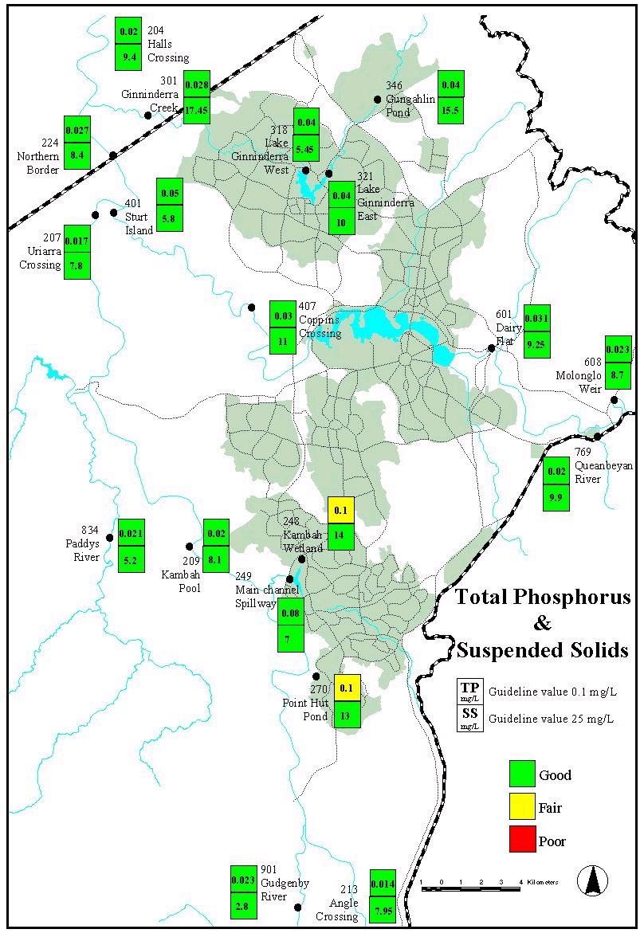

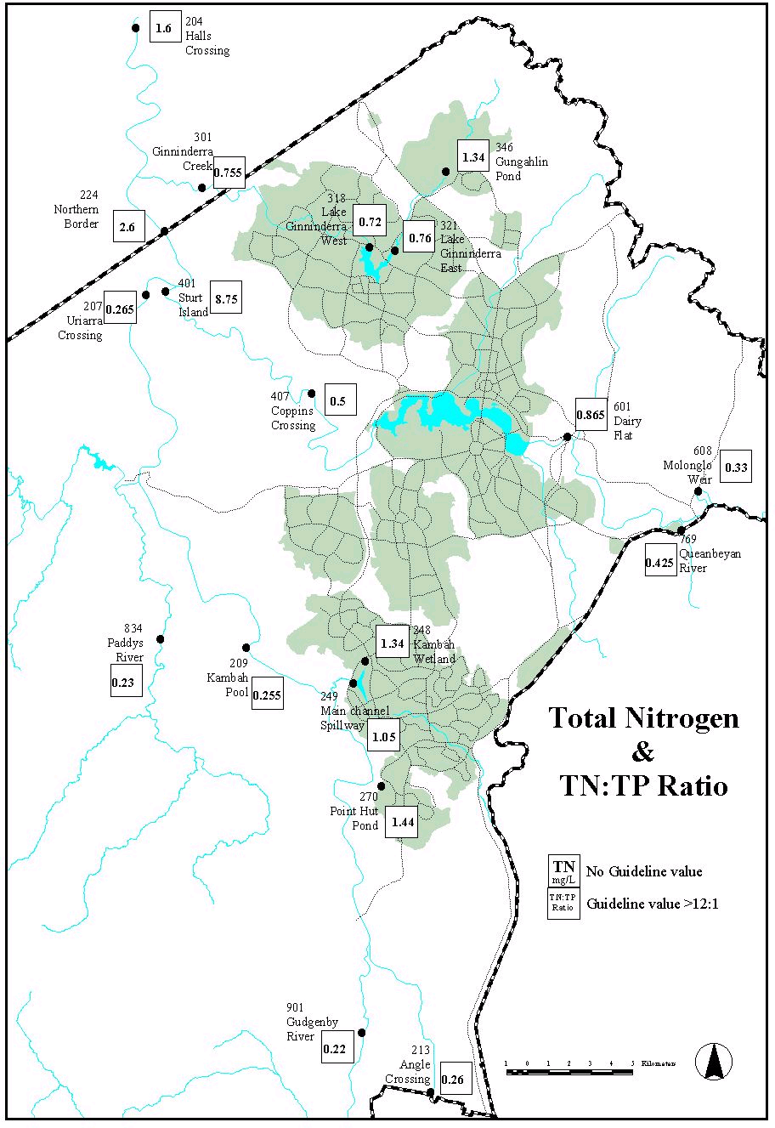
Faecal Coliforms
Bacteria occur naturally in all waterbodies. Only bacteria of faecal origin are monitored in the sampling program. The presence of faecal coliforms in a water sample is an indication that the water has been contaminated by human or animal faeces, and consequently that more harmful, less easily detectable pathogens may be present. High levels of faecal coliforms are not necessarily a problem for aquatic ecosystems. Faecal coliforms generally do not infect aquatic organisms, and may in fact serve as a food source.

Presence of high numbers of faecal coliforms is a problem for some human uses of water bodies, particularly water supply and recreation involving bodily contact. This report looks at bacterial levels in water used for primary contact recreational use, but does not deal with the quality of tap water.

Results are expressed as colony forming units (cfu) per 100 mL. Median values ranged from 4 cfu/100 mL at Lake Tuggeranong at the dam wall to 780 cfu/100 mL at Ginninderra Creek at Parkwood. The guideline value for recreational use is 150 cfu/100 mL.

Turbidity
Turbidity, or opacity, of a water body is related to the suspended solids concentration because it is affected by any sediment in the water, but also includes colouration. A stream may have very low quantities of suspended material but be strongly coloured, for example the tannin rich streams in Namadgi National Park. Turbidity has an important ecological effect in determining the depth to which light penetrates the water, affecting plant growth and changing the type of algae present.

Turbidity data are reported in Nephelometric Turbidity Units (NTU). To provide a sense of scale, water with a turbidity of 1 NTU is crystal clear, water at 5 NTU has a tiny trace of discolouration, and water at 100 NTU is brown and opaque.

Median Turbidity values ranged from 3.65 NTU at Tennant on the Gudgenby River to 64.6 NTU at Point Hut Pond. The guideline value is less than 10 NTU for rural streams and rivers and less than 30 NTU for urban lakes and ponds.

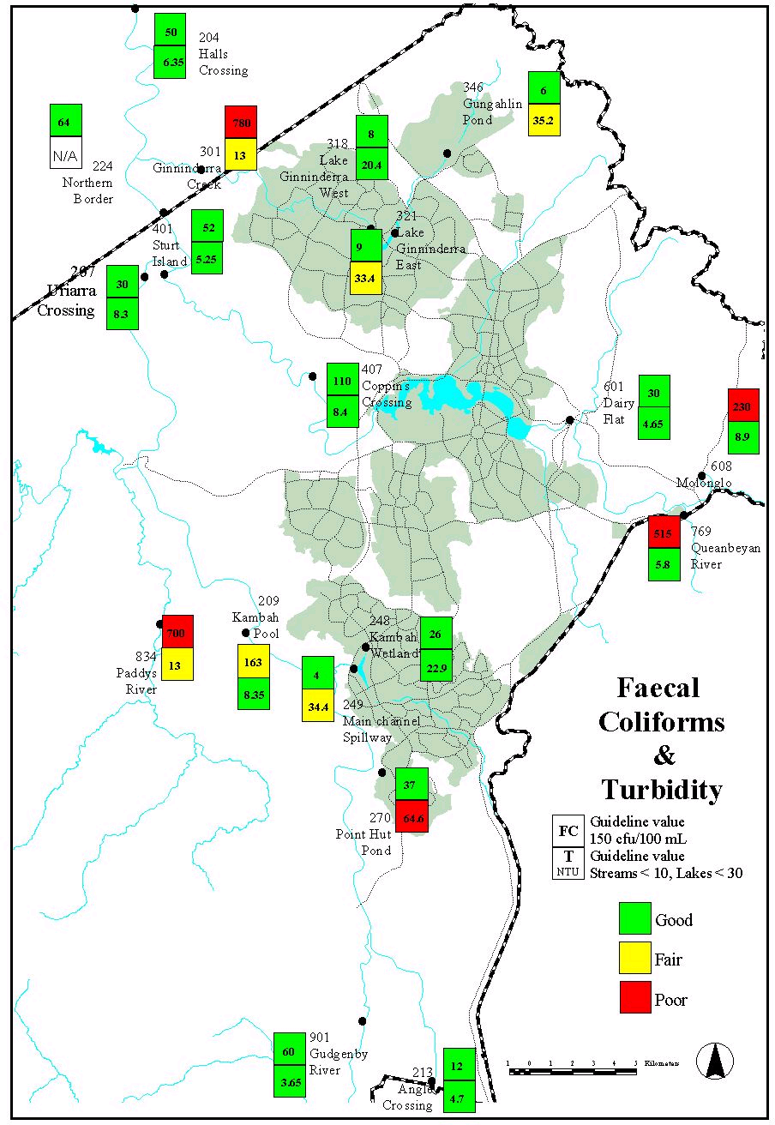
pH (Acidity and Alkalinity)
The pH refers to the degree of acidity or alkalinity of a substance. A pH of 7 is neutral. A value above 7 indicates that the water is more alkaline with a pH below 7 indicating acidic conditions. It is generally accepted that the range pH 5-9 is acceptable for aquatic ecosystems.

Median values ranged from 7.2 at Dairy Flat on the Molonglo River to 8.4 at Sturt Island on the Molonglo River. The guideline value is 6.5 - 9 for rural streams and rivers and 6 - 9 for urban lakes and ponds.

Ammonia
Ammonia concentrations are generally related to the level of suspended and sedimented organic material in water and whether conditions exist which are conducive to ammonia formation. These conditions are exacerbated by the direct discharge of ammonia in municipal sewage or industrial waste water. The toxicity of ammonia (un-ionised component) is a function of the pH and the temperature of the water.
The median Ammonia concentrations ranged from 0.0035 mg/L at Angle Crossing on the Murrumbidgee River to 0.09 mg/L in Lake Tuggeranong. The guideline value is calculated from a table and is dependent on the pH and temperature of the water at the time of the sample. There is no indication that these results are beyond the guideline values.

Dissolved Oxygen
Dissolved oxygen (DO) is a measure of the oxygen in the water available to aquatic organisms. It is important for the maintenance of aquatic organisms as changes in DO can affect the species present. Low levels of DO can result in fish kills. Levels of DO are affected by turbulence, temperature (colder water can hold more dissolved oxygen), photosynthesis (during periods of sunlight algae produce oxygen while in darkness they consume oxygen) and the level of biochemical oxygen demand.

The Median DO concentrations ranged from 7 mg/L at the Kambah Wetland in Lake Tuggeranong to 10.5 mg/L at Sturt Island on the Molonglo River. The guidelines require DO to be greater than 4 mg/L.

Chlorophyll ‘a’
Chlorophyll ‘a’ is the plant pigment that gives algae their green colour, and is commonly used as a measure of the quantity of algae present (algal biomass). This measure can therefore serve as a useful indicator of the extent to which an ecosystem has been affected by nutrient inputs.

Chlorophyll ‘a’ is measured in micrograms per litre (μg/L). To provide a sense of scale, water with a chlorophyll ‘a’ concentration of 1 μg/L will be clear, a concentration of 20 μg/L will be slightly green, and 100 μg/L very green and possibly with algal scums on the surface.

Median Chlorophyll ‘a’ concentrations ranged from 1.3 μg/L at Gudgenby River and Paddys River to 23 μg/L at Halls Crossing. There is no guideline value for streams and rivers in the ACT while a guideline value of less than 10 applies for urban lakes and ponds.

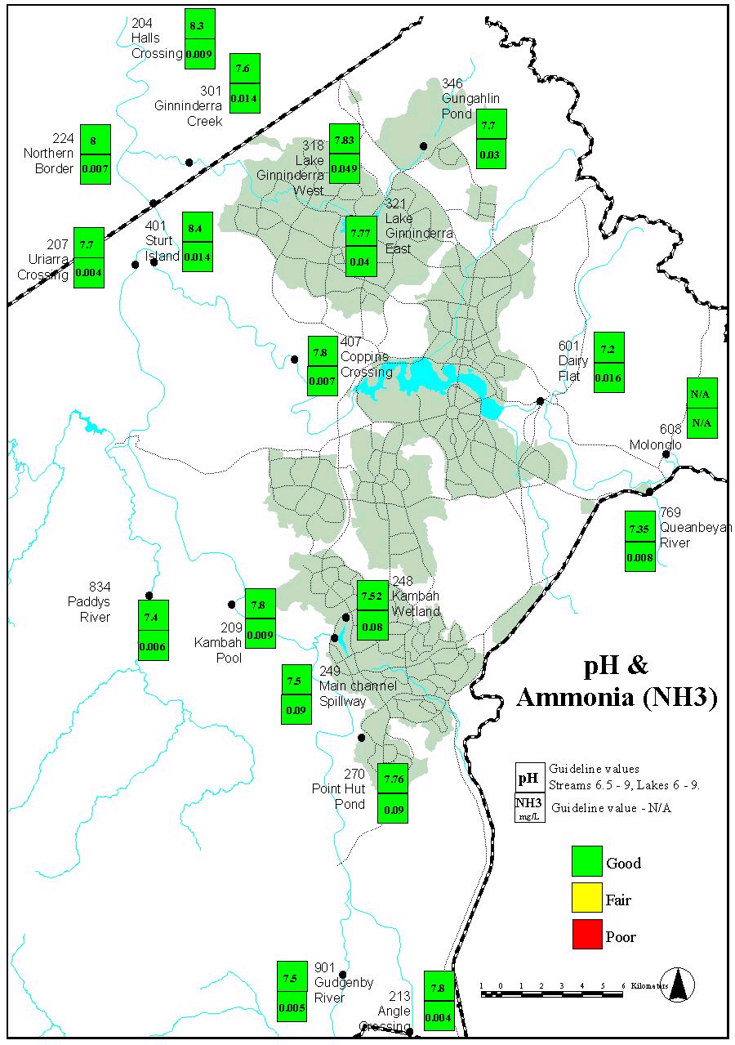
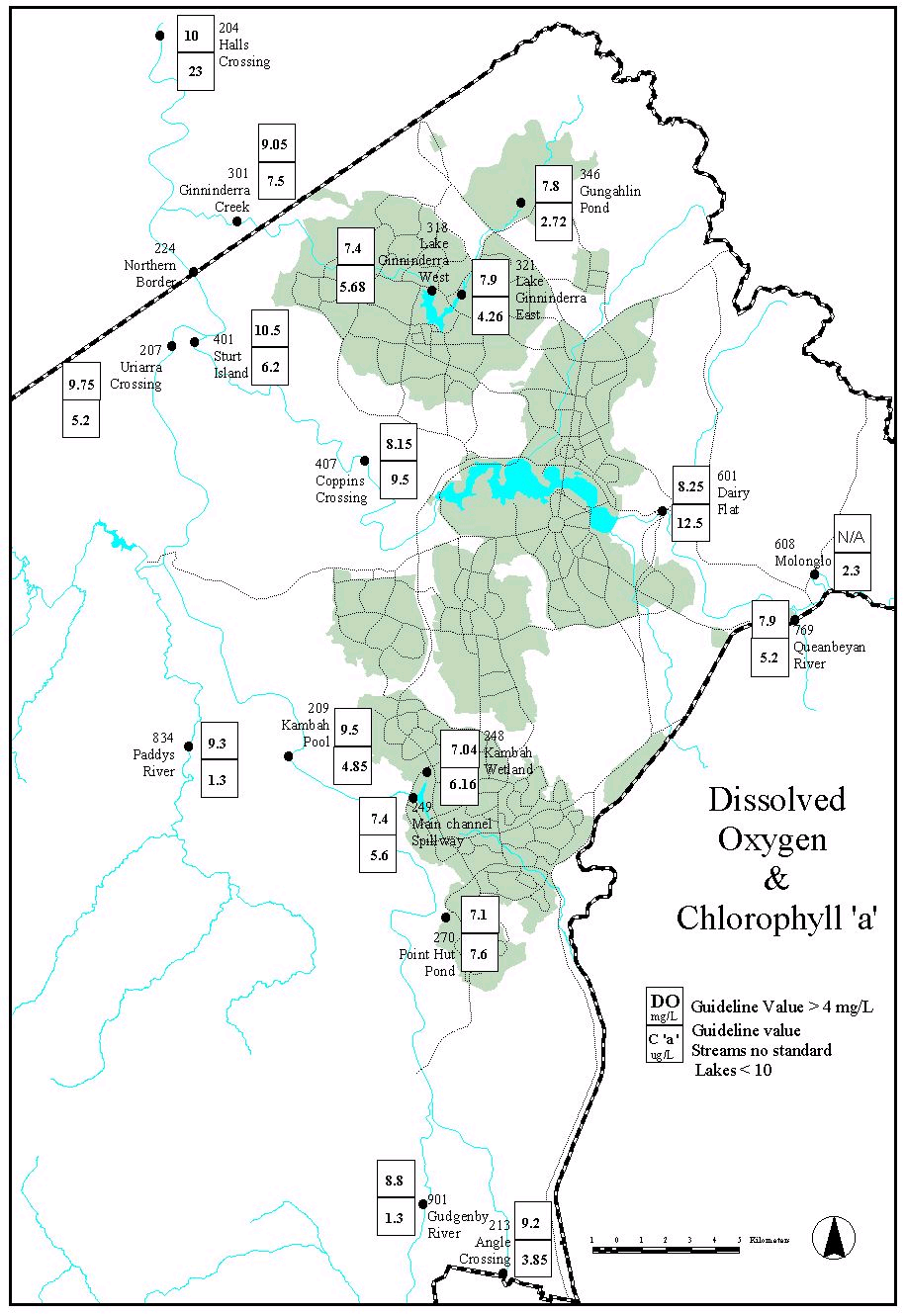
Lakes

Lake Tuggeranong
Two sites are monitored in Lake Tuggeranong, one at the Kambah Wetland (northern end of the lake) and the other at the dam wall. Water quality is generally good with the main exception being turbidity at the dam wall with a median value of 34 NTU. This high turbidity may be related to wave action as the site is more exposed than the Kambah Wetland site. Algae also have an affect on turbidity levels and may be a contributing factor.

The concentration of suspended solids was higher at the Wetland site and decreased from 14 mg/L to 7 mg/L at the dam wall indicating that the lake is effectively removing suspended solids from the water column (figure 10). All other indicators measured were within the guideline value.

Lake Tuggeranong experienced a blue-green algae bloom significant enough to close the lake for a short period during January 1997. On another occasion a warning was issued for high levels of algae, however it was not significant enough to close the lake.

Trend analysis over a five year period indicates that water quality in Lake Tuggeranong appears to be improving as the catchment stabilises after extensive development since the mid-eighties. Turbidity, suspended solids, total nitrogen and conductivity (dissolved salts) are all gradually reducing in concentration.
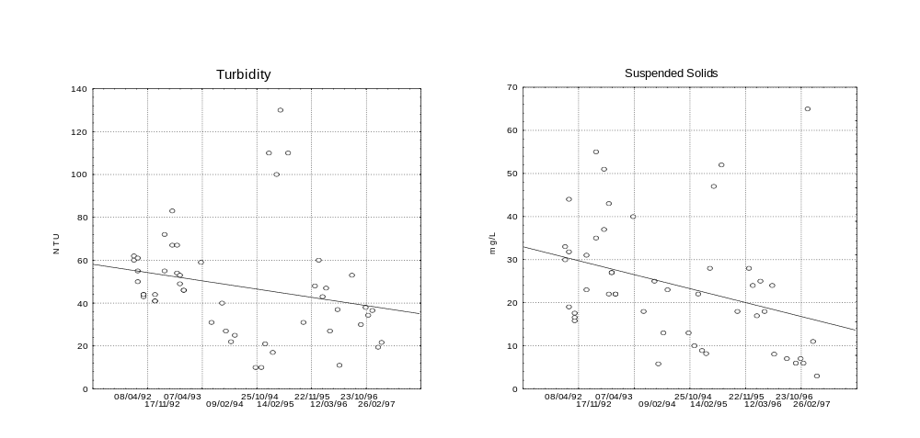
Figure 10: Lake Tuggeranong at Dam Wall

An increase in the clarity of the water can result in a corresponding increase in blue-green algae numbers particularly where there is a likelihood of release of stored nutrients from the sediments. However, blue-green blooms have declined over the past five years in Lake Tuggeranong. As there are many factors involved in the development of blue-green algae blooms including weather conditions, it is difficult to explain the trend or to predict the incidence of future blooms.

Point Hut Pond
Point Hut Pond is monitored at a site adjacent to the dam wall before the water discharges to the Murrumbidgee River. Water quality in the pond is fair with the guideline value exceeded for turbidity and the median value for Total Phosphorus equal to the guideline value at 0.1 mg/L.

Several factors may be causing these high values. The considerable urban development adjacent to the pond has the potential to increase the suspended sediment and carriage of nutrients used in fertilisers and from human and animal waste products. A second factor is the wind driven wave action to which the pond is particularly susceptible because of its shallow nature and minimal vegetation around the margins.

The elevated level of phosphorus may be caused by the use of fertilisers in establishing gardens in the catchment and the increase in suspended solids. Point Hut Pond is a relatively new lake and has not yet reached its full nutrient removal potential. All other indicators were within the guideline values.

Point Hut has only been monitored since 1994 and shows no change in water quality over this period.

Lake Ginninderra
Two sites are monitored in Lake Ginninderra, one below the Naval Station in the East Arm and the other at the dam wall. Water quality in the lake was quite good and generally better than the other lakes monitored with the only exception being a turbidity value of 33.4 NTU at the East Arm. This may be due to the continuing development occurring upstream in the catchment as the value had decreased to 20.4 NTU at the dam wall. Correspondingly, suspended solids concentrations also dropped from 10 - 5.45 mg/L indicating that the dam is effectively removing suspended solids. All other indicators were within the guideline values.
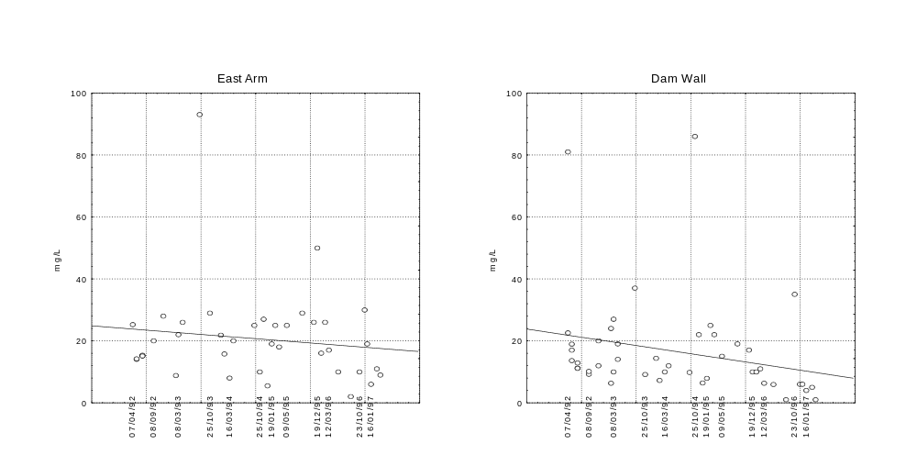
Figure 11: Suspended Solids in Lake Ginninderra
Figure 11 shows how both the concentration of suspended solids is reducing over time, and as it flows through the lake.

Trends over a five year period indicate that turbidity and suspended solids in Lake Ginninderra are generally dropping. This long term decline may be partly explained by a decline in the rate of development in Gungahlin, together with stabilisation of new development. It also indicates the effectiveness of Gungahlin Pond in reducing sediment levels.

Gungahlin Pond
This pond suffers from a similar situation to Point Hut with a median turbidity in excess of the guideline value, the total phosphorus concentration however is not as high. As with Point Hut, residential development is continuing within the Gungahlin catchment and the erosion from development sites would contribute to the high turbidity. The level of suspended solids, while within the guideline value, was higher than most other sites monitored and may reflect the effects of urban development. All other indicators were within the guideline value.

Trend analysis over the past five years indicates no noticeable change in water quality.

Rivers

Ginninderra Creek
Water quality in Ginninderra Creek is the subject of a special section later in this report detailing investigations that occurred between April 1995 and February 1997. During this reporting period the main issue for the site sampled is turbidity and suspended solids (figure 12). As discussed for Lake Ginninderra and Gungahlin Pond, the continuing residential development would be a factor in the high levels in Ginninderra Creek.

The increased flow in the creek as shown in figure 4, are likely to be contributing to the high turbidity and suspended solids levels.

Trends over a five year period indicate that turbidity and suspended solids are increasing slightly in Ginninderra Creek downstream of the confluence with Gooromon Ponds Creek. This is probably the result of greenfields development in West Belconnen over this period.

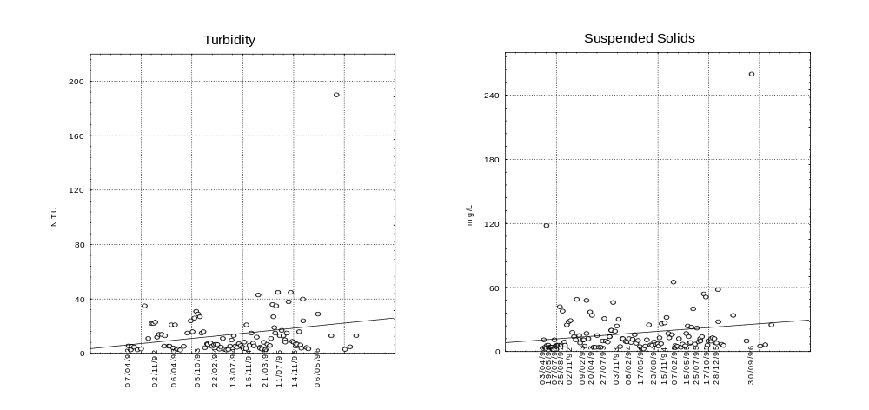
Figure 12: Ginninderra Creek at Parkwood

Paddys River
Water is sampled at Flints Crossing on Paddys River. Although the water quality was generally good, turbidity and faecal coliform median values exceeded the guideline. The median value for turbidity was 13 NTU, exceeding the guideline value of 10 NTU for rural rivers and streams. Paddys River may experience erosion from rural leases or forestry practices. The elevated levels of faecal coliforms may also be a result of rural run off carrying the faeces of grazing and native animals.

The TN median concentration was the second lowest (0.23 mg/L) and the TP median concentration also one of the lowest (0.021 mg/L) compared with the other sites monitored. With the low nutrient concentrations there is little possibility of an algal bloom.

Trend analysis is not possible for Paddy’s River as monitoring has only been carried out at this particular site for one year.

Gudgenby River
The Gudgenby is a rural catchment that comprises predominantly native forest and registered the lowest median concentration for a number of indicators. The water quality generally is quite good. It is worth noting that the TN median concentration was the lowest (0.22 mg/L) and the TP median concentration was also one of the lowest (0.023 mg/L) compared with the other sites monitored. At such low concentrations there is little possibility of an algal bloom.

There is not a noticeable change in water quality over the past five years.

Murrumbidgee River
The Murrumbidgee River is sampled at a number of sites between Angle Crossing at the southern ACT Border and Halls Crossing north of the ACT Border. The water quality at all sites is quite good with median values for the indicators complying with guideline values at all sites, except Kambah Pool. At this site, while the water quality generally is good, the median concentration of faecal coliforms is slightly above the guideline value for primary contact recreational use.

The good water quality is encouraging as it shows that the ACT has a minimal impact on the Murrumbidgee River and that management practices including sediment retention ponds and building development licensing appear to be effective in controlling pollution from the ACT.

Trend analysis indicates that suspended solids and turbidity have increased slightly in the Murrumbidgee River at the ACT/NSW border upstream of the ACT and at Kambah Pool over the past five years (figure 13). At Uriarra Crossing (upstream of the confluence with the Molonglo River) suspended solids have also increased slightly although ammonia and total dissolved solids have decreased slightly. The catchments for these sections of the river comprise mainly rural land use. These trends may be explained by abnormal rainfall patterns or natural variation in the river.
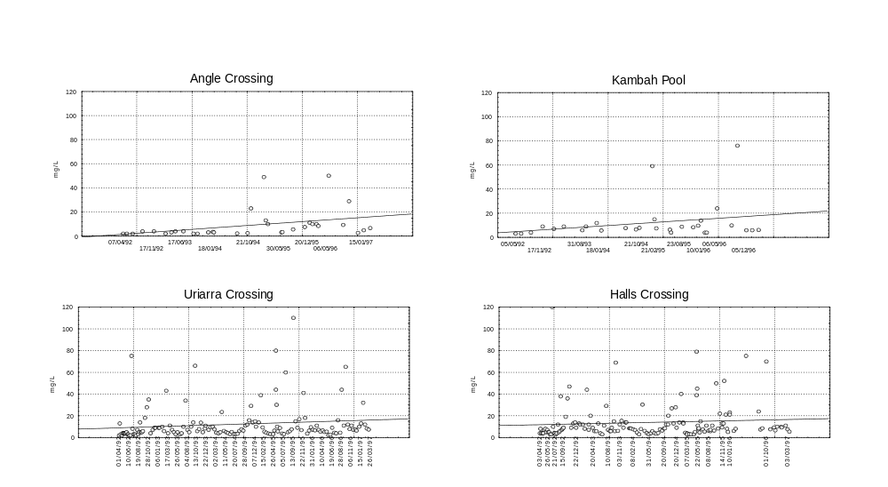
Figure 13: Suspended Solids in the Murrumbidgee River

Water quality in the Murrumbidgee River as it leaves the ACT shows no noticeable change over the past five years other than an increase in total nitrogen. This trend is reversed further down the Murrumbidgee at Hall’s Crossing where total nitrogen is decreasing. Total nitrogen in the discharge from LMWQCC has gradually decreased over this period.

Molonglo River
The Molonglo River is sampled at two sites above Lake Burley Griffin and two sites below Lake Burley Griffin before it enters the Murrumbidgee River. At all sites the median values comply with the guideline values. The most noticeable change in water quality between the sites is the sharp rise in TN due to the effluent from the Lower Molonglo Water Quality Control Centre which discharges to the Molonglo River 1 Km upstream of the confluence with the Murrumbidgee River.

There is no noticeable change in water quality over the past five years.
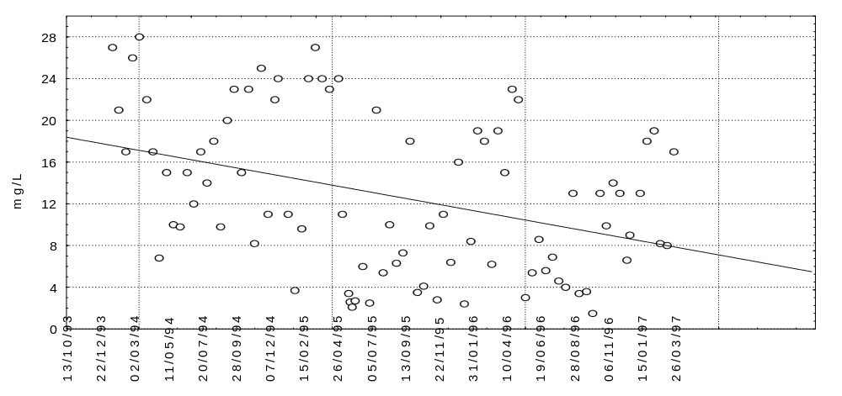
Figure 14: Total Nitrogen at Sturt Island on the Molonglo River

Monitoring of the Molonglo River downstream of Lake Burley Griffin at Coppins Crossing over the past five years shows a gradual increase in Total Dissolved Solids while ammonia levels have decreased.

Water quality in the Molonglo River downstream of the Lower Molonglo Water Quality Control Centre appears to have remained unchanged over the past five years except for total nitrogen and total dissolved solids.

Total nitrogen has decreased reflecting the reduction in nitrogen from the LMWQCC effluent (figure 14).

Total Dissolved Solids in the stream has increased while the effluent concentration has remained unchanged. There is no obvious explanation for the trend other than the increase in Total Dissolved Solids is consistent with the increase that has occurred upstream at Coppins Crossing.

Special Studies

Event Sampling

The purpose of event based monitoring is to measure the export of pollutants from catchments rather than to identify ambient water quality of streams. As it is the cumulative exports of surface runoff and its constituents which determine lake and stream water quality, monitoring of trends in exports is pertinent to the assessment of water quality. The ACT Water Quality Guidelines include ‘sustainable loading guidelines’ for critical pollutants and water bodies across the ACT.

Event based monitoring is conducted in different land use areas to enable an understanding of the respective pollutant export loadings. The urban area is represented by the Stranger catchment while rural residential is represented by Burra.

As noted in last years report, an event-based sampling program was established on Jerrabomberra Creek in March 1996 with the intention of sampling 10 events.

Jerrabomberra Creek was chosen as a priority site for event-based sampling as it is largely a rural catchment with potential for future urban development. Results of the program will assist in the planning for future development and in the development and assessment of pollution control measures.

Due to the lack of significant rainfall events during 1996-97, only 5 of the planned 10 events have been sampled. When completed, it is planned to undertake similar programs on other small streams.

A significant rainfall event is considered to have occurred for Jerrabomberra Creek when flow exceeds 0.66 cubic metres per second (660 litres per second). To put this in perspective, the average monthly flow in Jerrabomberra Creek is 0.125 cubic metres per second. There is an insufficient number of results to make any conclusions at this stage.

Ginninderra Creek Investigations

Between April 1995 and February 1997 a number of investigations into water quality in Ginninderra Creek were undertaken by staff and students at the University of Canberra and Department of Urban Services staff.

The initial study by Associate Professor Richard Norris of the University of Canberra and his students was designed as a part of a teaching exercise. It investigated water quality using both biological and physical/chemical techniques. The results from the biological monitoring suggested that the urban parts of the stream had a lower biological diversity than would be expected. Physical and chemical monitoring in 1995, 1996 and 1997 showed corresponding abnormalities. High turbidity and suspended solids levels were found in the urban areas in the upper part of the catchment and low dissolved oxygen levels were found in the urban areas below Lake Ginninderra.

The high turbidity and suspended solids in the upper part of the catchment are most probably due to the development activities in the Gungahlin area. While it is inevitable that there will be some impact on downstream waters from the land development and construction activities in Gungahlin, erosion and sediment controls should minimise the impact. In light of these results the erosion and sediment control measures in Gungahlin were reviewed, and while there was some room for improvement, the overall level of compliance appeared acceptable.

The investigations into the low dissolved oxygen levels pointed to a combination of the shading effect of the willows, the absence of riffles during long periods of low flow particularly in the warmer months, and a significant oxygen demand from organically rich sediments. No dominant source of organic material was identified. However, it is thought that the densely matted willow roots over a large section of the creek have been very effective in trapping organic material sourced from both the urban areas and leaf fall from the willows. The DO is also the only source of oxygen for the willow roots.

Apart from the usefulness of the results, these investigations demonstrate the value of cooperative efforts between government and non-government organisations. In this, opportunities for further cooperative investigations between Environment ACT and Waterwatch into Ginninderra Creek water quality have also been identified.

Waterwatch

Waterwatch activities were boosted during the period through the employment by the community of two part-time Waterwatch catchment coordinators to assist with promoting the program. Funding was provided through a Waterwatch Australia grant.

Currently there are over 60 groups taking part in the program. A study was undertaken to determine the reliability of the data and showed that the groups are capable of producing data suitable to indicate changes in water quality.

A Water Quality Monitoring Project Plan has been developed incorporating quality assurance requirements. The document is being trialed among a small number of groups before review and implementation with other groups.

This will allow a level of confidence to be assigned to the data. The information collected will also contribute to a database of water information for the ACT that includes the ACT Water Quality data. Such information will then be available for a number of purposes including State of the Environment reporting and community use.

ACT AusRivas Report

As a part of the National AusRivas study, surveys of macro-invertebrates in ACT streams have been undertaken over the period 1993-96. Fifty one reference sites and 40 test sites were sampled for a range of ACT streams. Reference sites were established on the basis of environmental factors, and used as a basis for comparison with the test (impacted) sites.

The Reference site data was used to develop a predictive model of taxa expected (E) at sites, based on environmental factors. Observed taxa (O) for the test sites were then compared with expected (E) taxa for those sites, and O/E ratios used as a measure of the level of impactedness.

Impacts are ranked according to O/E bands, as follows:
A Equivalent to Reference sites
B Slightly impaired
C Moderately impaired
D Severely impaired

The analysis of sites is as follows:

 |  | O/E | Ecosystem quality
Murrumbidgee | Upstream ACT | 1.09 | A
 | Downstream ACT | 1.12 | A
Molonglo | Downstream Lake Burley Griffin | 0.78 | B
 | Upstream Lake Burley Griffin | 0.48 | C
Urban | Downstream Tuggeranong | 0.90 | A
 | Tuggeranong urban | 0.18 - 0.36 | D
 | Downstream Ginninderra | 0.72 | B
 | Ginninderra urban | 0.18 - 0.36 | D

Assessment of Performance of Urban Pollution Control Measures

The urban stormwater management strategy comprises a range of measures directed at minimising the discharge of urban stormwater pollutants to lakes and streams. The pollution control measures comprise:

- at-source controls including erosion and sediment control measures on building and construction sites, and awareness raising programs of government and community groups directed at minimising disposal of hazardous waste substances to stormwater;
- in-stream structural measures including Gross Pollutant Traps, pollution control ponds, wetlands and urban lakes, directed at intercepting pollutants discharged in stormwater.

Monitoring of the performance of the strategy is undertaken at a range of levels:

- overall water quality of lakes and streams across the catchment;
- water quality of local urban lakes; and
- the pollutant interception performance of individual measures.

Reporting of monitoring results for the overall strategy and urban lake management has been provided earlier in this report.

Records of material removed from the Gross Pollutant Traps by City Services Branch of Department of Urban Services indicate a high level of interception of sediment and trash by the traps.

Research undertaken on the performance of water pollution control ponds by the Cooperative Research Centre for Freshwater Ecology indicates that the ponds are intercepting 70% of Total Phosphorus and 80% of suspended solids discharged in the urban stormwater.
Appendix 1

The charts below illustrate the flow from three different climatic regions. Within each chart is the monthly mean flow, the mean monthly flow for the five year period 1992-97 and the mean monthly flow over the history of the sampling station.
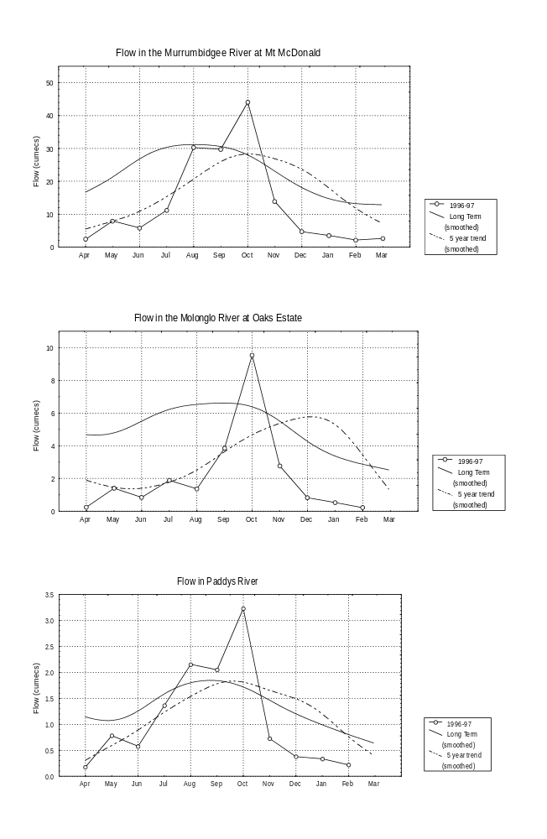
Appendix 2

This section contains the scatterplots for each indicator at the respective sites.

