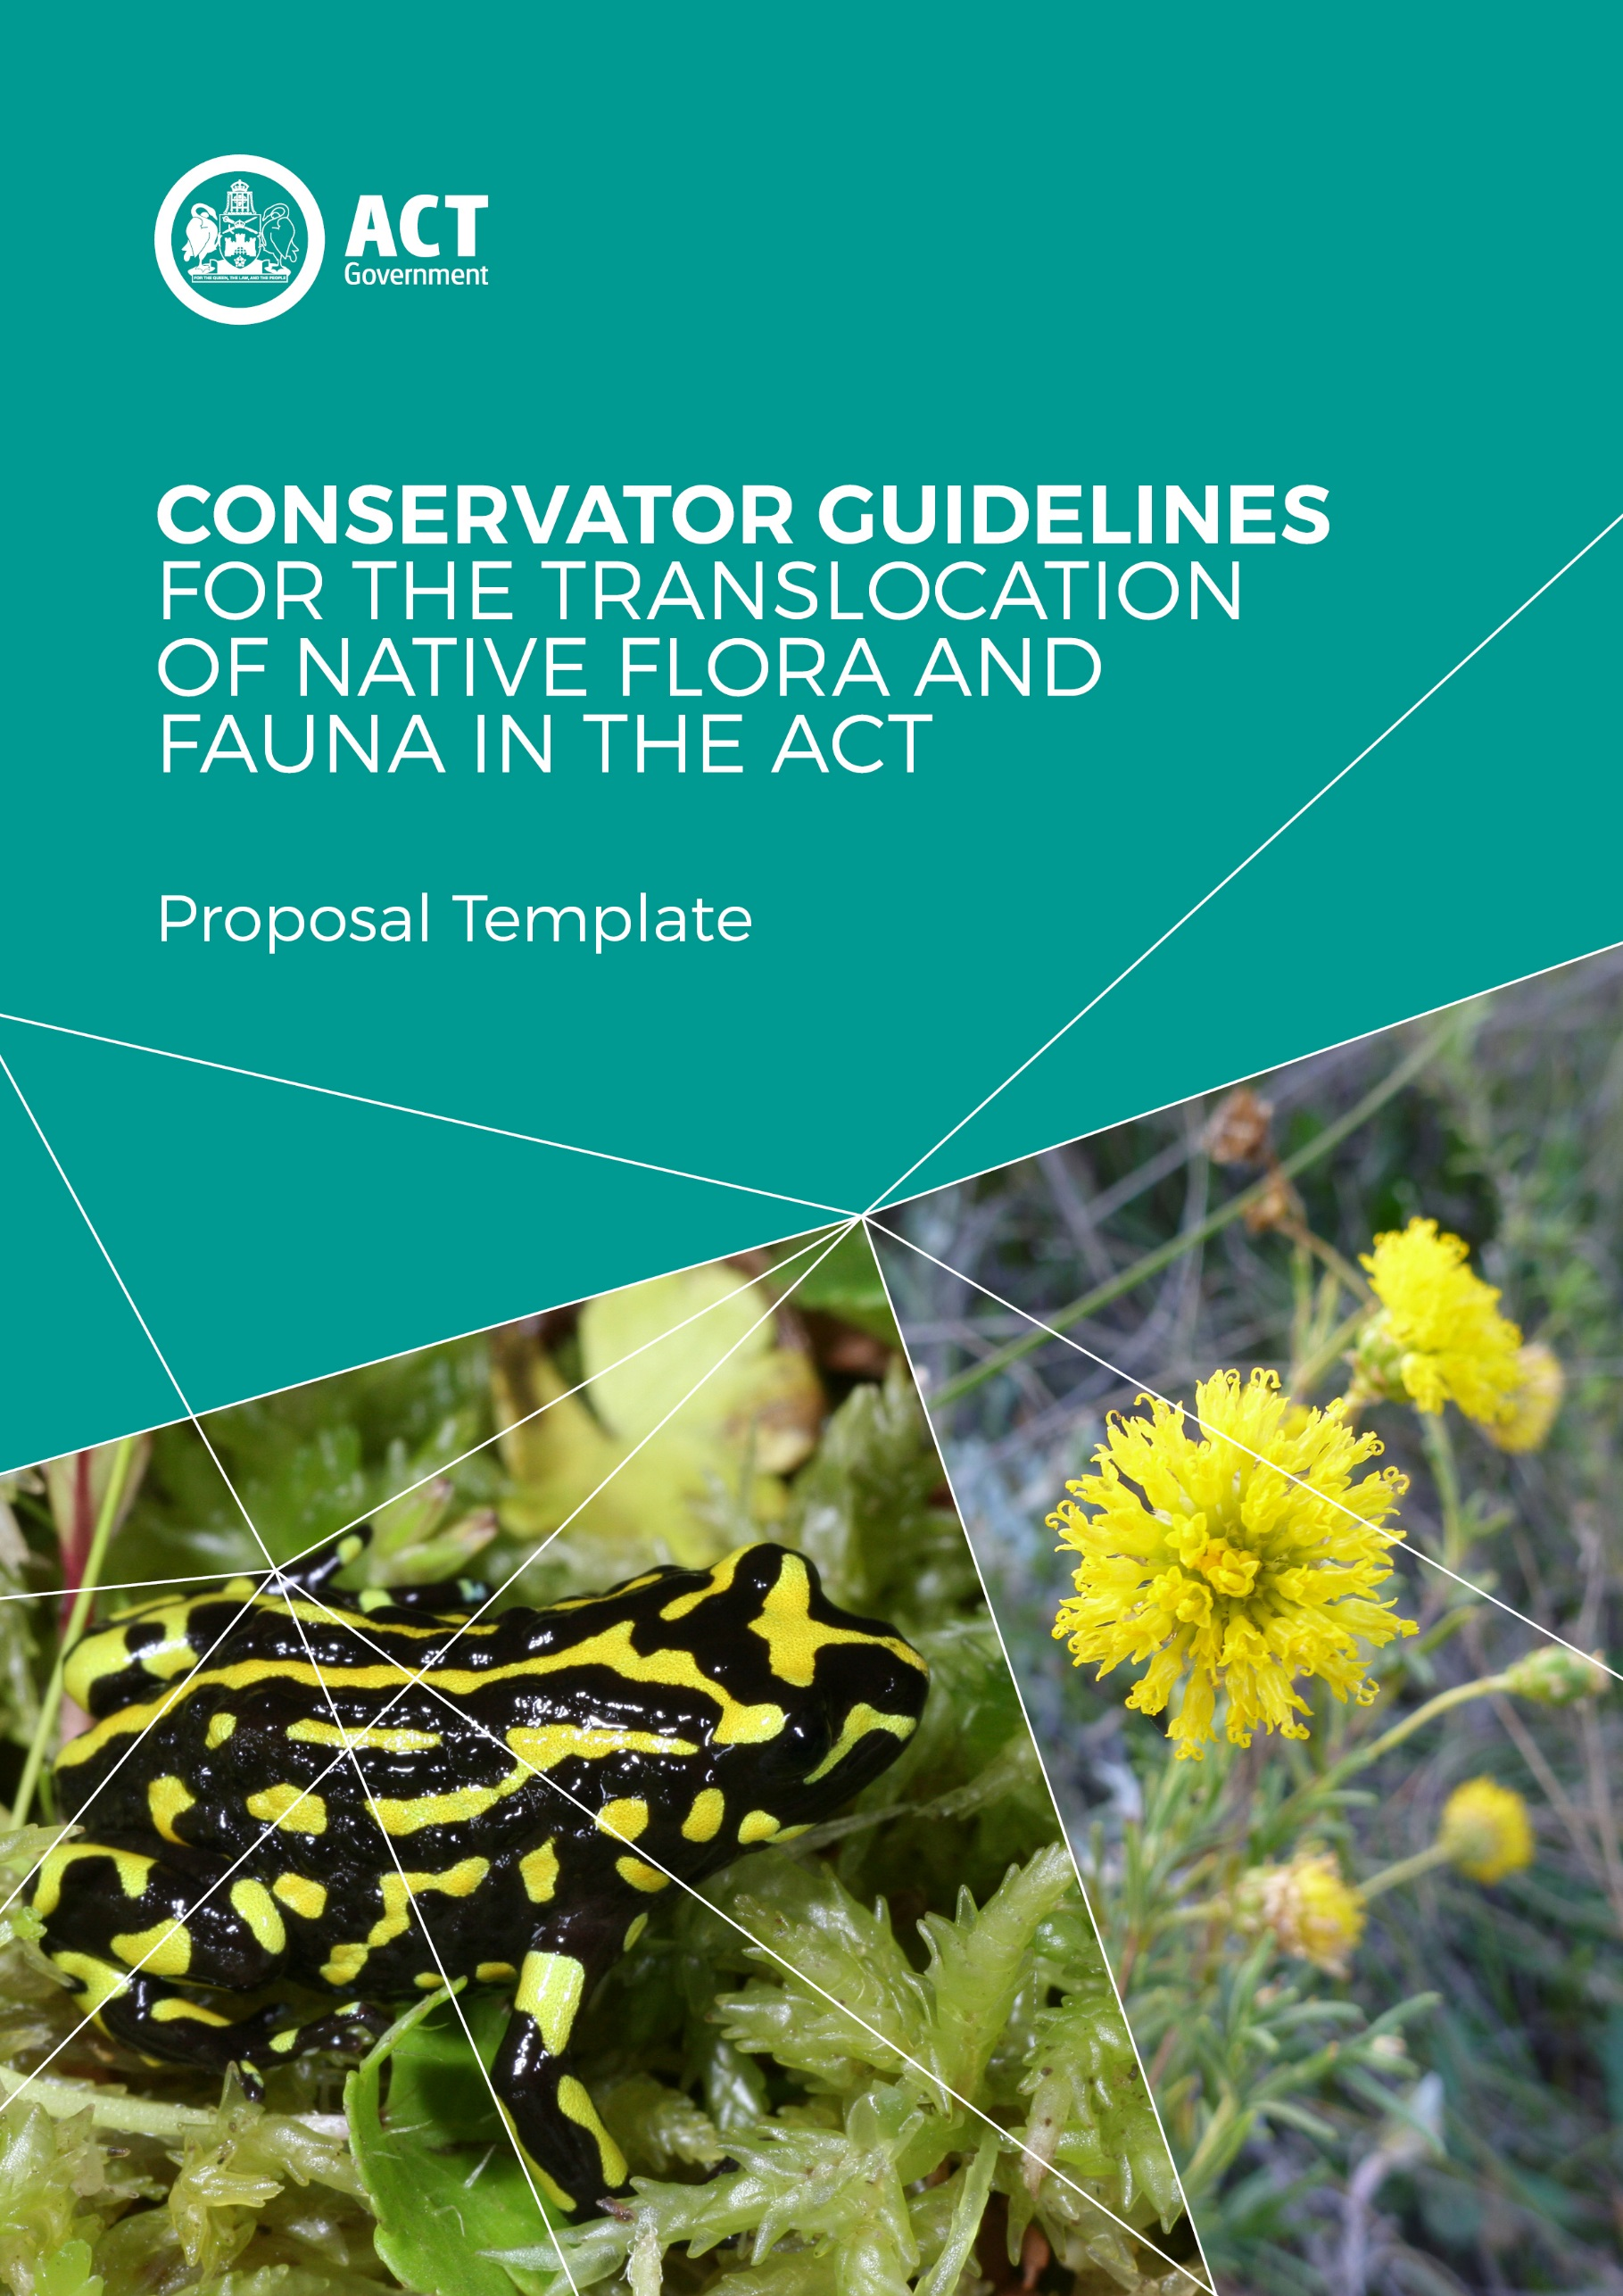

©Australian Capital Territory, Canberra 2017
Published by the Environment, Planning and Sustainable Development Directorate, Act Government
Website: www.environment.act.gov.au

The publication should be cited as
ACT Government 2017. Conservator Guidelines for the Translocation of Native Flora and Fauna in the ACT. Environment, Planning and Sustainable Development Directorate, ACT Government, Canberra.

Disclaimer
This document is not a legal instrument.
The Nature Conservation (Translocation of Native Flora and Fauna) Conservator Guidelines 2017 notifiable instrument can be found on the ACT Legislation Register.

Accessibility
The ACT Government is committed to making its information, services, events and venues as accessible as possible. If you have difficulty reading a standard printed document and would like to receive this publication in an alternative format, such as large print, please phone Access Canberra on 13 22 81 or email the Environment, Planning and Sustainable Development Directorate at epd_communications@act.gov.au. If English is not your first language and you require a translating and interpreting service, please phone 13 14 50.

If you are deaf, or have a speech or hearing impairment, and need the teletypewriter service, please phone 13 36 77 and ask for Access Canberra on 13 22 81. For speak and listen users, please phone 1300 555 727 and ask for Access Canberra on 13 22 81. For more information on these services visit the National Relay Service website.

Front Cover
Corroboree frog (M. Evans, ACT Government), Button wrinklewort (ACT Government).

Conservator Guidelines for the Translocation of Native Flora and Fauna in the ACT

Translocation Proposal Template
Conservator of Flora and Fauna
Environment Division
Environment, Planning and Sustainable Development Directorate
ACT Government

December 2017
This template is intended as a flexible, optional guide to indicate some of the information a proponent might provide in seeking approval from the Conservator. Depending on the translocation, information listed here may not be exhaustive, nor may all of it be relevant or known at the time or writing.
Therefore a proposal should be reflective of the scope, type and risks associated with a translocation. A proposal submitted to the Conservator of Flora and Fauna should be consisted with the Conservator Guidelines for the Translocation of Native Flora and Fauna in the ACT.
Further information can be found on the Environment, Planning and Sustainable Development Directorate website: www.environment.act.gov.au.
Translocation Proposal Template
Project details
Project Title | For example, Translocation of [species name] to [release location] from [source location].
Proposal number | If relevant.
Primary proponent name and organisation | Provide name and contact details.
Partner/contributing organisation/s | Provide names and contact details.
Animal Ethics Committee | If approval is required from an AEC, provide the details around this and any relevant conditions.
Translocation team | Provide the details of the main translocation team members including their role, skills, qualifications and expertise.
Species name | Scientific and common names.
Species conservation status | State, Commonwealth and International where relevant.
Source location | It may be useful to provide coordinates, maps, GPS locations, land tenure etc.
Holding/captive location
Release/planting location and site
Proposed numbers | This may be actual numbers, percentages, proportions, etc. Provide any information on specific sex rations, age rations, etc.
Funding source/s | Include any budget timelines and critical dates.
Duration | Provide information on the intended duration of the program.
Executive summary
Translocation purpose | For example, to establish a wild population, to improve the status of a species, climate change adaptation, etc.
Type of translocation | For example, population restoration or conservation introduction.
Conservation problem and/or reason for decline | Outline the issues that contribute to the need to translocate.
Major threats | May also be covered more explicitly in the risk assessment section, but may include landscape-scale threats such as climate change, development, etc. May also consider how understandings of these threats or processes will be better understood.
Distribution | Outline the species historical, current and/or potential distribution as relevant. Maps may be useful.
Previous conservation efforts | Outline any previous or current work that involves the species. Outline how the translocation adds value to any ongoing work, or how it anticipates to improve knowledge about the species, translocation/conservation methods, etc.
Goals, objectives and actions
Outline the overarching goals of the translocation. Provide for how these goals intend to be met through specific objectives, and how specific actions are driven by objectives.
Licensing and permits
Provide information on any existing licences, permits or authorisations.
Include any that are currently under application or any that will be applied in the future.
Animal welfare
Any translocation of native fauna that includes health testing, genetic assessment, breeding of source populations, capture, handling, transportation, release, post-release, radio-tracking, and other forms of monitoring, is considered to be 'research' and requires approval by an Animal Ethics Committee.

A proposal should demonstrate consideration and management of animal welfare concerns:
- of the animals being translocated
- of animals existing in the release location
- an animals impacted by control or management actions (e.g. fox control).

Provide information about how the Australian Code for the Care and use of animals for scientific purposes has been adhered to, and the animal ethics committee from which approval has been sought/attained.
Species information
Information relating to the species | - taxonomy  - current, historical and projected distribution  - biology and ecology  - habitat requirements  - climate suitability  - dispersal  - pressures and threats  - abundance and distribution  - previous and current conservation work/plans relevant to the act
Source population
Provide relevant details relating to the candidate individuals and the source population | - name/location/range  - suitability of source population (rationale)  - genetics  - number/percentage/proportion of individuals to be taken  - selection criteria
Holding/captive location & management
Provide information around any holding/captive locations involved during the translocation | - reasons for holding  - timing  - management of plants or animals during holding/captive periods  - animal welfare considerations
Release location
Providing relevant details relating to the release environment | - name/location  - current and historical land use  - site description  - habitat suitability  - presence/absence of required biotic interactions, e.g. mycorrhizae, pollinators, seed dispersal agents  - carrying capacity
Risk analysis & management
Provide a comprehensive risk analysis and risk management plan that encompasses all relevant risks and threats relating to the success of the translocation, the wellbeing of the translocated individuals, and the source and release populations and ecosystems.

A risk assessment should include:
- risk identification
- risk assessment (likelihood and consequence)
- risk prioritisation
- risk mitigation/threat management
A useful framework is set out by the Department of Prime Minister and Cabinet: Guide to Preparing Implementation Plans (http://nla.gov.au/nla.arc-53572)
Population viability analysis
By providing a population analysis (PVP), a proponent is able to demonstrate the minimum number of individuals to be translocated, and also to project the risk of extinction under difference scenarios.
Implementation
Provide details of the methods, design and implementation of the translocation | - timeline & phases  - experimental design  - capture/collection technique  - transportation  - release method  - management of threats
Project management
Provide any relevant details regarding management of the program and any long-term commitments | - long-term commitments (personnel, funding, equipment, etc)  - monitoring, reporting and evaluation plan (might include monitoring of the target species, the recipient ecosystem, sensitive species at the release location)  - success indicators  - stakeholder engagement  - conflict resolution procedures  - communications plan  - contingency plan/exit strategy  - project end/handover (e.g. to Landcare Group, community)
Funding and resources
Provide information on available funding and resources that will support the translocation, including | - funding source  - budget & timeline  - technical staff  - volunteers  - trained wildlife handlers/carers  - veterinarians  - other resources required (equipment, human, financial, etc)

