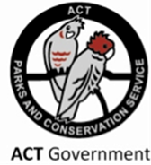
ACT Parks and Conservation Service
Strategic Plantation Management Plan
2017 – 2022

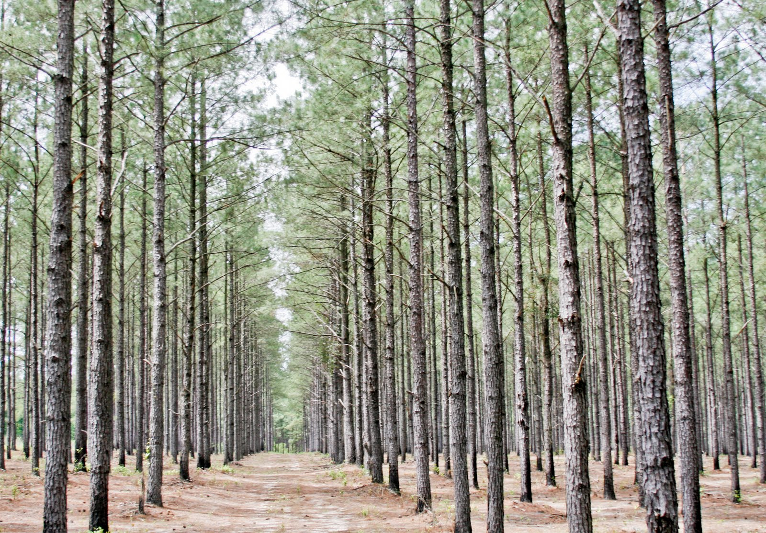

This is a controlled document held by the Forestry Coordinators within the ACT Parks and Conservation Service. All printed copies are uncontrolled.

Version 1 – September 2017

© Australian Capital Territory 2017

This work is copyright. Apart from any use as permitted under the Copyright Act 1968, no part may be reproduced without the written permission of the Environment, Planning and Sustainable Development Directorate, PO Box 158, Canberra ACT 2601.

Disclaimer: Any representation, statement, opinion, advice, information or data expressed or implied in this publication is made in good faith but on the basis that the ACT Government, its agents and employees are not liable (whether by reason of negligence, lack of care or otherwise) to any person for any damage or loss whatsoever which has occurred or may occur in relation to that person taking or not taking (as the case may be) action in respect of any representation, statement, advice, information or data referred to above.

Maps: ACT Government does not warrant that the data is free from errors.

Foreword

Plantation management in the ACT has a long and varied history. The first plantings occurred under the direction of the Afforestation Branch that formed in 1913. Their objective was to ‘protect the beauty of the landscape’ on degraded farmland. The Yarralumla Nursery opened in 1915 and several arboretums where established for species testing. Planting commenced at Mount Stromlo for erosion control during the same year and Pinus radiata was one of the first species planted, it performed well in Canberra’s climate.
ACT Forestry Branch formed in 1926 and continued planting with a twofold management objective;
- Improvement of the Cotter reservoir to reduce soil erosion and improve water quality, and
- provide for timber production to meet the ever-increasing demand for housing construction materials.
An annual plantation establishment program commenced and forestry enjoyed the support of the community as Canberra continued to grow. During the 1960’s the success of previous planting programs resulted in ACT Forestry developing plans to increase the size of the estate across the ACT and Jervis Bay. However, with the declaration of several formal Flora Reserves and National Parks, planned levels of plantation establishment never eventuated.
In 1989 ACT self-government commenced, ending the long history of ACT plantation management by the Commonwealth. At the time ACT Forests maintained management responsibility of a 26,000-hectare estate that included both plantations and native forests. ACT Forests was restructured in the early 2000’s to ensure a sustainable future and financial independence.
However, in 2003 bushfires burnt through two thirds of the ACT and destroyed 10,500 hectares of plantations. Kowen forest was the only large plantation area unaffected. A review of all land management agencies in the ACT followed and a Government decision was made to combine the two largest rural land managers. In 2006, Environment ACT and ACT Forests amalgamated into one agency which is today known as the ACT Parks and Conservation Service (PCS).
The ACT PCS is in the unique position of being a single Government land management agency with responsibility for all rural land tenures across one jurisdiction. These tenures include National Parks, Nature Reserves, rural lands and commercial pine plantations. This represents an exciting and challenging opportunity to balance society’s needs for conservation, farming and recreation with the commercial business of producing timber.
In recognition of this opportunity, PCS Forestry staff identified the need for a Strategic Plantation Management Plan. A planning workshop was held in April 2017 and attended by key PCS staff. Future management intent of specific plantation areas was discussed and outcomes from the workshop informed this Plan.
The purpose of this Plan is to enable a cooperative and strategic approach for ongoing and future plantation management between all PCS staff, including Senior Management, Foresters and District Area Managers. All PCS staff are responsible for implementing this Plan and ensuring objectives are met. With improved understanding, communication and cooperation, plantations management in the ACT will continue to make history by reaching their full commercial, environmental and social benefit potential.
September 2017

Table of Contents
Background 1
ACT Plantation Management Policy 1
Legal and Planning Requirements 1
ACT Planning 1
Environmental Authorisation 2
Continuous Improvement 2
Purpose and Scope 3
Our People 6
PCS Forest Staff 6
PCS District Rangers and Field staff 6
How We Communicate 7
Our Business 9
Sustainable Wood Flow 9
Plantation Rotation 10
Plantation Health - Pests and Disease 11
The Environment 13
Biodiversity 13
Soil and Water 15
Climate Change and Carbon 16
Our Social Values 17
Cultural Heritage 17
Recreation 17
Stakeholder and Neighbours 19
Research and Education 19
Operational Control 20
Code of Operational Practice 20
Annual Schedules 20
Data Management 21
Works Plans 21
Monitoring, Audit and Reporting 22
Monitoring 22
Annual Reporting 22
Appendix 1 – Forestry Terms and Acronyms 23
Forestry Terms 23
List of Acronyms used in this Plan 24
Appendix 2 – Relevant Legislation and ACT Plans 25
ACT Legislation 25
Commonwealth Legislation 25
ACT Planning 25
ACT Plantation Manuals 26
Relevant Plans of Management 26

Background
The current structure of ACT plantation management is the result of two significant events. In 1989 ACT self-government commenced and ACT Forests was tasked to achieve financial and environmental sustainability. This involved a significant review into operational delivery of works and resulted in a major re-structure. With a new financial focus, staff levels reduced, contractors where engaged and new timber markets established. The re-structure was successful, however, a second and more significant event occurred when the plantations were destroyed by the January 2003 Canberra bushfires.
The bushfires killed four people, destroyed over 400 homes, burnt through two thirds of ACT bush land and destroyed 10,500 hectares of ACT pine plantations. A review into ACT land management followed with an eventual Government decision to combine Environment ACT and ACT Forests into a single land management agency, now known as the ACT Parks and Conservation Service (PCS).
The ACT PCS recognises that plantations are a sustainable and renewable resource, providing an annual financial return to the ACT Government. Plantations are valued for balancing society’s needs for timber products and recreational opportunities along-side the need for native forest conservation. Without plantations timber will need to be sourced from elsewhere (such as in the past when ACT native forests where harvested). Furthermore, plantations take pressure off event based recreation, ensuring high impact activities do not occur on native forest.

ACT Plantation Management Policy
ACT Plantations are managed to ensure social, environmental and water aspects are continuously improved with land management costs offset through the sale of timber products.

Legal and Planning Requirements
The key legislation that applies to plantation forest management is stated below. All other legislation is detailed in Appendix 2.
The Planning and Development Act 2007 governs land use and development in the ACT and allows for the ACT Territory Plan. The Territory Plan is the key statutory planning document in the ACT and provides the policy framework for land administration and planning. The Territory Plan lists development zones and permitted activities within each. Whilst the Territory Plan is not an instrument of approval, a development that is inconsistent with its provisions cannot be approved.
The Planning and Development Regulation 2008 includes provisions that exempt plantation forestry operations from requiring Development Approval where they are conducted within an existing plantation.

ACT Planning
The National Capital Plan (NCP) sets out general land use policies for the ACT. At its most detailed level the NCP manages the development of Designated Areas. Designated Areas are those parcels of land that are identified as having special characteristics in contributing to the setting and role of the ACT as the seat of government for Australia. The National Capital Authority retains responsibility for planning, design and development control within Designated Areas.
Note: Issacs’s Ridge is the only plantation administered by PCS on a Designated Area.
The purpose of the Territory Plan is to manage land use and development in areas not identified as Designated Areas in the NCP. Plantations not on a Designated Area are in one of several Non-Urban Zones, listed in the Territory Plan. The objectives of the Non-Urban Zones vary to provide for appropriate land use depending on location, however common amongst them all are objectives to protect ACT’s water supply, natural heritage and biodiversity.
The Territory Plan lists plantation forestry as a prohibited development in all zones. However existing plantation areas are identified in Precinct Codes with special provisions allowing for the assessment of plantation forestry. This has the effect of allowing for management of existing plantations, whilst preventing the establishment of new areas without a variation to the Territory Plan.
Land management in the ACT is also guided by strategies and management plans. These include, the ACT Water Strategy, ACT Weeds Strategy, ACT Pest Animal Management Strategy, Strategic Bushfire Management Plan and Action Plans for threatened species and ecological communities. These are summarised in Appendix 2 and are to be read in conjunction with this Plan.

Environmental Authorisation
The Environmental Protection Authority (EPA) issues an Authorisation (number 0288) for timber harvesting in the ACT. Plantations included within this Authorisation are identified on precinct maps in the Territory Plan. The Authorisation requires PCS to maintain an Environmental Management Plan (EMP) for plantation management. The EMP identifies high risk activities and lists controls to limit the potential of environmental harm.
PCS is required to monitor its activities and report on any environmental non-compliance against listed conditions. A simple recording sheet is utilized for this. Additionally, PCS Forestry Coordinators are listed in the Authorisation to;
- speak on behalf of the Authorisation holder; and
- provide information or documentation required by the EPA under the Authorisation.

Continuous Improvement
The ACT PCS works within the Environment, Planning and Sustainable Development Directorate (EPSDD). A key result area for EPSDD is to demonstrate leadership, innovation and accountability by instilling a Directorate wide culture of continuous improvement.
PCS plantations managers are committed to continuous improvement and the management framework outlined in Figure 2 demonstrates how this is achieved. The framework allows for self-evaluation of performance that may in turn result in operational change to improve future outcomes. This adaptive management approach ensures flexibility in an ever-changing operating environment.
The aim of the PCS continuous improvement framework is to;
- Meet environmental and other legal requirements.
- Realise stated, commercial, environmental and social objectives.
- Promote a positive image to the community, stakeholders and customers.
- Retain plantation management skills and knowledge through strategic thinking and documenting outcomes of implementation.
Figure 2: PCS Plantation Management Framework
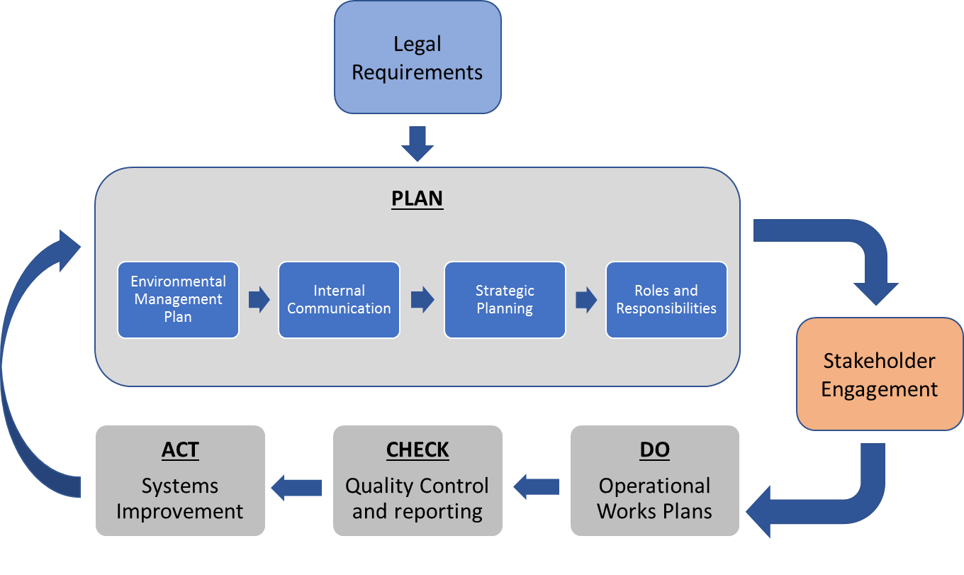
Adopting a continuous improvement framework is the first step towards PCS seeking Australian Forestry Standard (AFS) certification. This standard is a guarantee to end users that the timber they are purchasing has been grown and harvested legally from sustainably managed forests. Certification in sustainable forest management has increasingly become a market access requirement for timber products globally.

Purpose and Scope
This document outlines a systematic approach to sustainable plantation management. PCS has four key focus areas that highlight plantation values, including;
- our people,
- our commercial business,
- the environment, and
- our social values.
Objectives aligning with this management framework are stated for each focus area and cover the five-year period, from 2017-2022.
In recognition of the similarities between land tenures managed by PCS, this document follows a similar framework to the statutory requirements of existing Reserve Management Plans. Values and management considerations for each focus area are detailed.

In summary, the purpose of this Plan is to;  - Outline a systematic approach to sustainable forest management and ensuring planning decisions are in line with other ACT planning instruments;  - Ensure compliance with relevant legislation and other external requirements;  - Demonstrate the commitment to continuous improvement in performance outcomes;  - Ensure all PCS staff understand their roles and responsibilities regarding plantation management;  - Provide a process of regular review; and  - Ensure proactive engagement with relevant stakeholders. | Figure 1: Key Focus Areas  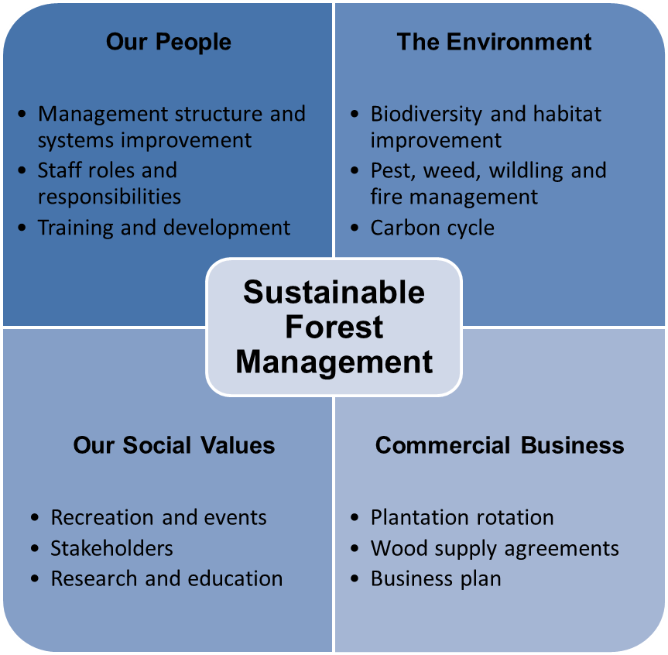
Lands to Which this Plan Applies
This Plan covers the gross area of the pine plantations as mapped in PCS GIS databases with management intent detailed in Table 1, the gross area will be made available online in ACTmapi (www.actmapi.act.gov.au) in time. The mapped gross area will include commercial plantations, roads, riparian zones and areas of native forest that were formerly part of the original ACT Forest estate.
This Plan also includes areas where other strategic plans are in place. This recognises the existence of commercial plantations within these areas and ensures future operations comply with best practice. An example of this is the commercially viable plantations within the Lower Cotter Catchment.
The attached map shows areas of past and present plantation location for reference.
Note: Some areas of the original ACT Forests estate are outside the scope of the Plan since they are no longer commercially viable. These include, Block 60 (Jedbinbilla), Giralang Pines, Fadden Pines, Westbourne Woods, Fyshwick Pines, Gungahlin and Lyneham Ridge eucalypt plantings.
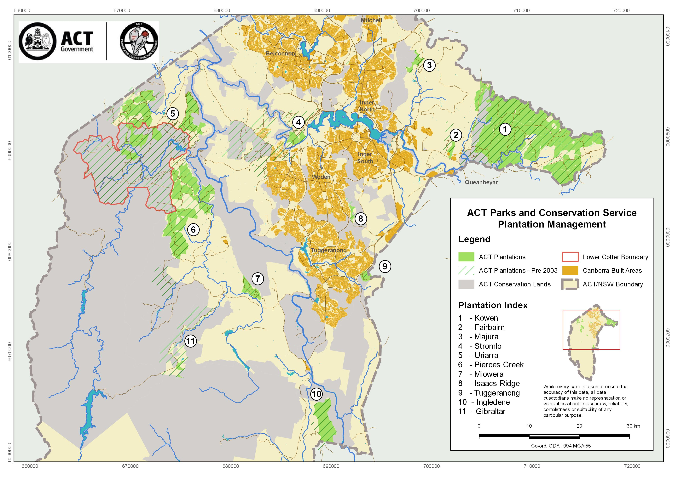

The table below outlines the management intent for all plantations within the scope of this Plan. In most cases timber harvesting and re-establishment to pines is the principle land use, however several plantation areas will transition out of the commercial estate at the end of their current rotation. These are highlighted in grey.
Table 1: Plantation Management Intent
FOREST | DISTRICT | PRINCIPLE LAND USE | OPERATIONS  2017 - 2022 | MANAGEMENT CONSIDERATIONS
1. Kowen | Googong Foreshores | - Commercial harvesting  - Plantation re-establishment | - Thinning  - Clear fall  - plantation re-establishment | - Approximately 35 hectares of plantation is growing on land owned by the Commonwealth Department of Finance. ACT maintains the rights to harvest and replant these areas, however this is not yet formalised.  - Firing Range block is Department of Defence land. ACT requires a licence agreement with Defence to harvest and replant these areas.  - Kowen has been Identified for future housing.
2. Fairbairn | Googong Foreshores | - Commercial harvesting  - Plantation re-establishment | - Thinning | - Continuous access to the Air Disaster Memorial is required.  - Paintball licence notice period for works.
3. Majura | North | - Recreation with transition out of commercial harvesting | - Clear fall  - Native forest establishment | - The Majura Pines Recreation Master Plan guides future planning and management of the plantation.  - Limited commercial value, harvesting and re-establishment may occur under direction of district staff.
4. Stromlo | North | - Commercial harvesting  - Future housing | - Thinning | - Stromlo has been Identified for future housing, will not be re-established after harvesting.
5. Uriarra - LCC | Murrumbidgee River Corridor | - Commercial harvesting  - No plantation re-establishment | - Thinning | - The LCC Reserve Management Plan guides the future planning, development and management of pine plantations.
5. Uriarra | Murrumbidgee River Corridor | - Commercial harvesting  - Plantation re-establishment | - Thinning  - Plantation infill | - Pine regrowth along Blue Range Road is considered a high fire risk and is managed under a separate ‘Blue Range Plan’. Includes pine regrowth inside and outside the LCC.
6. Pierces Creek | Tidbinbilla | - Commercial harvesting  - Plantation re-establishment | - Thinning  - Plantation infill | - Identify areas of pine re-growth that can be managed as plantations.
7. Miowera | Tidbinbilla | - Commercial harvesting  - Plantation re-establishment | - Scrubbing | - Regularly used for car rally training by recreation groups.
8. Isaacs Ridge | South | - NCA Designated Area  - Recreation with transition out of commercial harvesting | - Monitor and manage hazardous trees | - Limited commercial value, however harvesting and re-establishment may occur under direction of district staff.
9. Tuggeranong Pines | South | - Commercial harvesting  - Transition out of commercial harvesting | - Thinning | - Limited commercial value, however harvesting and re-establishment may occur under direction of district staff.  - Paintball licence notice period for works.
10. Ingledene | Namadgi | - Plantation re-establishment  - Carbon farming  - Commercial harvesting | - Plantation re-establishment | - Re-establishment may occur under carbon farming project.
11. Gibraltar | Namadgi | - Native forest conservation | - Clear fall  - Native forest establishment | - Harvesting and re-establishment may occur under direction of district staff.

Our People
Objective - Promote and maintain a motivated plantation management workforce by valuing and respecting the professionalism, contributions and aspirations of all employees.
Plantations in the ACT are managed by 2.5 full time equivalent foresters and directed by the Manager of Fire Forests, Roads (FFR). This level of staffing is historically low, requiring foresters to work in close partnership with district staff to ensure plantation management objectives are met. This creates a diversity of skills that PCS uses to its advantage with an understanding that our people are the key to our success.

PCS Forest Staff
PCS Foresters are trained and skilled professionals who specialise in the science of managing forests for multiple use and community needs. PCS foresters work in a range of disciplines including timber production, bush fire management, ecological restoration and day-to-day management of protected areas. With the rapid rise in global greenhouse gas emissions, the PCS foresters are also working on maximising carbon sequestration from lands they manage.
The PCS Forestry Coordinators (Senior Professional Officer – Level C) have oversite of all plantation management in the ACT and are supported by a Forestry Officer (Professional Officer – Level 1/2). Their duties include;
      - Delivery of the operational silviculture and harvesting forestry programs
- Manage an operational budget to provide a $500,000 annual dividend to the ACT Government from harvesting and marketing.
- Plan, implement, monitor and continuously improve forestry programs.
- Management of detailed and high value supply contracts on behalf of the ACT Government.
- Ensure operations are carried out in accordance with ACT Codes of Practices, and EPA Authorisation 0288.
- Formulation of policy and technical advice for senior management on forestry matters.
- Preparation of strategic planning and policy documentation for revegetation and rehabilitation programs of all forest areas.
- Fire management activities across the entire PCS managed estate.
2. Management of staff and contractors
- Supervision of professional, technical and field staff to ensure high quality outcomes.
- Enhance communication in the workplace.
- Identify and support individual learning and career development needs.
- Assist in the continual improvement of individual, team and agency performance.
3. Liaison and coordination within EPSDD and with external agencies:
- Attending high level meetings with other agencies in the ACT, representing the interests of PCS.
- Contribute to regular land management team meetings within PCS.
- Liaising with managers across PCS to provide efficient delivery of service wide objectives.
- Operate cooperatively with PCS District staff to deliver Whole of Government programs such as strategic weed control and vertebrate pest programs.

PCS District Rangers and Field staff
PCS Districts are managed by Area Managers (Senior Officer – Level C), Technical Officers, Rangers (Ranger – Level 1 to 4) and General Service Officers (GSO - Levels 5 to 9). Many of these staff are professionally trained and are skilled in an array of land management operations. District staff have the vision to deal with long-term planning issues relevant to their area of interest. This allows PCS to implement functions, policies and legislative requirements set out in the various legislative instruments.
The role of district staff is as diverse as the land they manage. District staff maintain a broad area of expertise in natural, cultural and rural land management. Under the leadership of Area Managers, districts manage wildlife, undertake restoration works, interpret and nurture heritage values, control invasive pest plants and animals, maintain recreation facilities and undertake fire management activities. District staff are front-line managers and are required to liaise with members of the public and numerous stakeholder groups.
Table 2 demonstrates how forestry and district staff work together to deliver on ACT plantation management. Staff accountabilities and responsibilities are listed for all management tasks allowing staff to take ownership of required duties.
Table 2: Staff Accountabilities and Responsibilities on Plantation Lands
A – Accountable for task being completed, R – Responsibility to get the job done, C – Consulted but not directly involved
Focus Area - Task | Foresters | Districts | Rural | TCCS
OUR BUSINESS
- Silviculture (growing trees) | A/R
- Timber sales and harvest | A/R
- *Roads (timber haulage) | R | C
- Plantation health | A/R | C
- Grazing | C | R | A
THE ENVIRONMENT
- Biodiversity (flora and fauna) | A/R | C
- Environmental weed control | C | R | A
- Pest animal control and management | C | R | A
- Pine wildling control | R | C | A
- Ex-Plantation rehabilitation | C | A/R
- Pine regrowth management (commercial) | A/R | C
- Soil and water (EPA 0288) | A/R
- Fire Preparedness | A/R | A/R | A/R
- Carbon | A/R
OUR SOCIAL VALUES
- Maintaining, reporting on heritage | A/R | A/R
- Recreation event approvals | C | R |  | A
- Recreation facility maintenance | C | A/R
- Gate and fencing maintenance | C | A/R | C
- Licensing (Special purpose permits) | C | A/R
- **Stakeholder engagement | A/R | A/R
- Education and research | A/R
- Compliance and illegal activities | C | A/R
* Accountability for roads within the plantation estate rests with functional staff in Fire, Forests and Roads.
** Stakeholder engagement depends on context. For example, if the harvesting schedule impacts on a planned recreation event then foresters are accountable and responsible for engagement. In other instances, such as working with the historical society districts may take the lead.

How We Communicate
The aim of formalising communication is to ensure all staff are informed and given the appropriate opportunity to provide input into ongoing plantation management. Effective communication will;
- Clarify accountabilities and responsibilities.
- Ensure PCS management, district and forestry staff remain ‘on the same page’.
- Simplify decision making.
- Reduce potential conflict in land use, e.g. harvesting versus approved event based recreation.
- Articulate a consistent message to stakeholders.
- Develop working relationships across the PCS team.
Table 3 outlines the minimum level of communication forestry staff commit to undertake. This does not replace the need for routine daily communication.
Table 3: Communication Plan
AUDIENCE | INFORMATION/DISCUSSION | METHOD | TIMING
Minister and Government Staff | - Professional advice on plantation forestry management. | - Response to ministerial questions.  - Meetings and field days when requested | - As required
PCS Director and Senior Staff | - Performance against wood supply agreements and budget  - Environmental non-conformance  - Staffing matters and resources  - Change in land management intent | - Annual report  - All staff team days  - Senior managers meeting | - Annually  - Monthly
PCS Area Managers | - Gross area map  - Change in land management intent  - Environmental non-conformance  - Annual work schedules | - Gross area stored in ACTmapi – single point of truth  - Operational Maps  - Agenda driven meetings | - Bi-Annual meeting
PCS Rangers/ Technical Officers | - Gross area map  - Annual work schedules | - Gross area stored in ACTmapi – single point of truth  - Operational Maps | - Ongoing access to ACT and PCS databases
Contractors – Marketing, Harvesting and Haulage | - Annual work schedules  - Performance against wood supply agreements and budget  - Performance against agreed quality standards  - Environmental non-conformance | - Agenda driven meetings  - Operational Maps  - Contract management plan | - Annual review  - Quarterly meeting  - Ongoing
Contractors - Silviculture | - Annual work schedules  - Performance against agreed quality standards  - Environmental non-conformance | - Agenda driven meetings  - Operational Maps | - Annually  - Ongoing
PCS Fire Management Officer | - Annual work schedules | - Agenda driven meetings  - Operational Maps | - Annually  - FFR Monthly meeting
PCS Road Management Officer | - Annual work schedules | - Agenda driven meetings  - Operational Maps | - Annually  - FFR Monthly meeting
PCS Rural Staff | - Annual work schedules  - Weed priority areas | - Agenda driven meetings  - Operational Maps | - Annually  - Ongoing
PCS Healthy Country | - Annual work schedules | - Operational Maps | - Annually
PCS Community and Visitor Programs | - Annual work schedules | - Recreation user group meetings  - Operational Maps | - Annually, user group meetings
Recreation User Groups | - Tactical harvesting schedule (3-5 years)  - Annual work schedules | - Approvals/Permits issued  - Recreation user group meetings  - Operational Maps | - Annually, user group meetings
Regulator - EPA | - EMP updates  - Gross area map  - Environmental non-conformance  - Third party complaints | - Annual Report | - Annually
Icon Water | - Annual work schedules  - Environmental non-conformance | - Agenda driven meetings after operations commence in LCC  - Operational Maps | - Annually
Neighbours | - Work Plan maps by request | - Phone, email, face to face meetings | - Ongoing
Community | - Availability of recreation areas and facilities  - Herbicide application, exclusion zones  - General plantation management information | - PCS Forestry Management Brochure  - Canberra Times public notice (Herbicide application)  - ACTmapi plantation data layers | - Ongoing  - Brochure to be displayed at each depot.

Our Business
Objective - Through sustainable harvesting and replanting commercial plantations, PCS will contribute directly to the ACT Government’s strategic priority for economic growth and diversification.
The ACT plantations support a range of commercial enterprises including timber harvesting, hosting sporting and recreation events and agistment of livestock. Timber sales account for most of the revenue and PCS seeks fair market value for all timber sales. The point of sale for timber is delivery to the mill door (purchasers). This means that PCS’s net revenue at harvest is the mill door price minus the costs of harvesting and transport. Forestry Corporation of NSW is contracted to provide yield scheduling, marketing, harvesting and transport services to PCS until January 2021, with an optional three-year extension to 2024.

Sustainable Wood Flow
Wood supply agreements (WSA) outline the quantity and quality of timber that PCS is required to supply under customer purchase contracts. These agreements provide certainty for planning and are detailed annually in the forestry budget and used when determining plantation value for insurance purposes. Current wood supply commitments include the annual delivery of 70,000 tonnes of specified timber products and are in place until 2020. To meet these sustainable volumes PCS is required to clear fall around 200 hectares of mature plantation and commercially thin a further 250 hectares of plantation each year. PCS aims to replant all cleared sites with the next rotation 12-18 months after harvesting.
To negotiate and deliver on long term WSA’s, PCS requires an estimate of the sustainable timber yields that can be harvested into the future. Modelling is undertaken by Forestry Corporation NSW using specialist software (Woodstock) built for this purpose. Model inputs include net stocked area, stand history, plantation condition and growth rates. Figure 3 was generated using Woodstock to show long term volume and product mix estimates from the ACT plantation estate over the next two rotations.
Figure 3: ACT Sustainable Wood Flow (Modelled 2016 by Forestry Corporation NSW)

The wood flow underpins the current long-term contract commitments made by the ACT Government and makes assumptions based on the future management intent of plantation areas. In this scenario assumptions include;
- Lower Cotter Catchment plantations will not be re-established after clear fall.
- Stromlo plantations will not be re-established after clear fall.
- Issacs Ridge and Tuggeranong Pines are excluded, i.e. no commercial interest.
- Ingeldene will be re-established as a commercial plantation under a carbon project.
- All other plantations will be harvested and re-established in line with a ACT’s typical plantation rotation.

Plantation Rotation
The length of time a tree is grown before harvesting is referred to as the rotation length. Rotation length is governed by many factors, including growth rates, site conditions and available product markets. The end of a rotation is generally the age where the tree is no longer increasing in volume or value. In the ACT, the rotation length is typically 28-35 years and is summarised in Table 4.
Species Selection
Radiata pine (Pinus radiata) is the most widely planted commercial timber species in the region. It is grown in large plantations on the southern slopes and central tablelands of NSW near Tumut and Bathurst. Local and regional timber mills will only accept P. radiata since it can be felled, sawn and dried for use within 24 hours.
The species is suited to a range of climate and soil conditions. P. radiata tolerates cold and frost, and grows well in areas with an average rainfall below 600mm. It provides larger timber yields in a shorter rotation than most other species and given its climatic conditions the ACT plantations are well placed to operate within established markets.
Trials of other species such as Pinus ponderosa were established early and some plantations remain in Kowen. There is no local market for these alternative species and opportunistic export sales are required. These sites will be returned to P. Radiata for the following rotation.
Site Preparation
Site preparation refers to all actions undertaken to prepare the ground before seedlings are planted, ensuring the maximum growth potential of trees are realised. Preparing a site for planting improves initial growth rates by breaking hard pans in the soil, managing water, nutrients and reducing competition. Site preparation involves clearing debris, deep ripping, mounding, competition weed control and fertilising.
- Clearing Debris, deep ripping and mounding
On harvested sites logging residue (slash) is retained wherever possible for nutrient recycling. The preference is to reincorporate the slash into the soil using a chopper roller to hasten the breakdown of material. In some cases, excessive residue is sticked raked into windrows and burnt, however this is minimised to limit nutrient loss. Deep ripping is undertaken to improve root depth and provide a path for moisture to penetrate the soil. Mounding reincorporates the soil into the rip line providing a deeper planting profile and avoiding soil saturation around the roots of the seedling during periods of wet weather.

- Competition Weed Control
Weed control is undertaken with the use of herbicides. This is carried out prior to planting or during the first year of rotation when pine seedlings are most susceptible to competition. Weeds compete for both nutrients and moisture that are often limited in the soil profiles of the ACT. PCS is committed to chemical use only where appropriate and under strict operational guidelines that protect biodiversity, water quality and neighbouring properties.

- Fertilising
Nutrition is managed through fertilising and is important to maintain early tree health and vigorous growth. Extensive research undertaken by PCS foresters over many years has identified the level of fertiliser required in the first year of planting. Boron is also applied as a routine operation in the first two years of the rotation. All soils across South East Australia have a significant boron deficiency and if left unchecked trees will grow with deformed stems that have limited commercial value.
Timber Harvesting
There are two types of plantation timber harvesting, thinning and clear fall. Thinning is the process of ensuring the best and largest trees in a plantation are given the opportunity to grow unhindered. The thinning operation allows for the removal of defective and poor-quality trees to encourage growth in the remaining trees. A rotation can have one or two thinning operations prior to clear fall, depending on site conditions and markets. Timber produced from thinning operations is generally lower quality and a high proportion is destined for the small log and pulp market. Clear fall is the final harvest and is usually undertaken at the commercial endpoint of the rotation when maximum return on investment can be obtained with the higher valued large sawlog.
Road and Trail Maintenance
A road network is in place that allows for timber harvesting and is maintained to ensure safe haulage of timber products during wet and dry weather conditions. The road network also provides access for fire protection and public recreation. The current ACT road network is extensive and historic, having been in place for nearly 100 years. The completion of a clear fall operation allows for strategic decisions to be made around the ongoing requirements of certain roads and the opportunity to close redundant roads. This brings more land into production, reduces edge effects on timber quality and reduces turbid runoff from road drainage during wet weather. Optimal plantation road density (kilometre of road required per hectare of forest to harvest) has reduced significantly since the 1920s with the progression from manual to mechanised harvesting systems.

Plantation Health - Pests and Disease
Pests and diseases can damage trees in all stages of development and affect the ability of plantations to meet their management objectives. The following are common plantation pests and diseases that can affect the health of Pinus Radiata;
- Dothistroma septosporum – (Red needle blight) A fungal disease commonly referred to as needle blight. The disease causes defoliation that increases year on year and reduces timber growth, can lead to tree mortality. Again, it has not caused wide spread damage to the ACT plantation resource to date.
- Essigella californica (Monterey pine aphid) – An aphid that sucks sap from pine needles and causes premature needle-cast. The aphid can reduce timber growth; however, it has not caused wide spread damage to the ACT plantation resource to date.
- Marchalina hellenica (Giant pine scale) – Recorded in Australia for the first time in 2014. A scale insect the lives by sucking the sap of pine trees. If detected, movement of host material will be restricted. In large populations, the scale can lead to tree mortality. Not yet found in the ACT.
- Sirex noctilio (Wood wasp) – An invasive wasp that is attracted to stressed or damaged trees. Females will bore holes in the sapwood to lay eggs and spore a white root fungus for larvae to feed upon. The fungus can lead to tree mortality. Sirex has been recorded in the ACT since the early 1980’s and is controlled through an annual biological control program involving trap tress injected with nematodes which cause sterility in the female wasp.
- Sphaeropsis sapinea (Previously known as Diplodia tip blight) - A fungal disease that causes stem cankers, shoot dieback, dead topping or stem death. Infection begins in wounds or weakened trees and the disease is common in drought affected or hail damaged plantations.

OUR BUSINESS
Management Considerations:
When managing site preparation and silviculture PCS Plantation managers will:
- Aim to maintain the productive capacity of the land.
- Undertake work in accordance with the ACT Silviculture Manual.
- Manage site preparation through a risk assessment process and implementation of work plans.
- Provide public notice about herbicide and pesticide use, as per the Environment Protection Act 1997.
- Monitor, audit and report outcomes to ensure continuous improvement.
- Maintain regular communications with PCS District staff.
When managing timber harvesting PCS Plantation managers will:
- Aim to maximise financial return for the sale of timber products.
- Focus on contractual compliance and timber deliveries with Forest Corporation NSW
- Undertake work in accordance with the ACT Harvesting Manual.
- Manage harvesting through a risk assessment process and implementation of work plans.
- Consult with relevant stakeholders, particularly recreation user groups to ensure there are no conflicts with planned events.
- Monitor, audit and report outcomes to ensure continuous improvement.
- Maintain regular communications with PCS District staff
When planning the road network required for harvesting PCS Plantation managers will:
- Undertake work in accordance with the ACT Roading Manual.
- Manage road maintenance and construction through a risk assessment process and implementation of work plans.
- Monitor, audit and report outcomes to ensure continuous improvement.
Table 4: Typical ACT Plantation Rotation
AGE | MONTH | SILVICULTURE
Pre-plant | 12 months prior to planting | Seedling Order  - Select appropriate genetically improved seed source (currently GF19).  - Determine number of seedlings required and contract nursery to grow them as either containerised or bare rooted stock (site specific).
Pre-plant | Nov - Mar | Site Preparation  - Prepare harvested area 3-18 months prior to planting. Various operations are applied depending on site conditions.  - Rolling - Crusher roller is used to break down harvesting debris.  - Stick raking and windrow burning – This burning is not best management practice, however is occasionally required when excessive harvest debris prevents re-establishment.  - Ripping and mounding - Implemented on a modified contour pattern aimed to passively drain water towards ridges. Soil needs to be dry for adequate fracturing and shattering of the profile.
Pre-plant | Apr | Pre-Plant Weed Control  - Pre-plant application of residual and knock-down herbicides, generally undertaken by helicopter. Timing is important since the chemical often needs to have at least 4 weeks on the ground prior to planting.  - Scrub advanced weeds using brush-cutters or chainsaws.
Plant | Jun - Aug | Planting  - Plant pines at 1000-1100 stems/ha. Pine seedlings are grown interstate and transported in refrigerated trucks from the nursery to the field.  - The year the seedlings are planted is also known as the ‘age class’ of each crop throughout its rotation.
0-1 | Aug - Sept | Fertilise – NPK  - Fertilise seedlings by hand with NPK.
0-1 | Aug – Oct  (If required) | Post-Plant Weed Control  - Post plant spray weeds and regrowth if required, usually by helicopter.
2 | Dec - Feb | Boron Application  - Apply Boron when competing grasses have died off, usually by helicopter.
8-10 | Year round | Low Prune  - Remove all branches to height of 2.2 to 2.4 metres above ground.  - Site specific specification of stems per hectare to be pruned and can be combined with ‘non-commercial thinning’.  - Only done in strategic fire zones and along selected compartment edges.
9-12 | Year round | High Prune  - High prune stems using ladders and handsaws to 4.3 metres in years 9-10, then 6.1 metres in years 11-12. Only done in strategic fire zones.
15-18 | Year round | 1st Thinning  - Thin compartment to either a stocking and/or basal area specification.  - Produces mostly pulp logs and some small sawlogs.
23-26 | Year round | 2nd Thinning  - Thin compartment to stocking and/or basal area specification.  - Produces mostly small sawlogs and pulp logs.
28-35 | Year round | Clear fall  - Produces mostly sawlogs and some pulp logs from tops of any and/or remaining poorly formed trees.  - Log sales are based on weight or volume depending on customer requirements and log scanning systems.  - Mills generally cannot take any log greater than 60cm diameter and clear fall age of a compartment may be adjusted to meet this requirement
10-20 | Year round (with peak in June/July) | Sirex wasp program  - Wasp sterilising nematodes are introduced to the wasp population through inoculating Sirex wasp attacked trees in carefully selected trap sites.  - Billets from trap sites are monitored to understand background level of nematodes and changes in wasp population size or distribution.
0-35 | Year round | Plantation Pest, disease and other potential risks  - Monitor and manage when required.

The Environment

Biodiversity
Objective - Ensure populations of existing native fauna and flora within the plantation estate are maintained or enhanced by protecting and improving habitat and managing key threats.
Biodiversity is not only relevant in conservation ecosystems such as wetlands, nature reserves or national parks, research shows that remnant native vegetation, riparian zones and paddock trees within agricultural landscapes, such as plantations, contribute to biodiversity to varying levels at both the local and regional scale.
The scope of this Plan covers ecosystems and associated habitats within and surrounding the ACT plantations. This vegetation is quite diverse ranging from the lowland wet foothill forests of Namadgi National Park to the dryer forest types in Kowen Forest. Some, but not all, of these landscapes are managed through Reserve Management Plans or district planning instruments.
Biodiversity Values
- Greater species diversity ensures natural sustainability of flora and fauna.
- Healthy native ecosystems are more resilient and can better withstand and recover from a variety of disasters, including the predicted effects of climate change.
- native biodiversity provides ecosystem services such as clean water, stable soils and food resources for native species.
- Elements of biodiversity can contribute to cultural identity. For example, the grass tree forest within Pierces Creek.
To protect the biodiversity values of plantation areas, habitat needs to be maintained or enhanced and all threatening processes need to be managed. The threatening processes facing native forests in the ACT have been identified as, pest animals, exotic weeds, pine wildlings, past road design and density, and large scale intense wildfire. An understanding of the threatening processes, the values and the existing management practices is required to prioritise works.
Pest Animal Management
Pest animals can have a negative impact on biodiversity and rural neighbours. Management of pest animals is only effective if a strategic view is taken across the total landscape including all vegetation types. The ACT Pest Animal Management Strategy sets outs the key principles, objectives and strategic actions for reducing the damage caused by pest animals. PCS forestry and district staff work with rural vertebrate pest officers to manage pest animals across the plantation area.
Weed Management
Exotic weeds have significant impact on biodiversity when they prevent germination and regeneration of native vegetation. Weeds also impact on the productivity and management of plantations as they slow the growth rates of planted seedlings.
- The ACT Weed Strategy provides a framework to guide the negative social, economic and environmental impacts of weeds in the ACT.
- The ACT Silviculture Manual outlines operational conditions for managing competing weeds within the commercial plantation areas including riparian zones and native forest areas.
Pine Wildling Control
Pine wildlings have the potential to invade areas of native vegetation adjacent to mature plantations. For this reason, pine wildlings are listed in the ACT Weed Management Strategy as a species that must be contained.
Wildlings can compromise natural ecosystems and biodiversity and have an adverse visual impact. Pine wildlings are controlled using a range of methods including the use of prescribed fire, commercial harvesting, and chemical herbicide application. Physical culling is considered the easiest and most effective method of control and if carried out before trees set seed, has the least environmental impact. All pine wildling control programs undertaken by the PCS plantation management team and contractors is done within the overall context of the ACT Weed Management Strategy.
Pine wildings do occur in areas where the government has made the decision to cease commercial plantation management and revert the land to a natural landscape. Strategic management of these areas is considered in various Reserve Management Plans and is not to be confused with routine pine wildling control.

Fire Management
Plantation managers are aware of the impact of fire. As well as damage to the valuable commercial timber resource, fire reduces native vegetation cover, removes nutrients and can change the chemical properties of soil. Increased overland flows post intense bushfires, particularly after storm events accelerate erosion and can result in large quantities of ash, sediment and nutrients being deposited into streams and rivers.
PCS land managers work under the existing bushfire management framework and are committed to protecting life, property, the commercial timber resource, biodiversity and cultural values from high-intensity unplanned fire. The Strategic Bushfire Management Plan (SBMPv3) sets the high-level bushfire standards in the ACT and the Bushfire Operations Plan (BOP) is the annual program of works based on risk.
Plantation fuel management zones are additional to the SBMPv3 and are established by PCS specifically to protect its timber production assets from unplanned fire. These zones reduce crown fire potential by breaking the fuel ladder. Timely thinning, high pruning and strategic chopper rolling in clear fall operations prior to the declared fire season is consciously undertaken within these identified zones. These zones are mapped and stored in PCS GIS databases and all work is scheduled through the BOP.
BIODIVERSITY
Management Considerations:
PCS Plantation managers are committed to maintaining biodiversity values through:
- Maintaining a GIS data layer that records the locations of threatened and vulnerable species in and around the plantation estate.
- In consultation with district staff, identify areas of habitat where we have no active management plan in place. Survey values and prioritise areas for treatment.
- Implementing any operational control that is outlined in relevant Codes of Practice.
- Undertaking an environmental risk assessment prior to all operations.
- Monitoring, audit and reporting to ensure continuous improvement.
When managing pest animals PCS Plantation managers will:
- Report all sightings of pest animals to relevant rural staff.
- Work with rural and district staff to set priorities for pest animal control in relation to plantation management within the overall PCS strategic framework.
- Monitor, audit and report outcomes to ensure continuous improvement.
When managing noxious weeds PCS Plantation managers will:
- Report locations of noxious weeds to rural staff.
- Work with rural and district staff to set priorities for noxious weed control in relation to plantation management within the overall PCS strategic framework, ACT Weed Management Strategy.
- Provide annual funding for noxious weed control within the plantation gross area.
- Monitor, audit and report outcomes to ensure continuous improvement.
When managing pine wildlings PCS Plantation managers will:
- Map the extent of existing pine wildlings in the ACT.
- Work with rural and district staff to set priorities for pine wildling control within the overall PCS strategic framework.
- Provide annual funding to undertake pine wildling control within the plantation gross area.
- Monitor, audit and report outcomes to ensure continuous improvement.
When managing for bushfires PCS Plantation managers will:
- Work with the PCS Fire Management Planning Officer to determine and map fuel reduction zones for all plantations.
- Work with fire management and district staff to set priorities for the BOP within the overall PCS strategic framework.
- Carry out agreed works (listed in BOP) in timely manner.
- Participate in PCS fire suppression and preparedness activities as required.
- Monitor, audit and report outcomes to ensure continuous improvement.

Soil and Water
Objective - Maintain functioning streams and riparian zones and ensure sustainability of aquatic ecosystems within plantation areas.
As with many PCS land management activities, plantation forestry operations have the potential to impact on soil and water values.
Water Quantity
All vegetation types have an impact on water quantity (yield) through reducing runoff and infiltration. Grasslands yield the greatest amount of water while a similar yield can be expected between catchments planted to pines and native forest. However, water yield does increase after thinning and clear fall of plantations, therefore over the longer-term plantations yield slightly more water than native forests.
Within plantations, the greatest change in stream flow occurs after clearing and re-establishment (new growth stage). Stream flow is determined by the type, size and location of plantation operation creating the disturbance. Spreading out the age class of plantations throughout the catchment limits the risk of water quantity variations.
The Murry-Darling Basin Plan (2012) provides a coordinated approach to water use across relevant States and the ACT. Each State has set limits on the volume of surface water that can be diverted from the river systems. The net uptake of water from commercial plantations in the ACT is capped at 11 GL per year, which equates to approximately 12,000 hectares of plantation.
Soil and Water Quality
Studies on the long-term changes in water quality between intensively managed Pinus radiata and native forest paired catchments have been undertaken in Victoria and New South Wales. With well-maintained riparian buffers only minor differences in water quality between the two land uses where observed. However, in-stream sediment loads are affected by more than surface vegetation.
Existing gully networks and roads are typically the major sediment sources in catchments and dominate the in-stream sediment loads. To limit this risk, ACT Forests decommissioned many kilometers of poorly located roads after the 2003 bushfires. PCS has continued this practice whenever possible and has operational controls in place to manage current plantation activities to limit risks to water quality. These include, exclusion buffers, road closures and suspension of harvesting activities when soils are saturated or deemed too wet.
Soil and Water Values
- Water quality and quantity is fundamental for river and stream health. Water sustains ecological processes that support native fish, vegetation, wetlands and birdlife. Similarly, many of our own uses depend on suitable water quality for drinking, irrigation, watering stock and recreation.
SOIL AND WATER
Management Considerations:
When managing water quantity PCS Plantation managers will:
- Attempt to spread the plantation age class across the landscape and estate to limit variability in water yield.
- Implement operational controls outlined in relevant PCS Codes of Practice.
When managing soil and water quality PCS Plantation managers will:
- Comply with EPA Authorisation 0288 that allows for timber harvesting.
- Implement operational controls outlined in relevant PCS Codes of Practice and the ACT Soil Erodibility and Maintenance Manual.
- Where possible, design road networks to limit crossings and minimise sediment input into drainage lines.
- Rigorously apply wet weather controls and seasonality restrictions on forestry contractors.
- Monitor, audit and report outcomes to ensure continuous improvement.

Climate Change and Carbon
Objective - Maximise carbon stocks within ACT plantations and ensure clear felled areas are re-established as plantations, continuing the cycle of carbon sequestration.
Trees remove carbon dioxide from the atmosphere and store it in their branches, stems and roots. Approximately half the dry weight of a tree’s biomass is carbon. Carbon sequestration is maximised in forests as trees grow from the age of 10-30 years (approximately). After this time, the rate of sequestration slows until a forest has reached maturity, unless it is harvested.
Timber captures more carbon than is used in the production process (e.g. fuel emissions from site preparation, harvesting and transportation). Plantations are therefore carbon positive and successive rotations will incrementally increase carbon stocks. This is highlighted in the figure below.
Figure 4: Plantation Carbon Abatement
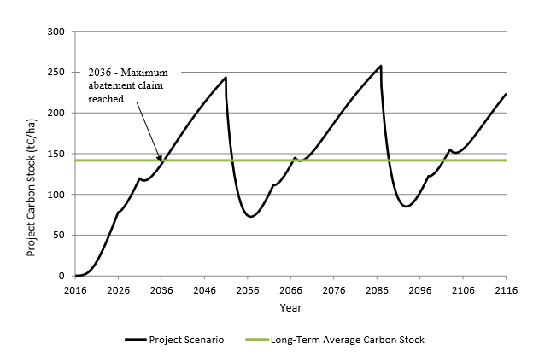
Carbon Values
- Plantations store carbon, during growth and after harvesting in timber with successive rotations incrementally increasing overall carbon stocks. Plantations are valued for their ability to combat climate change.

CARBON
Management Considerations:
PCS Plantation managers recognise the science of climate change and are committed to reversing its damaging trends. When managing for the impacts of climate change PCS Plantation managers will:
- Investigate opportunities for carbon accounting and sales.
- Maximise timber potential for each plantation through timely silviculture and harvesting.
- Maximise sawlog production for long term carbon storage.

Our Social Values

Cultural Heritage
Objective - Ensure cultural heritage values are included, understood and protected in all aspects of plantation management.
Culture is the basis of social identity and cultural heritage is a legacy that each generation receives and passes onto future generations. PCS recognises the need to protect cultural heritage in partnership with Government, stakeholders and community groups.
Aboriginal Cultural Heritage
Aboriginal culture heritage includes physical and spiritual sites, places, objects plus native flora and fauna. All Aboriginal places and objects in the ACT are protected under the Heritage Act 2004 and anyone finding an Aboriginal object or place has an obligation to report it to the ACT Heritage Council.
Healthy Country is a PCS initiative put in place to increase staff understanding and awareness of Aboriginal cultural heritage. Plantation managers engage Healthy Country staff on all Aboriginal culture heritage matters.
Other Cultural Heritage
European heritage items and places are those with heritage significance that the community wants to keep for future generations. European culture heritage is also administered by the ACT Heritage Council.
Cultural Heritage Values
- Cultural heritage is fundamental to the identity of communities.
CULTURAL HERITAGE
Management Considerations:
The PCS plantation managers are committed to the understanding and protection of cultural heritage. When managing cultural heritage PCS Plantation managers will:
- Report unregistered cultural heritage places or objects to the ACT Heritage Council.
- Support Healthy Country staff and work with them to increase awareness of Aboriginal cultural heritage.
- Implement operational controls outlined in Codes of Practice.
- Undertake a desk top analysis and risk assessment prior to all operations.
- Monitor, audit and report outcomes to ensure continuous improvement.
- Information management. Work with PCS, Healthy Country and the ACT Heritage Council to achieve a single GIS cultural heritage layer. Manage the differences between old ACT Forests layers and GIS existing data.

Recreation
Objective - Provide a safe and enjoyable venue for recreation activities and events that are compatible with ongoing timber harvesting and do not compromise the return on investment from timber marketing.
ACT plantations are extensively used and managed for recreational activities including walking, jogging, horse riding, cycling, motorcycling, dog-sled racing, camping, picnicking, fishing, musical events and car rallies. The number of events and participant usage in plantations is significant and removes high impact activities from the more sensitive native forest areas. This enables PCS to balance community needs for recreation with conservation of native landscapes.
Permits are used to facilitate formal recreation activities in the ACT and are issued to both not-for-profit groups and commercial entities. They can be issued for a single day or for longer periods of time. Permits are managed by Transport Canberra and City Services (TCCS) with input from PCS forestry and district staff.
Participant numbers within plantation areas for the past five years is shown in Table 5.
Table 5: Activities, events and participant numbers – 2011 to 2016
(Not including lease numbers, i.e. paintball in Fairbairn or Tuggeranong)
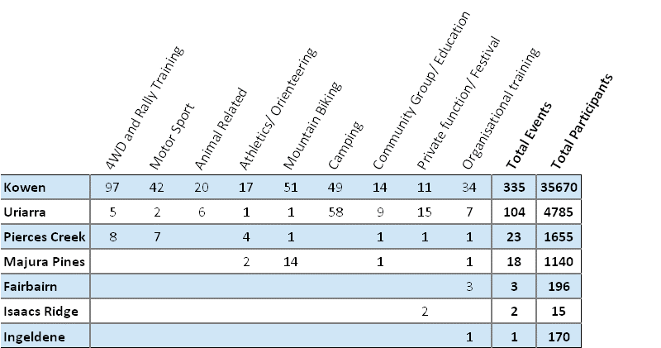
Incidental usage, i.e. day use that does not require a permit also occurs in plantations. Incidental usage is difficult to quantify, however in the 1990’s ACT Forests’ used their recreational data base to estimate that over one million incidental recreation visits occurred in Stromlo plantation forests annually. Plantations clearly provide high levels of non-market social benefit to the ACT community.
This non-market social benefit is difficult to calculate in terms of financial return on investment to Government, however various studies have been carried out elsewhere to compare the financial value of recreation use in plantations versus the annualized return from timber sales. A study in a radiata pine plantation close to Adelaide, South Australia, found that recreational benefits were worth 30 percent of annual timber sales. A similar study in New Zealand found that social benefit delivered a higher financial return in an accessible forest close to the urban interface. In this study, the recreation use area was a smaller part of a much larger commercial plantation estate. These studies found that the majority of plantation recreational use was from the local community rather than tourists or inter-state visitors.
The ACT Government has recognised the non-market social benefit of plantations through the construction of the Mount Stromlo Forest Park, National Arboretum and Majura Pines recreational areas, all part of the former ACT plantation estate. Future PCS policy on recreation needs to consider the current infrastructure spend on recreation in the ACT and best methods for optimizing the combined benefits of production forestry administered under long term wood supply agreement with non-market benefits.
Recreation Values
- Plantations allow the ACT government to accommodate legitimate high impact activities that are not necessarily compatible with other land tenures across the ACT.
- Recreation creates jobs and benefits the local community through increased tourism. Recreation increases personal health and wellbeing.
RECREATION
Management Considerations:
PCS is committed to providing safe places for recreation. When managing for non-market social benefit and recreation PCS Plantation managers will:
- Engage with the PCS Manager of Community and Visitor Programs to enhance recreation opportunities on plantations.
- Liaise regularly with the PCS District staff to ensure a PCS wide view on recreational activities.
- Respond in a timely manner to all recreation permit requests.
- Participate in the PCS recreation users group forum when required.
- Maintain ongoing communication with all legitimate forest recreational user groups.

Stakeholder and Neighbours
Objective - Facilitate stakeholder engagement and incorporate their views into plantation management when appropriate.
Plantation stakeholders include, PCS staff, Government directorates, timber customers, contractors, community groups, neighbours, forest users, non-government businesses and the ACT community.
The ACT PCS acknowledge the positive contribution stakeholders make to forest management and PCS Plantation managers are committed to facilitating and encouraging meaningful engagement with all stakeholders. This is achieved by providing opportunities for stakeholders to make their views known and by considering and where possible incorporating their ideas into planning processes.
PCS Plantation Managers engage stakeholders on three levels;
- During formal meetings such as those outlined in the Communications Plan.
- When dealing with specific issues that are of interest to one or two stakeholder groups only.
- Day-to-day, taking appropriate steps to accommodate concerns or issues from stakeholders on forestry operations as they arise.
STAKEHOLDERS AND NEIGHBOURS
Management Considerations:
PCS Plantation managers are committed to active engagement with relevant stakeholders. PCS Plantation managers will:
- Continue to build mechanisms for continued liaison with stakeholders and neighbours to further develop cooperative working arrangements on matters of mutual concern. These issues include, but are not confined to, recreation, fire management, weed control and stock grazing.

Research and Education
Objective - Utilise applied research at every opportunity and engage and encourage learning institutions to utilise ACT plantations for research and education purposes.
Without research, the capacity to advance our knowledge on commercial plantation management is limited. Best management practice may not be achieved which will in turn result in poor commercial, environmental and social outcomes.
PCS Plantation managers actively support various not-for-profit groups involved in forestry research and development, including;
- Forest and Wood Products Australia (FWPA). The FWPA supports forestry research and development that promotes internationally competitive and environmentally sustainable practice.
- Forestry and Forests Products Committee (FFPC). Consists of government officials from Australian, State, Territory and New Zealand agencies responsible for forestry and/or forest products.
- The Australian Plantation Forest Industry Herbicide Research Consortium. Focuses on sourcing and trialing alternative herbicide products.
- Australian Sirex Working Group. Shares information and provides results of latest research.
RESEARCH AND EDUCATION
Management Considerations:
PCS Plantation managers are committed to advancing the knowledge of forests through research and education. PCS Plantation managers will:
- Actively contribute to various not-for-profit groups that focus on forestry research and development.
- Develop and provide education institutions increased access to ACT plantations and be available to host forest tours and information sessions.
- Facilitate applied research to Improve forest management outcomes.

Operational Control
Most plantation operations in the ACT are delivered through contract arrangements. Operational control is designed to ensure day-to-day plantation activities are performed in a manner that is consistent with the objectives set out in this Plan and in line with Government and community expectations. Corrective action is taken where performance does not meet standards. This corrective action is not restricted to, but may involve, provision of additional resources to undertake the task, further training, motivation, discipline in the form of operator stand down or termination of contract.
A series of codes and manuals are in place to ensure compliance with legislation and objectives stated in this Plan. These are listed below and must be read in conjunction with this Plan.
- EPA Authorisation No.0288
- Plantation Environmental Management Plan (EMP)
- ACT Code of Forest Practice, Version 1, 2005
- PCS Manuals
  - ACT Silviculture Manual, 2006
  - ACT Harvesting Manual, 2006
  - ACT Roading Manual, 2006
  - ACT Soil Erodibility and Maintenance Manual, 2006
  - Forest Operations Guidelines and Quality Control Manual
- PCS Works Plans

Code of Operational Practice
The ACT Code of Operational Practice is under preparation and will supersede the ACT Code of Forest Practice. The new Code aims to:
- Be a dynamic document that incorporates best practice and takes an evidence-based approach to management, based on science and experience.
- Sets the standards for all PCS operational activities.
- Be a strategic high-level umbrella document for manuals, management plans and works plans.
- Enhance community confidence in the government’s ability to manage land.
The Code of Operational Practice is a set of rules to guide behavior and decisions in a specified situation. It will be a practical guide to assist PCS deliver on best management practice.

Annual Schedules
In addition to Codes and Manuals, PCS Plantation Managers prepare operational schedules of work for planning and budget purposes. These include;
- Harvesting: Harvesting schedules are prepared for various planning needs. These consider contract agreements, customer (mill) requirements, weather-related constraints and planned recreation events. Harvesting schedules are prepared over various lengths of time;
  - Seventy-year sustainable yield modeling, two rotation lengths.
  - Five-year strategic and tactical planning, in line with WSA’s.
  - One-year annual scheduling of harvesting operations.
- Road maintenance: Roads required for harvesting are closely aligned with the strategic and annual harvesting schedule. Other road works will be undertaken where the potential for environmental harm has been identified.
- Fire fuel management: Annual schedule of fuel management works is entered in the Bushfire Operations Plan (BOP). The schedule of works is influenced by the need for asset protection within and near the plantation estate and for ecosystem management.
- Plantation establishment: An annual schedule is prepared and considers current clear-felled areas, failed plantation areas and budget constraints.
- Pest and weed control: The annual schedule considers any issues raised by PCS district staff and outlines priorities within the mapped gross area of plantations. Weed control works fall under the strategic PCS Annual Weeds Operation Plan (AWOP)

Data Management
PCS Plantation managers access existing data for tactical planning, annual scheduling and preparation of Works Plans. During these planning phases, foresters identify whether any further information is required to assess the impacts of plantation operations. This enables foresters to implement additional controls required to limit site-specific risk.

Specialist plantation management software is available to store and link stand data with GIS spatial data. This provides a powerful tool for planning, analysis and reporting on plantation forest management outcomes. Currently, this software is utilised by Forest Corporation of NSW to calculate ACT’s sustainable wood flow on behalf of the PCS.

Works Plans
Most work undertaken by PCS requires the development of a specific Works Plan as per the Code of Operational Practice. This includes PCS plantation operations such as timber harvesting, silviculture treatment, roading and bushfire fuel reduction. The Works Plan is a means of managing risk and providing formal and documented instruction to contract operators and PCS employees.
Each PCS Forestry works plan includes a GIS generated operational map that identifies:
- Location, extent and boundaries of the operation.
- Topographic features such as contours and drainage.
- Excluded areas and the reason for the exclusion.
- Haulage roads and tracks.
The written section of the works plan outlines operational objectives, scope of works, area description, operating conditions and relevant approvals. Importantly a risk assessment is performed for each activity, ensuring all environmental and social aspects of the proposed activity are considered.
Before any operations commence the relevant forester briefs contractors and their employees on the contents of the works plan. This ensures a common understanding of processes and expected outcomes. In most cases control of the site is then temporally passed over to the contractors who are then responsible for their own crew and safety management.
Figure 5: Process undertaken to produce a Forestry related Works Plan

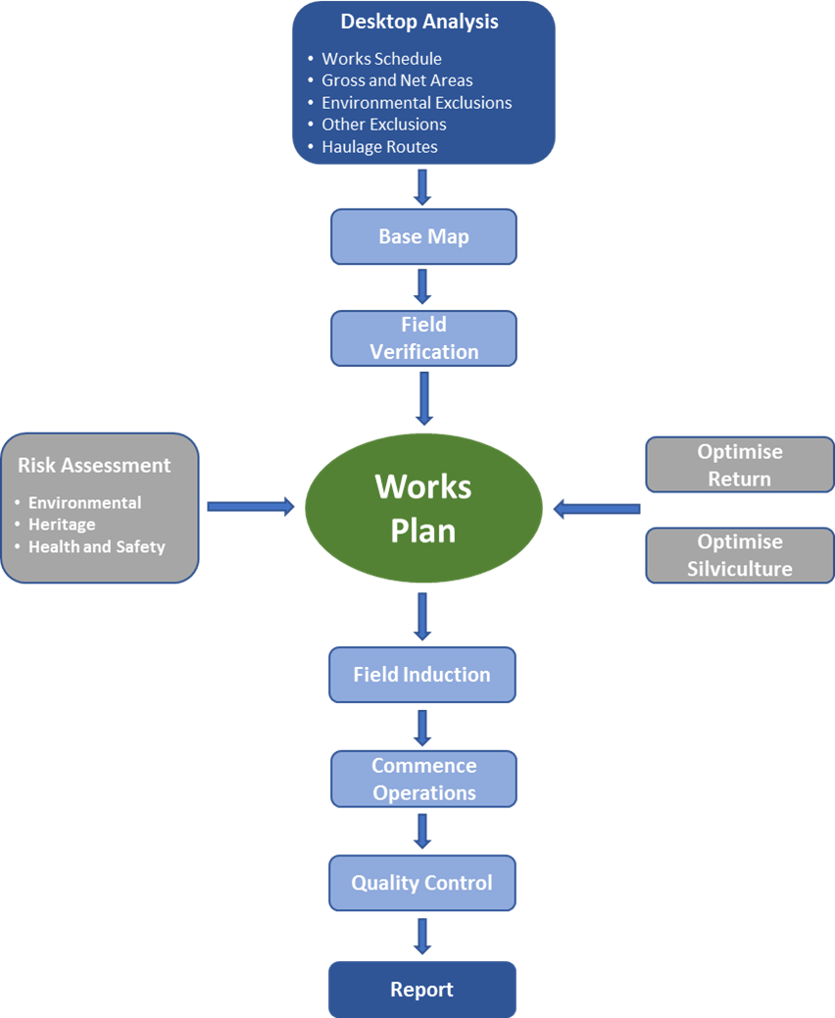

Monitoring, Audit and Reporting
Monitoring, audit and reporting are integral to the continuous improvement process and ensuring plantation management objectives are met. The absence of systematic monitoring means when problems arise it is often too late to make meaningful change.

Monitoring
Monitoring refers to the comparison of actual performance against a specified target. The aim of monitoring and reporting on progress is to:
- Control forest operations and assess the performance of contractors.
- Identify under achievement and non-compliance and determine the course of action required rectify the situation.
- Identify training or education requirements to make contractors/PCS staff aware of revisions to systems, the Code or works plans.
- Record achievement to allow for continued contractor engagement and celebrating success.
- Provide information for future revisions of this Plan and Operating Manuals.
Routine, or day-to-day monitoring is applied to closely control forest operations, enabling a frequent comparison between works plans and actual outputs. Monitoring guidelines for plantations are set out in PCS Forest Operations Guidelines and Quality Control Manual.
PCS implements an internal audit program for timber harvesting that assesses overall compliance with system requirements and standard operating procedures. This is additional to contractor audits and quality control that the PCS Forestry team expects to be carried out. Three levels of audit are performed on PCS timber harvesting operations.
- Level 1 – Principle contractor, two-weekly inspection
- Level 2 – PCS monthly inspection
- Level 3 – Third party inspections with notice, i.e. EPA
Under the Environmental Authorisation 0288, PCS is required to maintain a system of recording and reporting non-conformance and complaints in relation to pollution events. A simple recording sheet is utilized for this purpose, refer to ‘Non-compliance and Compliant Recording Sheet’, in the EMP. The same system is adopted for non-environmental or system non-compliance.
Whenever a non-compliance is identified:
- The incident is investigated and the cause of the non-compliance is established.
- Corrective actions are instigated where appropriate.
- Improvements are made to systems to prevent reoccurrence. Provision of additional resources, further training or adjusting annual schedules may be necessary.

Annual Reporting
PCS will annually review its performance against the strategic objectives described in this Plan. The annual report will inform ongoing business planning, budgets, staffing levels, schedule of works and planning updates.
The plantation annual report will provide detail on:
- Achievement against annual works schedules.
- Area descriptions, changes to net and gross area.
- Summary of commercial activities such as harvesting and silviculture.
- Summary of environmental activities such as pine wildling control and completion of BOP works.
- Summary of social activities such as recreation usage.
- System improvements made as part of the planning framework and continuous improvement requirements.

Appendix 1 – Forestry Terms and Acronyms

Forestry Terms
Basal Area | Sum of the stem cross sectional area at breast height over bark of all trees growing on one hectare. A parameter used in inventory. Growth and yield estimation expressed in square meters per hectare.
Breast Height | Refers to the usual point of measurement of standing tree or stem diameter (1.3 m in Australia) above ground on the uphill side of the tree.
Butt Log | The log directly above the stump. This is the biggest diameter log and usually has the greatest unit value of all the logs in a tree.
Chopper Roll | A chopper roller is used during site preparation to knock down and chop harvesting debris. Rolling also assists with decomposition and nutrient recycling.
Clear Fell | The practice of felling all the trees in each area.
Compartment | A generally contiguous area within a forest defined or recorded on a map. Used as the basic unit of forest record or description.
DBH | Diameter at breast height over bark, commonly used in acronym form. Usually expressed over bark, hence DBH and DBHOB are commonly equivalent terms.
Final Crop Tree | A tree expected to remain in the stand until the stand is clear felled.
Harvesting | The processes of felling, in-forest processing, and transport of logs to either a skid site or ay extend to the loading and cartage of logs to any site outside the forest: also, called logging.
Landing/Dump | An area of land in the forest, often specially prepared and surfaced, where logs or tree lengths extracted from the forest are accumulated and further processed by trimming, cutting to length, sorting, marking and stacking, and thereafter loaded onto trucks for removal.
LED | Large end diameter of a log. Usually refers to an under-bark measurement.
Log | Merchantable lengths of the tree stem to be selected at harvesting. Always refers to timber after felling.
Mensuration | The theory and practice of measuring forests, individual trees and logs to determine yields and other parameters.
Merchantable | Defines forest products for which there is a commercial market. A product may be merchantable even if its optimum sales value has not been reached.
Net Stocked Area | The area of land currently occupied by the tree crop.
Plantation Forest | Areas of land predominantly covered in trees grown for cropping and managed for commercial purposes.
Pine Wildlings | Pine wildlings are invasive trees growing outside the net stocked area of plantations. Not to be confused with pine regrowth.
Pine Regrowth | Regrowth or reforestation is the natural restocking of existing forests from an existing seed bed. Occasionally thinned to plantation stocking to reduce site establishment costs.
Prescription | The specification for the treatment of a growing forest, for example silvicultural or harvesting prescription.
Pruning | The silvicultural practice of removing the lower branches of a tree while the tree is still young to eliminate or prevent the formulation of knots and the deformation of wood. Pruning also used as bushfire fuel management strategy.
Pulp Log | A generally lower grade log used as fibre input to produce pulp and paper or reconstituted wood products.
Residue | The amount of wood left on the ground after harvesting.
Ripping and Mounding | A site preparation activity to loosen and elevate soil for tree planting.
Rotation | The length of time a tree is grown before harvesting. Rotation includes the cycle of planting, growing, harvesting, and replanting. The rotation length in the ACT is typically 28-35 years.
Sawlog | A log used in the sawmilling industry to produce a range of products.
SED | Small end diameter of a log. Usually refers to an under-bark measurement.
Seedlings | Small trees grown from seed in a nursery for planting out to establish a plantation.
Silviculture | The practice of cultivating and tending forest crops based on the knowledge of forestry. More specifically, managing aspects of plantation establishment and growth.
Site Quality | A measure of the productivity of a forest site. Can be expressed in general terms (low, medium, high) or quantified as a Site Index which is the average height of the tallest 50 trees per hectare at 20 years of age.
Scrubbing | Removal of non-plantation trees or shrubs from within the net stock area.
Stand | An area of contiguous trees, generally of the same age and species.
Stem | The major vertical structural member of a tree, the trunk or bole of the tree.
Stocking | Sometime referred to as stems per hectare. Generally, the number of living trees on a hectare of forest.
Stumpage | The value of the standing timber at the stump. Usually expressed in value per cubic meter (or ton).
Thinning | The practice of selecting certain trees for felling and leaving other trees to grow. A thinning ‘from below’ implies that the smaller trees are removed to enhance growth on the remaining trees.
Windrow | A line of raked harvesting debris laid out to dry and post-harvest burnt.
Woodstock | A proprietary software developed by Remsoft forest modeling.

List of Acronyms used in this Plan
ACT | Australian Capital Territory
AFS | Australian Forestry Standard
AWOP | PCS Annual Weeds Operations Plan
BOP | PCS Bushfire Operations Plan
EPA | ACT Environment Protection Authority
ESSPD | ACT Environment, Planning and Sustainable Development Directorate
FFCE | Forestry and Forests Products Committee
FFR | PCS Fire Forests and Roads
FWPA | Forest and Wood Products Australia
GSO | General Service Officer
PCS | ACT Parks and Conservation Service
SBMP | ACT Strategic Bushfire Management Plan
TCCS | Transport Canberra and City Services
WSA | Wood Supply Agreements

Appendix 2 – Relevant Legislation and ACT Plans

ACT Legislation
Emergencies Act 2004 establishes requirements for fire management in the ACT, including the preparation of the ACT Strategic Bushfire Management Plan.
Environment Protection Act 1997 provides the regulatory framework to help reduce and eliminate the discharge of pollutants into air, land and water in the ACT. Regulations under the Act determine which water pollutants cause environmental harm to waterways and set water quality standards.
Heritage Act 2004 establishes a system for the recognition, registration and conservation of natural and cultural heritage places and values.
Human Rights Act 2004 acknowledges that Aboriginal and Torres Strait Islander peoples hold distinct cultural rights and must not be denied the right to maintain, protect and develop their culture. The Act also recognises their material and economic relationships with the land, waters and other resources.
Nature Conservation Act 2014 establishes a formal process for the identification and protection of threatened and non-threatened species, and ecological communities. The Act also requires plans of management where the Territory Plan has identified public land.
Pest Plants and Animals Act 2005 lists pest plants and animals and provides for development of pest animal and pest plant management plans.
Planning and Development Act 2007 allows for the ACT Territory Plan. The Territory Plan is the key statutory planning document in the ACT and provides the policy framework for land administration and planning. The Territory Plan lists development zones and permitted activities within each, however is not an instrument of approval
The Planning and Development Regulation 2008 includes provisions that exempt plantation forestry operations from requiring Development Approval where they are conducted within an existing plantation, as identified in a Precinct Code and where general exemption criteria are met.
Planning and Land Management Act 1988 was proclaimed on 31 January 1989. The Act introduced new arrangements for the planning and development of the Territory. The Act is designed to provide for continuing Commonwealth involvement in the development of the National Capital through self-Government while ensuring the interests of the people of Canberra are fully represented and protected.
Water Resources Act 2007 provides for the sustainable use and management of ACT water resources, the protection of aquatic ecosystems and aquifers from damage and, where practicable, the reversal of past damage.

Commonwealth Legislation
Environment Protection and Biodiversity Conservation Act 1999 (EPBC Act). This Act provides for environmental impact assessment for matters of national environmental significance and includes Commonwealth-listed threatened species and ecological communities.

ACT Planning
ACT Environmental Offsets Policy (2014) - Outlines the ACT Government’s approach to the use of environmental offsets for matters of national environmental significance under the Environment Protection and Biodiversity Conservation Act 1999 (EPBC Act) and for ACT protected matters.
ACT Nature Conservation Strategy (2013) – Provides guidance on priorities for investment in management and restoration of natural areas and biodiversity. The strategy states that the Lower Cotter Catchment is a priority for native vegetation restoration. The strategy also states that plantation forests are managed both for timber production and to stabilise large areas of the water catchment that were burnt in the 2003 fires (page 13, ACT Nature Conservation Strategy 2013-2023).
Action plans for threatened species/ecological communities under the Nature Conservation Act 2014.
- Action Plan No. 27: Woodlands for Wildlife, ACT Lowland Woodland Conservation Strategy. This strategy focuses on lowland woodland in the approximate altitudinal range 600–1000 meters. It includes the threatened Yellow Box–Red Gum Grassy Woodland and threatened species associated with woodland habitat.
- Action Plan No. 28: A Vision Splendid of the Grassy Plains Extended, ACT Lowland Native Grassland Conservation Strategy. This strategy focuses on lowland native grassland, generally occurring at altitudes below 625 meters where tree growth is limited by cold air drainage.
- Action Plan No. 29: Ribbons of Life: ACT Aquatic Species and Riparian Zone Conservation Strategy. This strategy focuses on aquatic and riparian corridors species in the ACT.
A New Climate Change Strategy and Action Plan for the ACT (2012) - The ACT Government has set ambitious greenhouse gas reduction targets and this strategy provides the pathway to achieve the Territory’s legislated 2020 greenhouse gas reduction targets.
ACT - NSW Memorandum of Understanding (MoU) on Regional Collaboration (2011) – Strengthens the collaboration between the ACT and NSW governments and serves to optimise regional outcomes and service delivery to the people of the ACT and the South-East NSW Region. The MoU reflects the desire to pursue a regional approach on a range of issues.
ACT Pest Animal Management Strategy (2012–2022) - This sets outs the key principles, objectives and strategic actions for reducing the damage caused by pest animals in the ACT.
ACT Strategic Bushfire Management Plan - The SBMP is a requirement of the Emergency Services Act 2004. It is the overarching document that sets the tone and directs bushfire management throughout the ACT.
ACT Territory Wide Risk Assessment (2012) – Identifies bushfire as a potential extreme hazard for the ACT that could result in fatalities, property damage, loss and disruption to infrastructure and utilities as well as severe environmental impact.
ACT Water Strategy (2014 2044) - Guides management of water supply and catchment management. The Strategy has an 11GL per year water allocation for commercial plantations (based on a net stocked area of 12,000ha).
ACT Weed Strategy (2009) – Provides a framework to guide the negative social, economic and environmental impacts of weeds in the ACT. The strategy does list Pinus radiata as a species that must be contained outside of commercial use.

ACT Plantation Manuals
ACT Silviculture Manual (2006) - Is an extension of the ACT Code of Forest Practice and provides specific prescriptions for silvicultural operations within the ACT plantation estate.
ACT Harvesting Manual (2006) - Is an extension of the ACT Code of Forest Practice and provides specific prescriptions for harvesting and haulage within the ACT plantation estate.
ACT Roading Manual (2006) – Is an extension of the ACT Code of Forest Practice and states the minimum standards for road construction and maintenance within the ACT plantation estate.
ACT Soil Erodibility and Maintenance Manual (2006) – A guide for PCS land managers to determine erodibility potential of soils and appropriate application of erosion control measures.
Forest Operations Guidelines and Quality Control Manual – Outlines quality standards for various plantation operations. The Guidelines are used to monitor contractor performance.

Relevant Plans of Management
Lower Cotter Catchment Strategic Management Plan (2007) – Provided direction and budget planning for works in the LCC up until 2009. To be replaced with a statutory Plan of Management once approved. The draft statutory plan does not promote timber production as an ongoing land use in the LCC.

Refer to ‘Non-compliance and Compliant Recording Sheet’, in the EMP.
Bushfire fuel management, feral animal and noxious weed control operations will apply to all plantations during this period.
Transport Canberra and City Services (TCCS) manage the event permit function for all lands in the ACT.
Holman’s P and Bren LJ (2007). Long-term changes in water quality and solute exports in headwater streams of intensively managed radiata pine and natural eucalypt forest catchments in south-eastern Australia. (Forest Ecology and Management 253 (2007) 244 – 261).
Department of Environment, Draft Plantation Forestry Carbon Farming Determination, 2017. https://www.environment.gov.au/climate-change/emissions-reduction-fund/methods/draft-methods
Participant numbers supplied by Transport Canberra and City Services, 2017.
Smailes, P. J. & Smith, D.L. 2001. The growing recreational use of state forest lands in the Adelaide hills. Land Use Policy, 18(2): 137–152.
Mead, D.J. 2013. Sustainable management of Pinus radiata plantations. FAO Forestry Paper No. 170. Rome, FAO.

